Crystal Structure Report for A. Velian
by Dylan Rogers & Werner Kaminsky
Sample Submitted by Jon Kephart
ID – JAK_484
X-ray Crystallography Laboratory
University of Washington
31. July 2026

Data Collection started: 10/2/20
Documentation finished: 10/7/20

Data backup accessibly through http:
URL: http://cad4.cpac.washington.edu/structures

W.Kaminsky: tel. (206) 543 7585
(x-ray lab): tel. (206) 543 0210
Email: kaminsky@chem.washington.edu

Understanding crystallographic information is not trivial. If you discuss a structure in a publication, please let the crystallographers proof-read the final draft of that manuscript before you submit it.
For many structures it is true that crystallography is an intellectual performance (like synthesis or elucidation of mechanisms) and not a routine job. In these cases, particularly when the structures contribute significantly to the content of the publication, the crystallographers should be co-authors. Do not think this is not necessary because you pay for structures.
A black prism, measuring 0.30 x 0.10 x 0.05 mm³ was mounted on a loop with oil. Data was collected at -183ºC on a Nonius Kappa CCD FR590 single crystal X-ray diffractometer, Mo-radiation.

Crystal-to-detector distance was 50 mm and exposure time was 120 seconds per degree for all sets. The scan width was 1º. Data collection was 99.1% complete to 25º in ϑ. A total of 926609 partial and complete reflections were collected covering the indices, -35<=h<=35, -18<=k<=18, -39<=l<=39. A total of 45570 merged and 23857 symmetry independent reflections with R_{int} = 0.2182 were collected. Indexing and unit cell refinement indicated a triclinic lattice. The space group was found to be P 2₁/c (No.14).

The data was integrated and scaled using hkl-SCALEPACK. This program applies a multiplicative correction factor (S) to the observed intensities (I) and has the following form:

S is calculated from the scale and the B factor determined for each frame and is then applied to I to give the corrected intensity (I_{corr}).

Solution by direct methods (SHELXT or SIR97) produced a complete heavy atom phasing model consistent with the proposed structure. The structure was completed by difference Fourier synthesis with SHELXL., Scattering factors are from Waasmair and Kirfel. Hydrogen atoms were placed in geometrically idealised positions and constrained to ride on their parent atoms with C---H distances in the range 0.95-1.00 Angstrom. Isotropic thermal parameters U_{eq} were fixed such that they were 1.2U_{eq} of their parent atom Ueq for CH's and 1.5U_{eq} of their parent atom U_{eq} in case of methyl groups. All non-hydrogen atoms were refined anisotropically by full-matrix least-squares.

The structure required several constraints and restraints. All complex motives P(Ph)2Ntol were related with the SAME command. All three pyridine ligands were coupled with SAME. Overall, an ISOR for carbons, nitrogen, and oxygen to prevent non-positive definite displacement matrices, and a DELU command were needed connecting the isotropic displacements along bonds, including carbons, nitrogen, phosphorous and nickel. The nickel atoms may be slightly disordered or slightly off full site occupancy. Two hydrogen atoms of the four THF solvent molecules came slightly too close to each other which required their distances to be maintained with DFIX, and 159 bad reflections were removed. Ratio Observed / Unique Reflections was lower than hoped and commented in the cif file.
The structure is of high quality and ready for publication. Table 1 summarizes the data collection details. Figure 1 shows an ORTEP of the asymmetric unit.
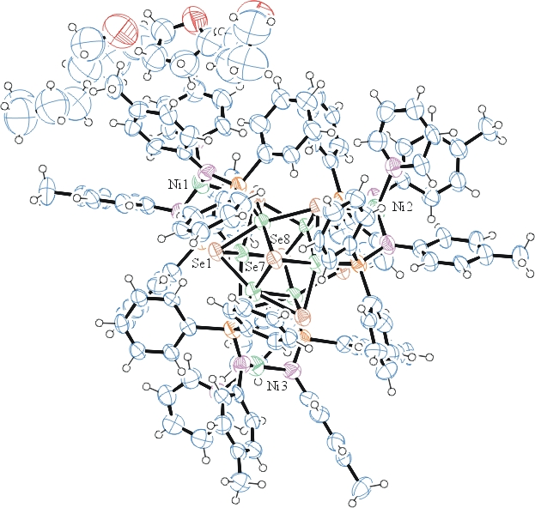
Figure 1. ORTEP of the structure with thermal ellipsoids at the 50% probability level.

Table 1: Crystallographic data for the structures provided.
Empirical formula C145 H149 Co6 N9 Ni3 O4 P6 Se8
Formula weight 3428.93
Temperature 90(2) K
Wavelength 0.71073 Å
Crystal system Monoclinic
Space group P 2₁/c
Unit cell dimensions a = 30.052(2) Å α= 90°.
b = 15.1306(13) Å β= 116.205(4)°.
c = 33.427(4) Å γ = 90°.
Volume 13637(2) Å3
Z 4
Density (calculated) 1.670 Mg/m3
Absorption coefficient 3.378 mm-1
F(000) 6888
Crystal size 0.300 x 0.100 x 0.050 mm3
Theta range for data collection 1.358 to 25.027°.
Index ranges -35<=h<=35, -18<=k<=18, -39<=l<=39
Reflections collected 45570
Independent reflections 23857 [R(int) = 0.2182]
Completeness to theta = 25.000° 99.1 %
Refinement method Full-matrix least-squares on F2
Data / restraints / parameters 23857 / 2270 / 1636
Goodness-of-fit on F2 1.070
Final R indices [I>2sigma(I)] R1 = 0.1253, wR2 = 0.2501
R indices (all data) R1 = 0.3320, wR2 = 0.3302
Largest diff. peak and hole 2.505 and -1.329 e.Å-3

Otwinowsky, Z.; Minor, W. In: Methods in Enzymology; Carter, C. W., Jr., Sweet, R. M., Eds.; Academic Press: New York, 1997, 276, 307-326.
Sheldrick GM. (2015) SHELXT - Integrated space-group and crystal-structure determination. Acta Cryst. A71, 3-8.
(a) Altomare A, Burla C, Camalli M, Cascarano G L, Giacovazzo C, Guagliardi A, Moliterni AGG, Polidori G, Spagna R. (1999) SIR97: a new tool for crystal structure determination and refinement Journal of Applied Crystallography, 32, 115-119. (b) Altomare A, Cascarano G L, Giacovazzo C, Guagliardi A. (1993) Completion and refinement of crystal structures with SIR 92. Journal of Applied Crystallography, 26, 343-350.
(a) Sheldrick GM. (1997) SHELXL-97, Program for the Refinement of Crystal Structures. University of Göttingen, Germany. (b) Sheldrick GM. (2015) Crystal structure refinement with SHELXL. Acta Cryst. (2015). C71, 3–8
Mackay, S.; Edwards, C.; Henderson, A.; Gilmore, C.; Stewart, N.; Shankland, K.; Donald, A. (1997) MaXus: a computer program for the solution and refinement of crystal structures from diffraction data. University of Glasgow, Scotland,.
Waasmaier, D.; Kirfel, A. Acta Crystallogr. A. 1995, 51, 416.
Farrugia, L. J. Appl. Cryst. 1997, 30, 565

