Crystal Structure Report for A. Velian
by Paige Gannon & Werner Kaminsky
Sample Submitted by Jon Kephart
ID – JAK768
X-ray Crystallography Laboratory
University of Washington
28. July 2026

Data Collection started: 4/15/2022
Documentation finished: 4/22/2022

Data backup accessibly through http:
URL: http://cad4.cpac.washington.edu/structures

W.Kaminsky: tel. (206) 543 7585
(x-ray lab): tel. (206) 543 0210
Email: kaminsky@chem.washington.edu

Understanding crystallographic information is not trivial. If you discuss a structure in a publication, please let the crystallographers proof-read the final draft of that manuscript before you submit it.
For many structures it is true that crystallography is an intellectual performance (like synthesis or elucidation of mechanisms) and not a routine job. In these cases, particularly when the structures contribute significantly to the content of the publication, the crystallographers should be co-authors. Do not think this is not necessary because you pay for structures.
A brown plate, measuring 0.24 x 0.20 x 0.06 mm³ was mounted on a loop with oil. Data was collected at -173ºC on a Bruker APEX II single crystal X-ray diffractometer, Mo-radiation, equipped with a Miracol X-ray optical collimator.

Crystal-to-detector distance was 40 mm and exposure time was 30 seconds per frame for all sets. The scan width was 0.5º. Data collection was 98% complete to 17.2º in ϑ. A total of 27978 reflections were collected covering the indices, -25<=h<=25, -23<=k<=23, -73<=l<=73. 4877 reflections were symmetry independent and the R_{int} = 0.0822 indicated that the data was usable. Indexing and unit cell refinement indicated a rombohedral lattice. The space group was found to be R‾3 c: H (No. 167).

The data was integrated and scaled using SAINT, SADABS within the APEX2 software package by Bruker.

Solution by direct methods (SHELXT or SIR97) produced a complete heavy atom phasing model consistent with the proposed structure. The structure was completed by difference Fourier synthesis with SHELXL. Scattering factors are from Waasmair and Kirfel. Hydrogen atoms were placed in geometrically idealised positions and constrained to ride on their parent atoms with C---H distances in the range 0.95-1.00 Angstrom. Isotropic thermal parameters U_{eq} were fixed such that they were 1.2U_{eq} of their parent atom Ueq for CH's and 1.5U_{eq} of their parent atom U_{eq} in case of methyl groups. All non-hydrogen atoms were refined anisotropically by full-matrix least-squares.

The high symmetry let to one cluster being related by one half to the other, a second one without iron by having only 1/6 in the asymmetric cell being completed by symmetry. A heavily disordered PF6 anion accounts for 2/3 of anion needed per iron containing cluster. No CNtBut was found, but two THF solvents.

There was no data bejond a resolution of 1.2 because of excessive disorder of solvent inside wide infinite channels. This causes large displacement parameters on all other atoms and makes the structure appear similar to being at a high temperature whereas measurement was carried out at 100K.

Many restraints were needed, the contribution of disordered solvent to the diffraction pattern including possibly some anions was removed with SQUEEZE

The structure may not lend itself for publication. Table 1 summarizes the data collection details. Figure 1 shows an ORTEP of the asymmetric unit.

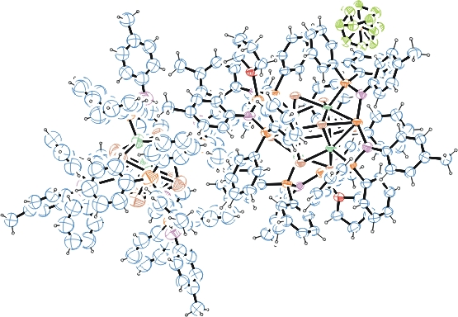
Figure 1. ORTEP of the structure with thermal ellipsoids at the 15% probability level.

Table 1: Crystallographic data for the structures provided.
Empirical formula C423 H408 Co21 F12 Fe9 N21 O6 P23 Se28
Formula weight 10773.05
Temperature 100(2) K
Wavelength 0.71073 Å
Crystal system Trigonal
Space group R -3 c :H
Unit cell dimensions a = 31.1321(12) Å α= 90°.
b = 31.1321(12) Å β= 90°.
c = 87.811(5) Å γ = 120°.
Volume 73705(7) Å3
Z 6
Density (calculated) 1.456 Mg/m3
Absorption coefficient 3.146 mm-1
F(000) 32082
Crystal size 0.240 x 0.200 x 0.060 mm3
Theta range for data collection 1.196 to 17.206°.
Index ranges -25<=h<=25, -23<=k<=23, -73<=l<=73
Reflections collected 27978
Independent reflections 4877 [R(int) = 0.0822]
Completeness to theta = 17.206° 98.0 %
Refinement method Full-matrix least-squares on F2
Data / restraints / parameters 4877 / 1171 / 813
Goodness-of-fit on F2 1.087
Final R indices [I>2sigma(I)] R1 = 0.1210, wR2 = 0.2721
R indices (all data) R1 = 0.2071, wR2 = 0.3660
Largest diff. peak and hole 1.142 and -0.538 e.Å-3

Bruker (2007) APEX2 (Version 2.1-4), SAINT (version 7.34A), SADABS (version 2007/4), BrukerAXS Inc, Madison, Wisconsin, USA.
(a) Sheldrick GM. (2008) A short history of SHELX. Acta Cryst. A64, 112-122. (b) Sheldrick GM. (2015) SHELXT - Integrated space-group and crystal-structure determination. Acta Cryst. A71, 3-8.
(a) Altomare A, Burla C, Camalli M, Cascarano G L, Giacovazzo C, Guagliardi A, Moliterni AGG, Polidori G, Spagna R. (1999) SIR97: a new tool for crystal structure determination and refinement Journal of Applied Crystallography, 32, 115-119. (b) Altomare A, Cascarano G L, Giacovazzo C, Guagliardi A. (1993) Completion and refinement of crystal structures with SIR 92. Journal of Applied Crystallography, 26, 343-350.
(a) Sheldrick GM. (1997) SHELXL-97, Program for the Refinement of Crystal Structures. University of Göttingen, Germany. (b) Sheldrick GM. (2015) Crystal structure refinement with SHELXL. Acta Cryst. C71, 3–8
Waasmaier, D.; Kirfel, A. (1995) New Analytical Scattering Factor Functions for Free Atoms and Ions. Acta Crystallographica A., 51, 416-430.
(a) A. Spek, J. Appl. Cryst. (2003), 36, 7-13; (b) P. van der Sluis & A. L. Spek, Acta Cryst. (1990). A46, 194-201. (c) Spek, A. L. (2009). Acta. Cryst. D65, 148-155.
Farrugia LJ. (1997) Ortep-3 for Windows. Journal of Applied Crystallography, 30, 565

