Crystal Structure Report for A. Velian
by Dylan Rogers & Werner Kaminsky
Sample Submitted by Jon Kephart
ID – JAK_201
X-ray Crystallography Laboratory
University of Washington
28. July 2026

Data Collection started: 8/17/2018
Documentation finished: 9/7/2018

Data backup accessibly through http:
URL: http://cad4.cpac.washington.edu/structures

W.Kaminsky: tel. (206) 543 7585
(x-ray lab): tel. (206) 543 0210
Email: kaminsky@chem.washington.edu

Understanding crystallographic information is not trivial. If you discuss a structure in a publication, please let the crystallographers proof-read the final draft of that manuscript before you submit it.
For many structures it is true that crystallography is an intellectual performance (like synthesis or elucidation of mechanisms) and not a routine job. In these cases, particularly when the structures contribute significantly to the content of the publication, the crystallographers should be co-authors. Do not think this is not necessary because you pay for structures.
A black piece, measuring 0.17 x 0.11 x 0.09 mm³ was mounted on a loop with oil. Data was collected at -173ºC on a Bruker APEX II single crystal X-ray diffractometer, Mo-radiation.

Crystal-to-detector distance was 40 mm and exposure time was 60 seconds per frame for all sets. The scan width was 0.5º. Data collection was 97.4% complete to 25º in ϑ. A total of 121684 merged reflections were collected covering the indices, -22<=h<=22, -35<=k<=35, -42<=l<=42. 64091 reflections were symmetry independent and the R_{int} = 0.2236 relates to the small sample size. Indexing and unit cell refinement indicated a triclinic lattice. The space group was found to be P‾1 (No. 2).

The data was integrated and scaled using SAINT, SADABS within the APEX2 software package by Bruker.

Solution by direct methods (SHELXT or SIR97) produced a complete heavy atom phasing model consistent with the proposed structure. The structure was completed by difference Fourier synthesis with SHELXL., Scattering factors are from Waasmair and Kirfel. Hydrogen atoms were placed in geometrically idealised positions and constrained to ride on their parent atoms with C---H distances in the range 0.95-1.00 Angstrom. Isotropic thermal parameters U_{eq} were fixed such that they were 1.2U_{eq} of their parent atom Ueq for CH's and 1.5U_{eq} of their parent atom U_{eq} in case of methyl groups. All non-hydrogen atoms were refined anisotropically by full-matrix least-squares.

The crystals were grown from a mixture of THF, pentane and ethyl-ether. Three complexes were found in the asymmetric unit and the contribution of disordered solvent to the diffraction pattern was removed with SQUEEZE. The three complexes differ slightly from each other. Complex a), Co1-Co6 etc., contains three iron, one of which (Fe3) coordinating with a pyridine ring (N115-C120). Complex b), Co7-Co13 etc., is composed 1:1 with one complex similar to complex a), but the other half, though, misses an iron and a solvent pyridine (N535-C540) occupies a similar location as the one (N235-C240) coordinated to Fe6. For this part, nitrogen atoms N11B and N12B appear protonated. The third complex, Co13-Co18 etc., consists 1:1 of a complex like a) but without pyridine on iron Fe9B, and the other half is again similar to a), but with Iron Fe9 coordinating with a pyridine (N367-C372). In all this leaves a complexly connected system of related disorder, which was sorted into two geometries with 3 complexes similar to complex a in the first geometry and the chemically differing ones in the second, all fitting together nicely. Thus, the five different molecules in the asymmetric unit are:

- C119 H107 Co6 Fe3 N7 P6 Se8
- 0.5(C119 H107 Co6 Fe3 N7 P6 Se8),
0.5(C114 H104 Co6 Fe2 N6 P6 Se8), 0.5(C5 H5 N),
- 0.5(C119 H107 Co6 Fe3 N7 P6 Se8),
0.5(C114 H102 Co6 Fe3 N6 P6 Se8)

The refinement required numerous restraints listed in the .res file to stabilize the refinement. The structure is of high quality and ready for publication. Table 1 summarizes the data collection details. Figure 1a and b show ORTEP diagrams of the asymmetric unit of parts 1 and 2 in projection normal to (001).

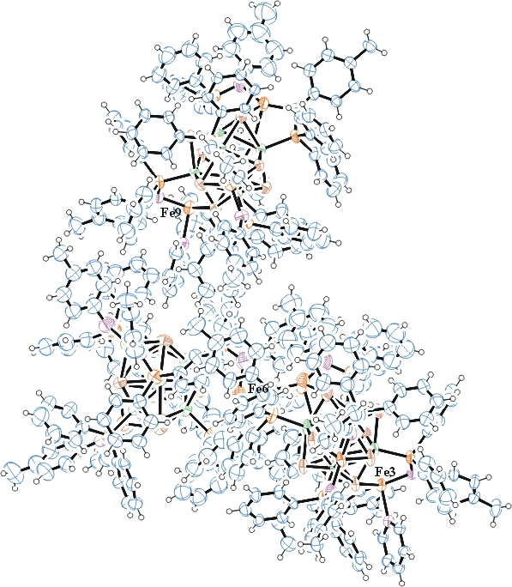
Figure 1a. ORTEP of part 1 of the structure with thermal ellipsoids at the 50% probability level.
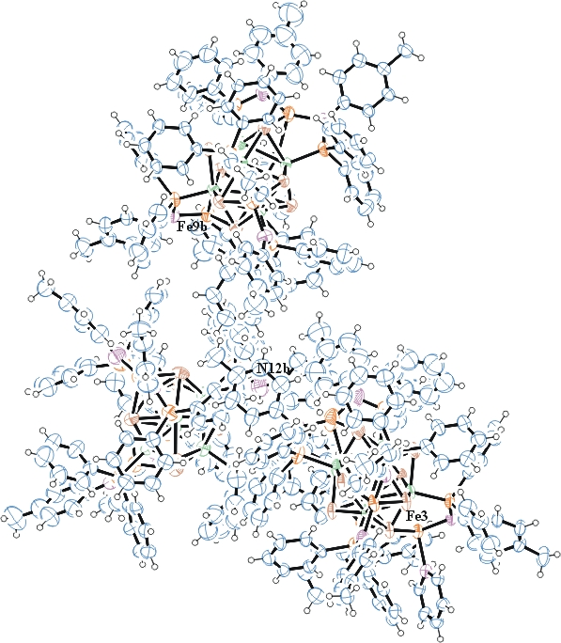
Figure 1b. ORTEP of part 2 of the structure with thermal ellipsoids at the 50% probability level.

Table 1: Crystallographic data for the structures provided.
Empirical formula C709 H639 Co36 Fe17 N41 P36 Se48
Formula weight 17709.50
Temperature 100(2) K
Wavelength 0.71073 Å
Crystal system Triclinic
Space group P -1
Unit cell dimensions a = 18.3995(16) Å α= 100.073(6)°.
b = 29.552(3) Å β= 103.883(6)°.
c = 35.103(3) Å γ = 96.048(6)°.
Volume 18026(3) Å3
Z 1
Density (calculated) 1.631 Mg/m3
Absorption coefficient 3.690 mm-1
F(000) 8766
Crystal size 0.170 x 0.110 x 0.090 mm3
Theta range for data collection 1.279 to 25.439°.
Index ranges -22<=h<=22, -35<=k<=35, -42<=l<=42
Reflections collected 121684
Independent reflections 64091 [R(int) = 0.2236]
Completeness to theta = 25.000° 97.4 %
Refinement method Full-matrix least-squares on F2
Data / restraints / parameters 64091 / 5557 / 3429
Goodness-of-fit on F2 1.024
Final R indices [I>2sigma(I)] R1 = 0.1284, wR2 = 0.2901
R indices (all data) R1 = 0.3259, wR2 = 0.3767
Largest diff. peak and hole 3.128 and -1.443 e.Å-3

Bruker (2007) APEX2 (Version 2.1-4), SAINT (version 7.34A), SADABS (version 2007/4), BrukerAXS Inc, Madison, Wisconsin, USA.
Sheldrick GM. (2015) SHELXT - Integrated space-group and crystal-structure determination. Acta Cryst. A71, 3-8.
(a) Altomare A, Burla C, Camalli M, Cascarano G L, Giacovazzo C, Guagliardi A, Moliterni AGG, Polidori G, Spagna R. (1999) SIR97: a new tool for crystal structure determination and refinement Journal of Applied Crystallography, 32, 115-119. (b) Altomare A, Cascarano G L, Giacovazzo C, Guagliardi A. (1993) Completion and refinement of crystal structures with SIR 92. Journal of Applied Crystallography, 26, 343-350.
(a) Sheldrick GM. (1997) SHELXL-97, Program for the Refinement of Crystal Structures. University of Göttingen, Germany. (b) Sheldrick GM. (2015) Crystal structure refinement with SHELXL. Acta Cryst. (2015). C71, 3–8
Mackay, S.; Edwards, C.; Henderson, A.; Gilmore, C.; Stewart, N.; Shankland, K.; Donald, A. (1997) MaXus: a computer program for the solution and refinement of crystal structures from diffraction data. University of Glasgow, Scotland,.
Waasmaier, D.; Kirfel, A. (1995) New Analytical Scattering Factor Functions for Free Atoms and Ions. Acta Crystallographica A., 51, 416-430.
(a) A. Spek, J. Appl. Cryst. (2003), 36, 7-13; (b) P. van der Sluis & A. L. Spek, Acta Cryst. (1990). A46, 194-201. (c) Spek, A. L. (2009). Acta. Cryst. D65, 148-155.
Farrugia LJ. (1997) Ortep-3 for Windows. Journal of Applied Crystallography, 30, 565

