Crystal Structure Report for A. Velian
by Dylan Rogers & Werner Kaminsky
Sample Submitted by Jon Kephart
ID – JAK_278
X-ray Crystallography Laboratory
University of Washington
28. July 2026

Data Collection started: 12/8/18
Documentation finished: 12/11/18

Data backup accessibly through http:
URL: http://cad4.cpac.washington.edu/structures

W.Kaminsky: tel. (206) 543 7585
(x-ray lab): tel. (206) 543 0210
Email: kaminsky@chem.washington.edu

Understanding crystallographic information is not trivial. If you discuss a structure in a publication, please let the crystallographers proof-read the final draft of that manuscript before you submit it.
For many structures it is true that crystallography is an intellectual performance (like synthesis or elucidation of mechanisms) and not a routine job. In these cases, particularly when the structures contribute significantly to the content of the publication, the crystallographers should be co-authors. Do not think this is not necessary because you pay for structures.
A black plate, measuring 0.03 x 0.04 x 0.01 mm³ was mounted on a loop with oil. Data was collected at -173ºC on a Bruker APEX II single crystal X-ray diffractometer, Mo-radiation.

Crystal-to-detector distance was 40 mm and exposure time was 60 seconds per frame for all sets. The scan width was 0.5º. Data collection was 100% complete to 25º in ϑ. A total of 75032 reflections were collected covering the indices, -19<=h<=19, -19<=k<=19, -20<=l<=20. 13726 reflections were symmetry independent and the R_{int} = 0.1273 indicated that the data was of worse than average quality (0.07). Indexing and unit cell refinement indicated a triclinic lattice. The space group was found to be P -1 (No.2).

The data was integrated and scaled using SAINT, SADABS within the APEX2 software package by Bruker.

Solution by direct methods (SHELXT or SIR97) produced a complete heavy atom phasing model consistent with the proposed structure. The structure was completed by difference Fourier synthesis with SHELXL., Scattering factors are from Waasmair and Kirfel. Hydrogen atoms were placed in geometrically idealised positions and constrained to ride on their parent atoms with C---H distances in the range 0.95-1.00 Angstrom. Isotropic thermal parameters U_{eq} were fixed such that they were 1.2U_{eq} of their parent atom Ueq for CH's and 1.5U_{eq} of their parent atom U_{eq} in case of methyl groups. All non-hydrogen atoms were refined anisotropically by full-matrix least-squares.

The structure has a lithium atom coordinated between two of the phosphoamide moieties, with the third phosphoamide protonated. This results in a cluster with four phosphoamides involved in bonding, with two phosphoamides on opposite sides of the cluster uninvolved. Additionally, an acetonitrile molecule is coordinated to the lithium atom.

The structure is of high quality and ready for publication. Table 1 summarizes the data collection details. Figure 1 shows an ORTEP of the asymmetric unit.

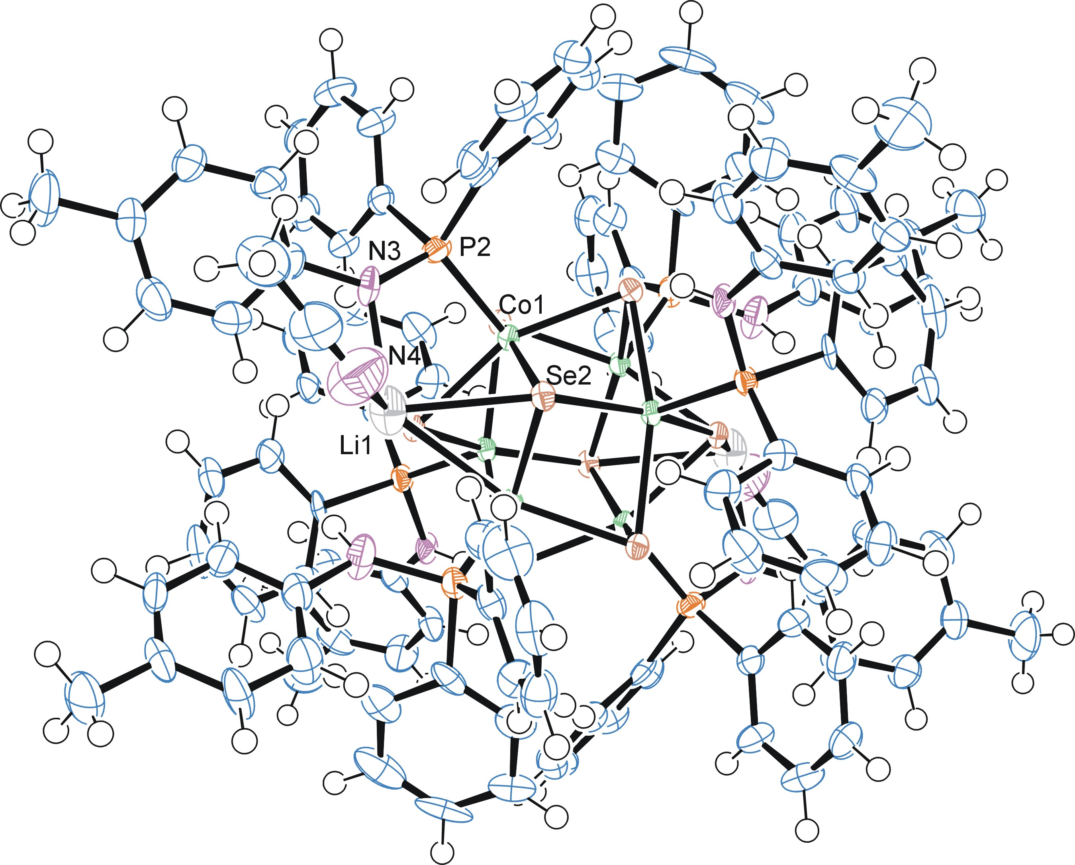

Figure 1. ORTEP of the structure with thermal ellipsoids at the 50% probability level.

Table 1: Crystallographic data for the structures provided.
Empirical formula C118 H112 Co6 Li2 N8 P6 Se8
Formula weight 2827.11
Temperature 100(2) K
Wavelength 0.71073 Å
Crystal system Triclinic
Space group P -1
Unit cell dimensions a = 14.4327(6) Å α= 81.546(2)°.
b = 14.5739(5) Å β= 64.453(3)°.
c = 15.6095(7) Å γ = 67.916(2)°.
Volume 2744.5(2) Å3
Z 1
Density (calculated) 1.711 Mg/m3
Absorption coefficient 3.680 mm-1
F(000) 1406
Crystal size 0.040 x 0.030 x 0.008 mm3
Theta range for data collection 1.446 to 28.508°.
Index ranges -19<=h<=19, -19<=k<=19, -20<=l<=20
Reflections collected 75032
Independent reflections 13726 [R(int) = 0.1273]
Completeness to theta = 25.000° 100.0 %
Absorption correction Semi-empirical from equivalents
Max. and min. transmission 0.746 and 0.641
Refinement method Full-matrix least-squares on F2
Data / restraints / parameters 13726 / 2 / 681
Goodness-of-fit on F2 0.989
Final R indices [I>2sigma(I)] R1 = 0.0488, wR2 = 0.0783
R indices (all data) R1 = 0.1109, wR2 = 0.0957
Largest diff. peak and hole 0.991 and -0.860 e.Å-3

Bruker (2007) APEX2 (Version 2.1-4), SAINT (version 7.34A), SADABS (version 2007/4), BrukerAXS Inc, Madison, Wisconsin, USA.
Sheldrick GM. (2015) SHELXT - Integrated space-group and crystal-structure determination. Acta Cryst. A71, 3-8.
(a) Altomare A, Burla C, Camalli M, Cascarano G L, Giacovazzo C, Guagliardi A, Moliterni AGG, Polidori G, Spagna R. (1999) SIR97: a new tool for crystal structure determination and refinement Journal of Applied Crystallography, 32, 115-119. (b) Altomare A, Cascarano G L, Giacovazzo C, Guagliardi A. (1993) Completion and refinement of crystal structures with SIR 92. Journal of Applied Crystallography, 26, 343-350.
(a) Sheldrick GM. (1997) SHELXL-97, Program for the Refinement of Crystal Structures. University of Göttingen, Germany. (b) Sheldrick GM. (2015) Crystal structure refinement with SHELXL. Acta Cryst. (2015). C71, 3–8
Mackay, S.; Edwards, C.; Henderson, A.; Gilmore, C.; Stewart, N.; Shankland, K.; Donald, A. (1997) MaXus: a computer program for the solution and refinement of crystal structures from diffraction data. University of Glasgow, Scotland,.
Waasmaier, D.; Kirfel, A. (1995) New Analytical Scattering Factor Functions for Free Atoms and Ions. Acta Crystallographica A., 51, 416-430.
Farrugia LJ. (1997) Ortep-3 for Windows. Journal of Applied Crystallography, 30, 565

