Crystal Structure Report for A. Velian
by Dylan Rogers & Werner Kaminsky
Sample Submitted by Jon Kephart
ID – JAK_334
X-ray Crystallography Laboratory
University of Washington
31. July 2026

Data Collection started: 03/01/19
Documentation finished: 03/11/19

Data backup accessibly through http:
URL: http://cad4.cpac.washington.edu/structures

W.Kaminsky: tel. (206) 543 7585
(x-ray lab): tel. (206) 543 0210
Email: kaminsky@chem.washington.edu

Understanding crystallographic information is not trivial. If you discuss a structure in a publication, please let the crystallographers proof-read the final draft of that manuscript before you submit it.
For many structures it is true that crystallography is an intellectual performance (like synthesis or elucidation of mechanisms) and not a routine job. In these cases, particularly when the structures contribute significantly to the content of the publication, the crystallographers should be co-authors. Do not think this is not necessary because you pay for structures.
A black piece, measuring 0.06 x 0.42 x 0.09 mm³ was mounted on a loop with oil. Data was collected at -173ºC on a Bruker APEX II single crystal X-ray diffractometer, Mo-radiation.

Crystal-to-detector distance was 40 mm and exposure time was 10 seconds per frame for all sets. The scan width was 0.5º. Data collection was 99.8% complete to 25º in ϑ. A total of 69531 reflections were collected covering the indices, -26<=h<=25, -26<=k<=26, -27<=l<=27. 34926 reflections were symmetry independent and the R_{int} = 0.0472 indicated that the data was of better than average quality (0.07). Indexing and unit cell refinement indicated a triclinic lattice. The space group was found to be P‾1 (No.2).

The data was integrated and scaled using SAINT, SADABS within the APEX2 software package by Bruker.

The contribution of disordered solvent to the diffraction pattern was removed with SQUEEZE

Solution by direct methods (SHELXT or SIR97) produced a complete heavy atom phasing model consistent with the proposed structure. The structure was completed by difference Fourier synthesis with SHELXL., Scattering factors are from Waasmair and Kirfel. Hydrogen atoms were placed in geometrically idealised positions and constrained to ride on their parent atoms with C---H distances in the range 0.95-1.00 Angstrom. Isotropic thermal parameters U_{eq} were fixed such that they were 1.2U_{eq} of their parent atom Ueq for CH's and 1.5U_{eq} of their parent atom U_{eq} in case of methyl groups. All non-hydrogen atoms were refined anisotropically by full-matrix least-squares.

The cluster features two irons coordinated with tert-butyl isocyanide groups, and a third iron coordinated with a tetrahydrofuran molecule. The whole cluster is accompanied by a hexafluorophosphate anion. Multiple incidents of disorder required the implementation of numerous restraints.

The structure is of high quality and ready for publication. Table 1 summarizes the data collection details. Figure 1 shows an ORTEP of the asymmetric unit.

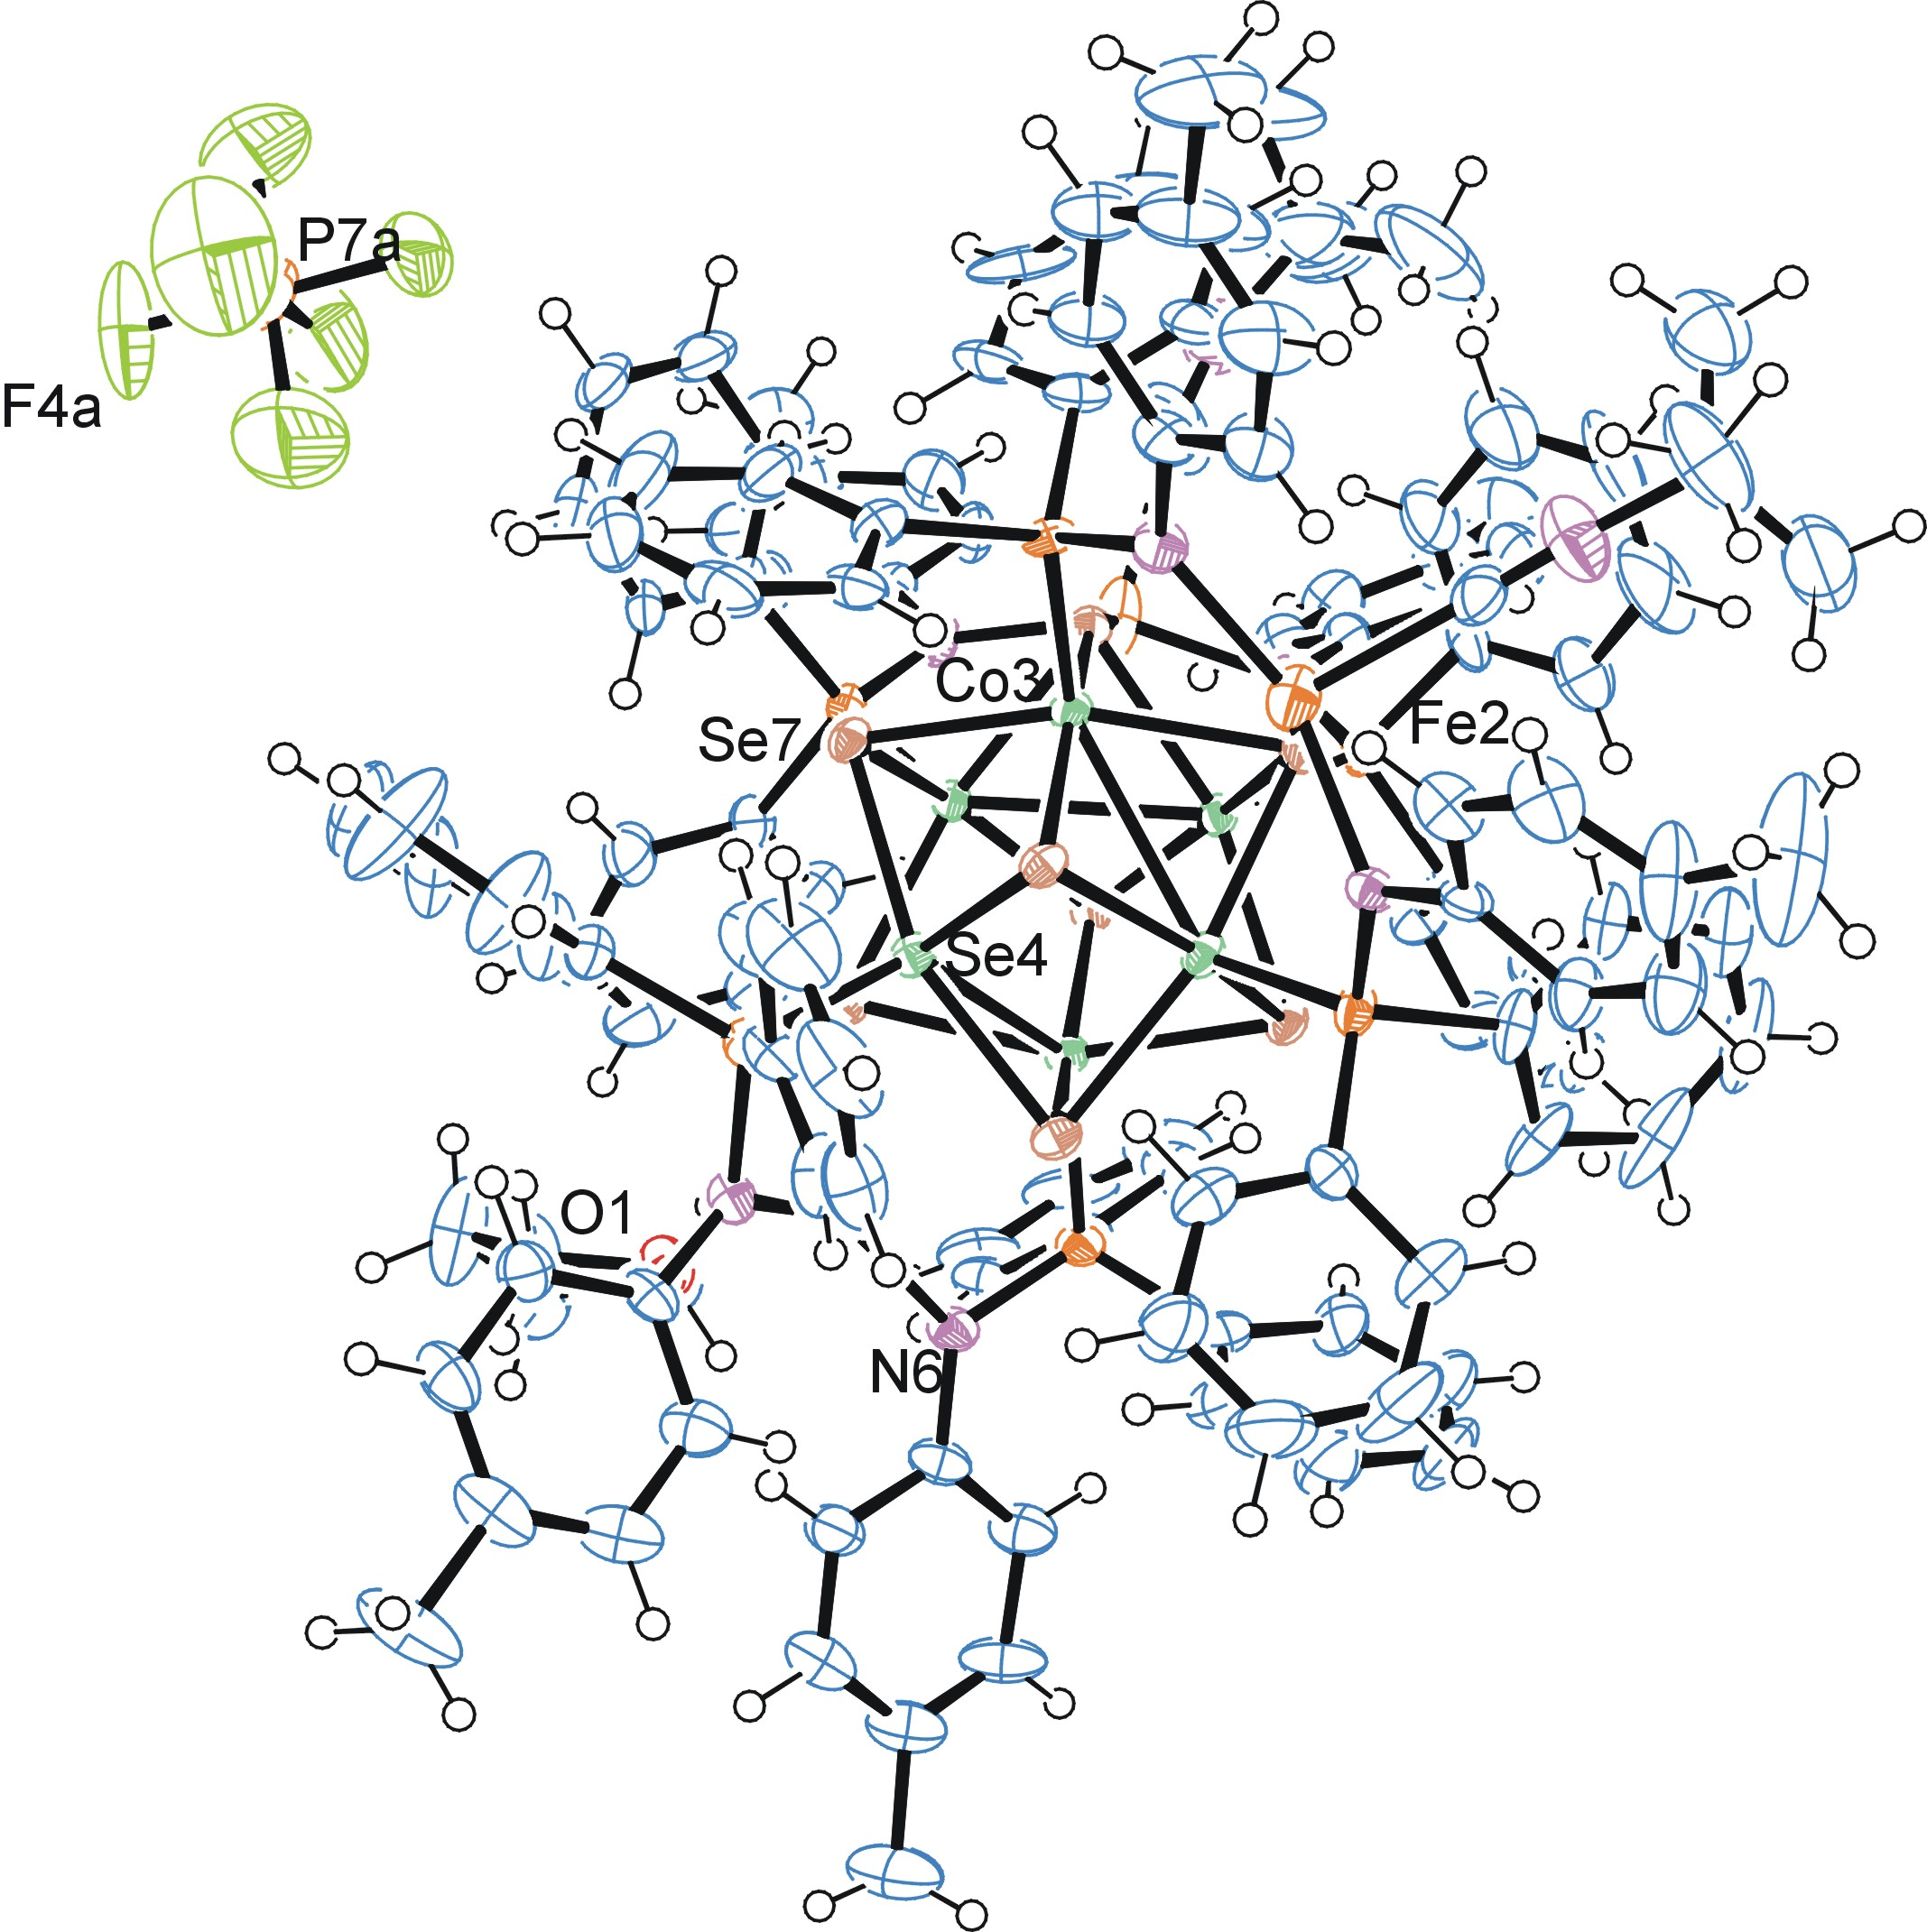
Figure 1. ORTEP of the structure with thermal ellipsoids at the 50% probability level. Disorder and alcohol solvent omitted for clarity.

Table 1: Crystallographic data for the structures provided.
Empirical formula C128 H128 Co6 F6 Fe3 N8 O P7 Se8
Formula weight 3277.98
Temperature 100(2) K
Wavelength 0.71073 Å
Crystal system Triclinic
Space group P -1
Unit cell dimensions a = 19.480(2) Å α= 89.548(3)°.
b = 19.724(2) Å β= 71.860(3)°.
c = 20.296(2) Å γ = 72.506(3)°.
Volume 7036.4(13) Å3
Z 2
Density (calculated) 1.547 Mg/m3
Absorption coefficient 3.193 mm-1
F(000) 3262
Crystal size 0.600 x 0.420 x 0.090 mm3
Theta range for data collection 1.445 to 28.339°.
Index ranges -26<=h<=25, -26<=k<=26, -27<=l<=27
Reflections collected 69531
Independent reflections 34926 [R(int) = 0.0472]
Completeness to theta = 25.000° 99.8 %
Refinement method Full-matrix least-squares on F2
Data / restraints / parameters 34926 / 441 / 1671
Goodness-of-fit on F2 1.019
Final R indices [I>2sigma(I)] R1 = 0.0605, wR2 = 0.1452
R indices (all data) R1 = 0.0964, wR2 = 0.1621
Largest diff. peak and hole 3.033 and -1.036 e.Å-3

Bruker (2007) APEX2 (Version 2.1-4), SAINT (version 7.34A), SADABS (version 2007/4), BrukerAXS Inc, Madison, Wisconsin, USA.
(a) A. Spek, J. Appl. Cryst. (2003), 36, 7-13; (b) P. van der Sluis & A. L. Spek, Acta Cryst. (1990). A46, 194-201. (c) Spek, A. L. (2009). Acta. Cryst. D65, 148-155.
Sheldrick GM. (2015) SHELXT - Integrated space-group and crystal-structure determination. Acta Cryst. A71, 3-8.
(a) Altomare A, Burla C, Camalli M, Cascarano G L, Giacovazzo C, Guagliardi A, Moliterni AGG, Polidori G, Spagna R. (1999) SIR97: a new tool for crystal structure determination and refinement Journal of Applied Crystallography, 32, 115-119. (b) Altomare A, Cascarano G L, Giacovazzo C, Guagliardi A. (1993) Completion and refinement of crystal structures with SIR 92. Journal of Applied Crystallography, 26, 343-350.
(a) Sheldrick GM. (1997) SHELXL-97, Program for the Refinement of Crystal Structures. University of Göttingen, Germany. (b) Sheldrick GM. (2015) Crystal structure refinement with SHELXL. Acta Cryst. (2015). C71, 3–8
Mackay, S.; Edwards, C.; Henderson, A.; Gilmore, C.; Stewart, N.; Shankland, K.; Donald, A. (1997) MaXus: a computer program for the solution and refinement of crystal structures from diffraction data. University of Glasgow, Scotland,.
Waasmaier, D.; Kirfel, A. (1995) New Analytical Scattering Factor Functions for Free Atoms and Ions. Acta Crystallographica A., 51, 416-430.
Farrugia LJ. (1997) Ortep-3 for Windows. Journal of Applied Crystallography, 30, 565

