Crystal Structure Report for A. Velian
by Dylan Rogers & Werner Kaminsky
Sample Submitted by Jon Kephart
ID – JAK_341
X-ray Crystallography Laboratory
University of Washington
31. July 2026

Data Collection started: 2/9/2019
Documentation finished: 2/20/2019

Data backup accessibly through http:
URL: http://cad4.cpac.washington.edu/structures

W.Kaminsky: tel. (206) 543 7585
(x-ray lab): tel. (206) 543 0210
Email: kaminsky@chem.washington.edu

Understanding crystallographic information is not trivial. If you discuss a structure in a publication, please let the crystallographers proof-read the final draft of that manuscript before you submit it.
For many structures it is true that crystallography is an intellectual performance (like synthesis or elucidation of mechanisms) and not a routine job. In these cases, particularly when the structures contribute significantly to the content of the publication, the crystallographers should be co-authors. Do not think this is not necessary because you pay for structures.
A black piece, measuring 0.16 x 0.15 x 0.14 mm³ was mounted on a loop with oil. Data was collected at -173ºC on a Bruker APEX II single crystal X-ray diffractometer, Mo-radiation.

Crystal-to-detector distance was 40 mm and exposure time was 60 seconds per frame for all sets. The scan width was 0.5º. Data collection was 99.6% complete to 25º in ϑ. A total of 21733 reflections were collected covering the indices, -21<=h<=21, -35<=k<=35, -27<=l<=27. 11080 reflections were symmetry independent and the R_{int} = 0.0453 indicated that the data should have been easy to deal with. Indexing and unit cell refinement indicated a C-centered monoclinic lattice. The space group was found to be C2/c (No.15).

The data was integrated and scaled using SAINT, SADABS within the APEX2 software package by Bruker.

Solution by direct methods (SHELXT or SIR97) produced a complete heavy atom phasing model consistent with the proposed structure. The structure was completed by difference Fourier synthesis with SHELXL., Scattering factors are from Waasmair and Kirfel. Hydrogen atoms were placed in geometrically idealised positions and constrained to ride on their parent atoms with C---H distances in the range 0.95-1.00 Angstrom. Isotropic thermal parameters U_{eq} were fixed such that they were 1.2U_{eq} of their parent atom Ueq for CH's and 1.5U_{eq} of their parent atom U_{eq} in case of methyl groups. All non-hydrogen atoms were refined anisotropically by full-matrix least-squares.

With a monoclinic angle of 90.169 degrees, the structure is pseudo-orthorhombic. A twin operation was found that improved the refinement significantly, but, for a multi-domain integration required for correct twin treatment failed due to the pseudo symmetry. Thus, this structure is low in quality. In addition, disorder is observed within the complex and the cation. The void occupied by a cation was analyzed to contain in absence of the cation 55 electrons. The tetrahedral geometry of a half cation inside the void did not allow a disordered PF6⁻ to be placed there, which would also require a larger electron density inside the void. Thus, without claiming this is correct, a PF4⁻ cation was fitted as disordered unit in the void, which showed agreeable displacement parameters and would fit the estimated number of electrons. One iron is split between two positions. In addition, the structure contains several azetonitrile solvent molecules, one of which is coordinating with Fe (two for the extended molecule, which is completed through symmetry).

The structure is of moderate quality but maybe publishable. Table 1 summarizes the data collection details. Figure 1 shows an ORTEP of the asymmetric unit.

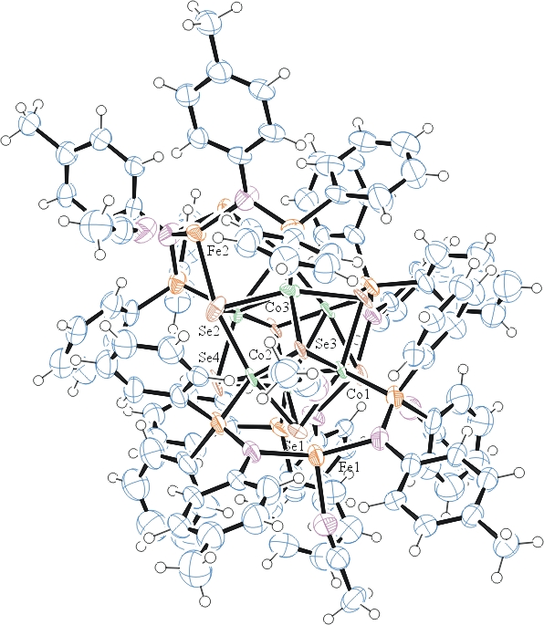
Figure 1. ORTEP of the structure with thermal ellipsoids at the 50% probability level. Cation omitted for clarity.

Table 1: Crystallographic data for the structures provided.
Empirical formula C124 H117 Co6 F4 Fe3 N11 P7 Se8
Formula weight 3206.88
Temperature 100(2) K
Wavelength 0.71073 Å
Crystal system Monoclinic
Space group C 2/c
Unit cell dimensions a = 17.591(2) Å α= 90°.
b = 29.975(3) Å β= 90.169(4)°.
c = 23.087(2) Å γ = 90°.
Volume 12174(2) Å3
Z 4
Density (calculated) 1.750 Mg/m3
Absorption coefficient 3.687 mm-1
F(000) 6364
Crystal size 0.160 x 0.150 x 0.140 mm3
Theta range for data collection 1.604 to 25.187°.
Index ranges -21<=h<=21, -35<=k<=35, -27<=l<=27
Reflections collected 21733
Independent reflections 11080 [R(int) = 0.0453]
Completeness to theta = 25.000° 99.6 %
Refinement method Full-matrix least-squares on F2
Data / restraints / parameters 11080 / 908 / 645
Goodness-of-fit on F2 1.054
Final R indices [I>2sigma(I)] R1 = 0.1531, wR2 = 0.3529
R indices (all data) R1 = 0.1884, wR2 = 0.3817
Largest diff. peak and hole 2.894 and -1.936 e.Å-3

Bruker (2007) APEX2 (Version 2.1-4), SAINT (version 7.34A), SADABS (version 2007/4), BrukerAXS Inc, Madison, Wisconsin, USA.
Sheldrick GM. (2015) SHELXT - Integrated space-group and crystal-structure determination. Acta Cryst. A71, 3-8.
(a) Altomare A, Burla C, Camalli M, Cascarano G L, Giacovazzo C, Guagliardi A, Moliterni AGG, Polidori G, Spagna R. (1999) SIR97: a new tool for crystal structure determination and refinement Journal of Applied Crystallography, 32, 115-119. (b) Altomare A, Cascarano G L, Giacovazzo C, Guagliardi A. (1993) Completion and refinement of crystal structures with SIR 92. Journal of Applied Crystallography, 26, 343-350.
(a) Sheldrick GM. (1997) SHELXL-97, Program for the Refinement of Crystal Structures. University of Göttingen, Germany. (b) Sheldrick GM. (2015) Crystal structure refinement with SHELXL. Acta Cryst. (2015). C71, 3–8
Mackay, S.; Edwards, C.; Henderson, A.; Gilmore, C.; Stewart, N.; Shankland, K.; Donald, A. (1997) MaXus: a computer program for the solution and refinement of crystal structures from diffraction data. University of Glasgow, Scotland,.
Waasmaier, D.; Kirfel, A. (1995) New Analytical Scattering Factor Functions for Free Atoms and Ions. Acta Crystallographica A., 51, 416-430.
Farrugia LJ. (1997) Ortep-3 for Windows. Journal of Applied Crystallography, 30, 565

