Crystal Structure Report for A. Velian
by Dylan Rogers & Werner Kaminsky
Sample Submitted by Jon Kephart
ID – JAK_348
X-ray Crystallography Laboratory
University of Washington
31. July 2026

Data Collection started: 2/20/2019
Documentation finished: 3/5/2019

Data backup accessibly through http:
URL: http://cad4.cpac.washington.edu/structures

W.Kaminsky: tel. (206) 543 7585
(x-ray lab): tel. (206) 543 0210
Email: kaminsky@chem.washington.edu

Understanding crystallographic information is not trivial. If you discuss a structure in a publication, please let the crystallographers proof-read the final draft of that manuscript before you submit it.
For many structures it is true that crystallography is an intellectual performance (like synthesis or elucidation of mechanisms) and not a routine job. In these cases, particularly when the structures contribute significantly to the content of the publication, the crystallographers should be co-authors. Do not think this is not necessary because you pay for structures.
A black prism, measuring 0.20 x 0.18 x 0.04 mm³ was mounted on a loop with oil. Data was collected at -173ºC on a Bruker APEX II single crystal X-ray diffractometer, Mo-radiation.

Crystal-to-detector distance was 40 mm and exposure time was 60 seconds per frame for all sets. The scan width was 0.5º. Data collection was 97.4% complete to 25º in ϑ. A total of 53108 symmetry independent reflections were collected covering the indices, -22<=h<=22, -23<=k<=23, -54<=l<=54; R_{int} = 0.1600 the big cell and small sample size. Indexing and unit cell refinement indicated a primitive orthorhombic lattice. The space group was found to be P ca2₁ (No. 29).

The data was integrated and scaled using SAINT, SADABS within the APEX2 software package by Bruker.

Solution by direct methods (SHELXT or SIR97) produced a complete heavy atom phasing model consistent with the proposed structure. The structure was completed by difference Fourier synthesis with SHELXL., Scattering factors are from Waasmair and Kirfel. Hydrogen atoms were placed in geometrically idealised positions and constrained to ride on their parent atoms with C---H distances in the range 0.95-1.00 Angstrom. Isotropic thermal parameters U_{eq} were fixed such that they were 1.2U_{eq} of their parent atom Ueq for CH's and 1.5U_{eq} of their parent atom U_{eq} in case of methyl groups. All non-hydrogen atoms were refined anisotropically by full-matrix least-squares.

The two clusters appear related by an inversion center, however, minute differences are observed and the PF6⁻ anions are not related by that inversion. Only one of potentially several THF solvent molecules could be refined individually. Most of the solvent (3319 electrons, 23% of refined F_000 = 14408) appeared delocalized inside infinite channels along [0 1 0] and that contribution to the diffraction patterns was removed via SQUEEZE. Several global and individual restraints were applied to ensure convergence of the refinement. The space group is non-centrosymmetric, however, the Flack parameter of 0.5 indicates mirror twinning normal to the c-axis.

The structure is of high quality and ready for publication. Table 1 summarizes the data collection details. Figure 1 shows an ORTEP of the asymmetric unit.

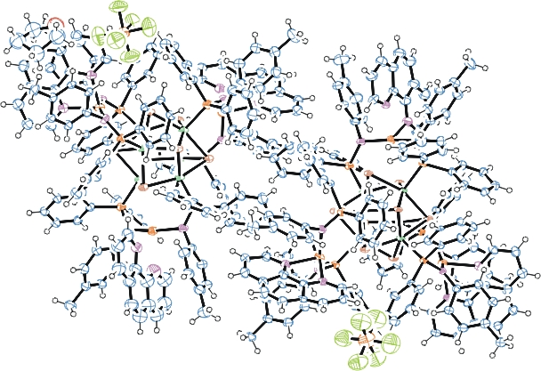
Figure 1. ORTEP of the structure with thermal ellipsoids at the 50% probability level.

Table 1: Crystallographic data for the structures provided.
Empirical formula C304 H260 Co12 F12 Fe6 N24 O P14 Se16
Formula weight 7232.54
Temperature 100(2) K
Wavelength 0.71073 Å
Crystal system Orthorhombic
Space group P c a 2₁
Unit cell dimensions a = 23.226(3) Å α= 90°.
b = 24.048(4) Å β= 90°.
c = 57.067(9) Å γ = 90°.
Volume 31873(8) Å3
Z 4
Density (calculated) 1.507 Mg/m3
Absorption coefficient 2.828 mm-1
F(000) 14408
Crystal size 0.200 x 0.180 x 0.040 mm3
Theta range for data collection 1.412 to 25.187°.
Index ranges -22<=h<=22, -23<=k<=23, -54<=l<=54
Reflections collected 53108
Independent reflections 53108 [R(int) = 0.1600]
Completeness to theta = 25.000° 97.4 %
Refinement method Full-matrix least-squares on F2
Data / restraints / parameters 53108 / 7153 / 3005
Goodness-of-fit on F2 1.038
Final R indices [I>2sigma(I)] R1 = 0.1282, wR2 = 0.3041
R indices (all data) R1 = 0.1974, wR2 = 0.3369
Absolute structure parameter 0.50(2)
Largest diff. peak and hole 1.774 and -2.280 e.Å-3

Bruker (2007) APEX2 (Version 2.1-4), SAINT (version 7.34A), SADABS (version 2007/4), BrukerAXS Inc, Madison, Wisconsin, USA.
Sheldrick GM. (2015) SHELXT - Integrated space-group and crystal-structure determination. Acta Cryst. A71, 3-8.
(a) Altomare A, Burla C, Camalli M, Cascarano G L, Giacovazzo C, Guagliardi A, Moliterni AGG, Polidori G, Spagna R. (1999) SIR97: a new tool for crystal structure determination and refinement Journal of Applied Crystallography, 32, 115-119. (b) Altomare A, Cascarano G L, Giacovazzo C, Guagliardi A. (1993) Completion and refinement of crystal structures with SIR 92. Journal of Applied Crystallography, 26, 343-350.
(a) Sheldrick GM. (1997) SHELXL-97, Program for the Refinement of Crystal Structures. University of Göttingen, Germany. (b) Sheldrick GM. (2015) Crystal structure refinement with SHELXL. Acta Cryst. (2015). C71, 3–8
Mackay, S.; Edwards, C.; Henderson, A.; Gilmore, C.; Stewart, N.; Shankland, K.; Donald, A. (1997) MaXus: a computer program for the solution and refinement of crystal structures from diffraction data. University of Glasgow, Scotland,.
Waasmaier, D.; Kirfel, A. (1995) New Analytical Scattering Factor Functions for Free Atoms and Ions. Acta Crystallographica A., 51, 416-430.
(a) A. Spek, J. Appl. Cryst. (2003), 36, 7-13; (b) P. van der Sluis & A. L. Spek, Acta Cryst. (1990). A46, 194-201. (c) Spek, A. L. (2009). Acta. Cryst. D65, 148-155.
Farrugia LJ. (1997) Ortep-3 for Windows. Journal of Applied Crystallography, 30, 565

