Crystal Structure Report for A. Velian
by Dylan Rogers & Werner Kaminsky
Sample Submitted by Jon Kephart
ID – JAK_360
X-ray Crystallography Laboratory
University of Washington
28. July 2026

Data Collection started: 4/11/2019
Documentation finished: 4/29/2019

Data backup accessibly through http:
URL: http://cad4.cpac.washington.edu/structures

W.Kaminsky: tel. (206) 543 7585
(x-ray lab): tel. (206) 543 0210
Email: kaminsky@chem.washington.edu

Understanding crystallographic information is not trivial. If you discuss a structure in a publication, please let the crystallographers proof-read the final draft of that manuscript before you submit it.
For many structures it is true that crystallography is an intellectual performance (like synthesis or elucidation of mechanisms) and not a routine job. In these cases, particularly when the structures contribute significantly to the content of the publication, the crystallographers should be co-authors. Do not think this is not necessary because you pay for structures.
A black plate, measuring 0.25 x 0.15 x 0.04 mm³ was mounted on a loop with oil. Data was collected at -173ºC on a Bruker APEX II single crystal X-ray diffractometer, Mo-radiation.

Crystal-to-detector distance was 40 mm and exposure time was 30 seconds per frame for all sets. The scan width was 0.5º. Data collection was 97.3% complete to 25º in ϑ. A total of 114789 reflections were collected covering the indices, -31<=h<=31, -20<=k<=20, -40<=l<=40. 29517 reflections were symmetry independent and the R_{int} = 0.0860 indicated that the data was of average quality. Indexing and unit cell refinement indicated a primitive monoclinic lattice. The space group was found to be P 2₁/c (No. 14).

The data was integrated and scaled using SAINT, SADABS within the APEX2 software package by Bruker.

Solution by direct methods (SHELXT or SIR97) produced a complete heavy atom phasing model consistent with the proposed structure. The structure was completed by difference Fourier synthesis with SHELXL., Scattering factors are from Waasmair and Kirfel. Hydrogen atoms were placed in geometrically idealised positions and constrained to ride on their parent atoms with C---H distances in the range 0.95-1.00 Angstrom. Isotropic thermal parameters U_{eq} were fixed such that they were 1.2U_{eq} of their parent atom Ueq for CH's and 1.5U_{eq} of their parent atom U_{eq} in case of methyl groups. All non-hydrogen atoms were refined anisotropically by full-matrix least-squares.

The contribution of disordered solvent to the diffraction pattern , i.e one ethyl ether and a half THF per cluster, was removed with SQUEEZE. Several phenyls, P2, as well as two toluenes and one of the THF coordinating with manganese moieties were disordered which required a number of restraints, applied to ensure convergence of the refinement.

The structure is of high quality and ready for publication. Table 1 summarizes the data collection details. Figure 1 shows an ORTEP of the asymmetric unit.

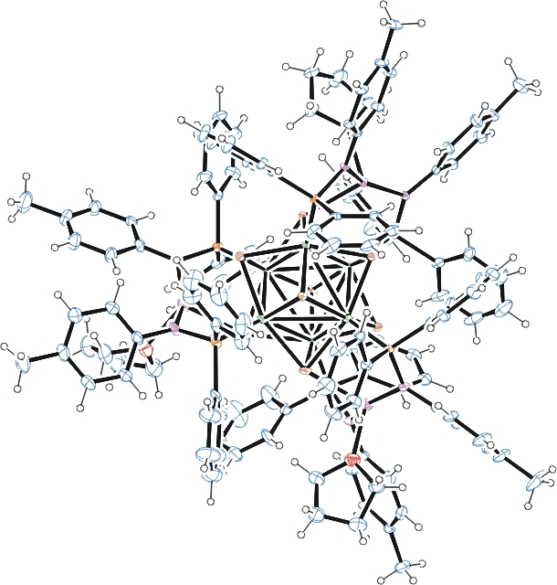
Figure 1. ORTEP of the structure with thermal ellipsoids at the 50% probability level. Disordered solvent and phenyl/toluene/THF disorder omitted for clarity.

Table 1: Crystallographic data for the structures provided.
Empirical formula C126 H126 Co6 Mn3 N6 O3 P6 Se8
Formula weight 3108.22
Temperature 100(2) K
Wavelength 0.71073 Å
Crystal system Monoclinic
Space group P 2₁/c
Unit cell dimensions a = 30.5493(19) Å α= 90°.
b = 15.5554(9) Å β= 117.184(3)°.
c = 30.3008(17) Å γ = 90°.
Volume 12808.7(13) Å3
Z 4
Density (calculated) 1.612 Mg/m3
Absorption coefficient 3.442 mm-1
F(000) 6188
Crystal size 0.250 x 0.150 x 0.040 mm3
Theta range for data collection 1.345 to 28.376°.
Index ranges -31<=h<=31, -20<=k<=20, -40<=l<=40
Reflections collected 114789
Independent reflections 29517 [R(int) = 0.0860]
Completeness to theta = 25.000° 97.3 %
Refinement method Full-matrix least-squares on F2
Data / restraints / parameters 29517 / 321 / 1472
Goodness-of-fit on F2 1.018
Final R indices [I>2sigma(I)] R1 = 0.0446, wR2 = 0.0922
R indices (all data) R1 = 0.0857, wR2 = 0.1108
Largest diff. peak and hole 1.095 and -1.433 e.Å-3

Bruker (2007) APEX2 (Version 2.1-4), SAINT (version 7.34A), SADABS (version 2007/4), BrukerAXS Inc, Madison, Wisconsin, USA.
Sheldrick GM. (2015) SHELXT - Integrated space-group and crystal-structure determination. Acta Cryst. A71, 3-8.
(a) Altomare A, Burla C, Camalli M, Cascarano G L, Giacovazzo C, Guagliardi A, Moliterni AGG, Polidori G, Spagna R. (1999) SIR97: a new tool for crystal structure determination and refinement Journal of Applied Crystallography, 32, 115-119. (b) Altomare A, Cascarano G L, Giacovazzo C, Guagliardi A. (1993) Completion and refinement of crystal structures with SIR 92. Journal of Applied Crystallography, 26, 343-350.
(a) Sheldrick GM. (1997) SHELXL-97, Program for the Refinement of Crystal Structures. University of Göttingen, Germany. (b) Sheldrick GM. (2015) Crystal structure refinement with SHELXL. Acta Cryst. (2015). C71, 3–8
Mackay, S.; Edwards, C.; Henderson, A.; Gilmore, C.; Stewart, N.; Shankland, K.; Donald, A. (1997) MaXus: a computer program for the solution and refinement of crystal structures from diffraction data. University of Glasgow, Scotland,.
Waasmaier, D.; Kirfel, A. (1995) New Analytical Scattering Factor Functions for Free Atoms and Ions. Acta Crystallographica A., 51, 416-430.
(a) A. Spek, J. Appl. Cryst. (2003), 36, 7-13; (b) P. van der Sluis & A. L. Spek, Acta Cryst. (1990). A46, 194-201. (c) Spek, A. L. (2009). Acta. Cryst. D65, 148-155.
Farrugia LJ. (1997) Ortep-3 for Windows. Journal of Applied Crystallography, 30, 565

