Crystal Structure Report for A. Velian
by Dylan Rogers & Werner Kaminsky
Sample Submitted by Jon Kephart
ID – JAK_472_e
X-ray Crystallography Laboratory
University of Washington
28. July 2026

Data Collection started: 8/7/2020
Documentation finished: 8/17/2020

Data backup accessibly through http:
URL: http://cad4.cpac.washington.edu/structures

W.Kaminsky: tel. (206) 543 7585
(x-ray lab): tel. (206) 543 0210
Email: kaminsky@chem.washington.edu

Understanding crystallographic information is not trivial. If you discuss a structure in a publication, please let the crystallographers proof-read the final draft of that manuscript before you submit it.
For many structures it is true that crystallography is an intellectual performance (like synthesis or elucidation of mechanisms) and not a routine job. In these cases, particularly when the structures contribute significantly to the content of the publication, the crystallographers should be co-authors. Do not think this is not necessary because you pay for structures.
A black prism, measuring 0.28 x 0.17 x 0.12 mm³ was mounted on a loop with oil. Data was collected at -173ºC on a Bruker APEX II single crystal X-ray diffractometer, Mo-radiation.

Crystal-to-detector distance was 40 mm and exposure time was 30 seconds per frame for all sets. The scan width was 0.5º. Data collection was 99.6% complete to 25º in ϑ. A total of 54946 reflections were collected covering the indices, -18<=h<=18, -25<=k<=25, -31<=l<=31. 28282 reflections were symmetry independent and the R_{int} = 0.0569 indicated that the data was of good quality. Indexing and unit cell refinement indicated a triclinic lattice. The space group was found to be P‾1 (No. 2).

The data was integrated and scaled using SAINT, SADABS within the APEX2 software package by Bruker.

Solution by direct methods (SHELXT or SIR97) produced a complete heavy atom phasing model consistent with the proposed structure. The structure was completed by difference Fourier synthesis with SHELXL., Scattering factors are from Waasmair and Kirfel. Hydrogen atoms were placed in geometrically idealised positions and constrained to ride on their parent atoms with C---H distances in the range 0.95-1.00 Angstrom. Isotropic thermal parameters U_{eq} were fixed such that they were 1.2U_{eq} of their parent atom Ueq for CH's and 1.5U_{eq} of their parent atom U_{eq} in case of methyl groups. All non-hydrogen atoms were refined anisotropically by full-matrix least-squares.

The molecule self-assembles via C126 – C132 and C121 – C121’ to form a 1-dim. Sheet. The R1 value is not as low as expected from the good Rint, most likely because of some small decomposition due to solvent loss. Solvent was indeed found inside two infinite voids along the a-axis.
An explicit solution found 9 toluene per unit cell, however, when removing the contribution of disordered solvent to the diffraction pattern with SQUEEZE, the electron density of a total of 14 toluene molecules was identified.
The molecule exhibits some disorder and thus the following restraints were applied:
Bond restraint (DELU) for C70 – C76, ISOR for several pyridine and toluene units, DFIX to set the single bond between PyrCH2 – CH2Pyr to the theoretical value, and EADP between equivalent disordered atoms. 19 bad intensities were removed.

The structure is of high quality and ready for publication. Table 1 summarizes the data collection details. Figure 1 shows an ORTEP of the asymmetric unit.

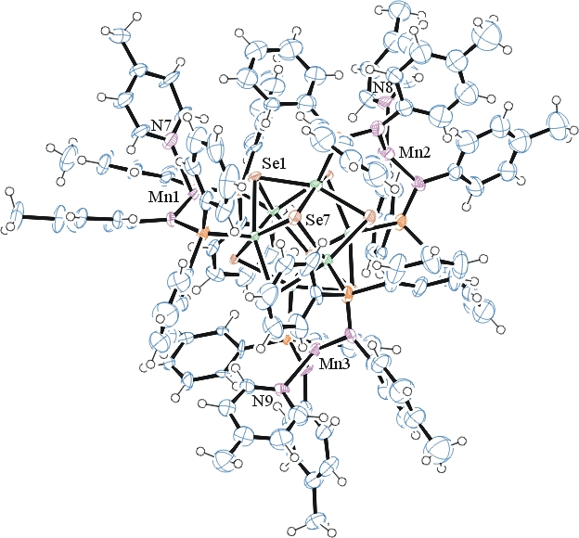
Figure 1. ORTEP of the structure with thermal ellipsoids at the 50% probability level. Disorder solvent omitted for clarity.

Table 1: Crystallographic data for the structures provided.
Empirical formula C132 H120 Co6 Mn3 N9 P6 Se8
Formula weight 3168.26
Temperature 100(2) K
Wavelength 0.71073 Å
Crystal system Triclinic
Space group P -1
Unit cell dimensions a = 15.622(2) Å α= 84.664(6)°.
b = 21.187(3) Å β= 76.255(6)°.
c = 26.693(4) Å γ = 69.256(6)°.
Volume 8025(2) Å3
Z 2
Density (calculated) 1.311 Mg/m3
Absorption coefficient 2.747 mm-1
F(000) 3148
Crystal size 0.280 x 0.170 x 0.120 mm3
Theta range for data collection 1.300 to 25.027°.
Index ranges -18<=h<=18, -25<=k<=25, -31<=l<=31
Reflections collected 54946
Independent reflections 28282 [R(int) = 0.0569]
Completeness to theta = 25.000° 99.6 %
Refinement method Full-matrix least-squares on F2
Data / restraints / parameters 28282 / 1264 / 1331
Goodness-of-fit on F2 1.043
Final R indices [I>2sigma(I)] R1 = 0.1385, wR2 = 0.3339
R indices (all data) R1 = 0.1803, wR2 = 0.3724
Largest diff. peak and hole 5.956 and -4.618 e.Å-3

Bruker (2007) APEX2 (Version 2.1-4), SAINT (version 7.34A), SADABS (version 2007/4), BrukerAXS Inc, Madison, Wisconsin, USA.
Sheldrick GM. (2015) SHELXT - Integrated space-group and crystal-structure determination. Acta Cryst. A71, 3-8.
(a) Altomare A, Burla C, Camalli M, Cascarano G L, Giacovazzo C, Guagliardi A, Moliterni AGG, Polidori G, Spagna R. (1999) SIR97: a new tool for crystal structure determination and refinement Journal of Applied Crystallography, 32, 115-119. (b) Altomare A, Cascarano G L, Giacovazzo C, Guagliardi A. (1993) Completion and refinement of crystal structures with SIR 92. Journal of Applied Crystallography, 26, 343-350.
(a) Sheldrick GM. (1997) SHELXL-97, Program for the Refinement of Crystal Structures. University of Göttingen, Germany. (b) Sheldrick GM. (2015) Crystal structure refinement with SHELXL. Acta Cryst. (2015). C71, 3–8
Mackay, S.; Edwards, C.; Henderson, A.; Gilmore, C.; Stewart, N.; Shankland, K.; Donald, A. (1997) MaXus: a computer program for the solution and refinement of crystal structures from diffraction data. University of Glasgow, Scotland,.
Waasmaier, D.; Kirfel, A. (1995) New Analytical Scattering Factor Functions for Free Atoms and Ions. Acta Crystallographica A., 51, 416-430.
(a) A. Spek, J. Appl. Cryst. (2003), 36, 7-13; (b) P. van der Sluis & A. L. Spek, Acta Cryst. (1990). A46, 194-201. (c) Spek, A. L. (2009). Acta. Cryst. D65, 148-155.
Farrugia LJ. (1997) Ortep-3 for Windows. Journal of Applied Crystallography, 30, 565

