Crystal Structure Report for A. Velian
by Dylan Rogers & Werner Kaminsky
Sample Submitted by Jon Kephart
ID – JAK_556
X-ray Crystallography Laboratory
University of Washington
28. July 2026

Data Collection started: 12/4/2020
Documentation finished: 12/11/2020

Data backup accessibly through http:
URL: http://cad4.cpac.washington.edu/structures

W.Kaminsky: tel. (206) 543 7585
(x-ray lab): tel. (206) 543 0210
Email: kaminsky@chem.washington.edu

Understanding crystallographic information is not trivial. If you discuss a structure in a publication, please let the crystallographers proof-read the final draft of that manuscript before you submit it.
For many structures it is true that crystallography is an intellectual performance (like synthesis or elucidation of mechanisms) and not a routine job. In these cases, particularly when the structures contribute significantly to the content of the publication, the crystallographers should be co-authors. Do not think this is not necessary because you pay for structures.
A black prism, measuring 0.08 x 0.07 x 0.06 mm³ was mounted on a loop with oil. Data was collected at -173ºC on a Bruker APEX II single crystal X-ray diffractometer, Mo-radiation.

Crystal-to-detector distance was 40 mm and exposure time was 120 seconds per frame for all sets. The scan width was 0.5º. Data collection was 100% complete to 25º in ϑ. A total of 27055 reflections were collected covering the indices, -33<=h<=33, -33<=k<=33, -19<=l<=19. 13529 reflections were symmetry independent and the R_{int} = 0.0939 indicated that the data was of good. Indexing and unit cell refinement indicated a primitive trigonal lattice. The space group was found to be P-3 (No. 147).

The data was integrated and scaled using SAINT, SADABS within the APEX2 software package by Bruker.

Solution by direct methods (SHELXT or SIR97) produced a complete heavy atom phasing model consistent with the proposed structure. The structure was completed by difference Fourier synthesis with SHELXL., Scattering factors are from Waasmair and Kirfel. Hydrogen atoms were placed in geometrically idealised positions and constrained to ride on their parent atoms with C---H distances in the range 0.95-1.00 Angstrom. Isotropic thermal parameters U_{eq} were fixed such that they were 1.2U_{eq} of their parent atom Ueq for CH's and 1.5U_{eq} of their parent atom U_{eq} in case of methyl groups. All non-hydrogen atoms were refined anisotropically by full-matrix least-squares.

The asymmetric unit contains two slightly different molecules and a disordered benzene. The molecules defer of each other in symmetry and mutual distances of nitrogen symmetry (molecule 2 has equidistant nitrogens

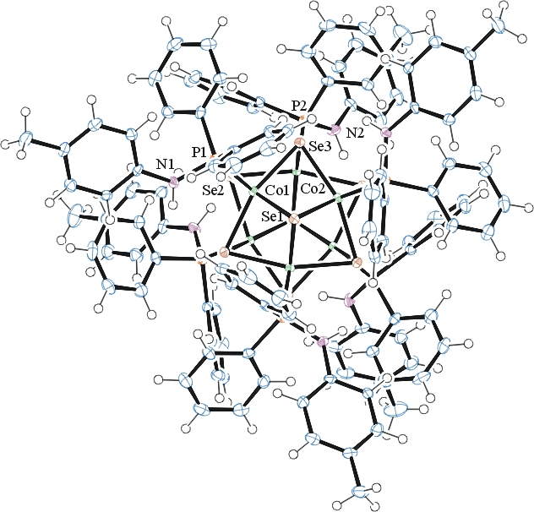
Figure 1. ORTEP of the first molecule with thermal ellipsoids at the 50% probability level.

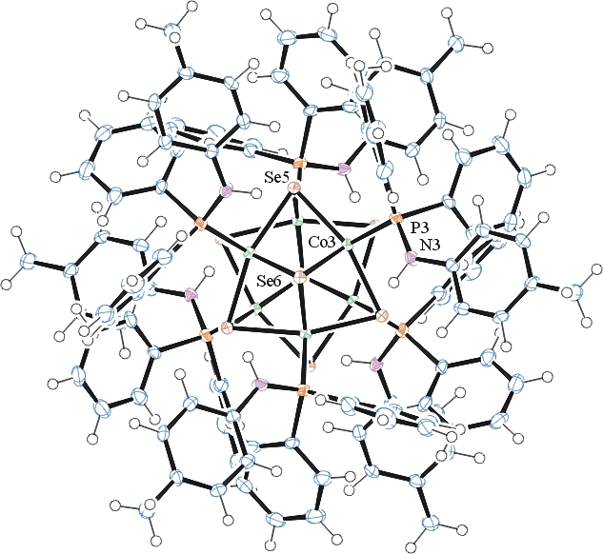
Figure 2. ORTEP of the second molecule with thermal ellipsoids at the 50% probability level.

The structure is of high quality and ready for publication. Table 1 summarizes the data collection details. Figure 1 shows an ORTEP of the asymmetric unit.

Table 1: Crystallographic data for the structures provided.
Empirical formula C116 H110 Co6 N6 P6 Se8
Formula weight 2759.17
Temperature 100(2) K
Wavelength 0.71073 Å
Crystal system Trigonal
Space group P -3
Unit cell dimensions a = 25.4182(8) Å α= 90°.
b = 25.4182(8) Å β= 90°.
c = 14.5448(6) Å γ = 120°.
Volume 8138.2(6) Å3
Z 3
Density (calculated) 1.689 Mg/m3
Absorption coefficient 3.720 mm-1
F(000) 4116
Crystal size 0.080 x 0.070 x 0.060 mm3
Theta range for data collection 1.400 to 28.335°.
Index ranges -33<=h<=33, -33<=k<=33, -19<=l<=19
Reflections collected 27055
Independent reflections 13529 [R(int) = 0.0939]
Completeness to theta = 25.000° 100.0 %
Refinement method Full-matrix least-squares on F2
Data / restraints / parameters 13529 / 9 / 655
Goodness-of-fit on F2 0.944
Final R indices [I>2sigma(I)] R1 = 0.0426, wR2 = 0.0561
R indices (all data) R1 = 0.1300, wR2 = 0.0723
Largest diff. peak and hole 0.734 and -0.689 e.Å-3

Bruker (2007) APEX2 (Version 2.1-4), SAINT (version 7.34A), SADABS (version 2007/4), BrukerAXS Inc, Madison, Wisconsin, USA.
Sheldrick GM. (2015) SHELXT - Integrated space-group and crystal-structure determination. Acta Cryst. A71, 3-8.
(a) Altomare A, Burla C, Camalli M, Cascarano G L, Giacovazzo C, Guagliardi A, Moliterni AGG, Polidori G, Spagna R. (1999) SIR97: a new tool for crystal structure determination and refinement Journal of Applied Crystallography, 32, 115-119. (b) Altomare A, Cascarano G L, Giacovazzo C, Guagliardi A. (1993) Completion and refinement of crystal structures with SIR 92. Journal of Applied Crystallography, 26, 343-350.
(a) Sheldrick GM. (1997) SHELXL-97, Program for the Refinement of Crystal Structures. University of Göttingen, Germany. (b) Sheldrick GM. (2015) Crystal structure refinement with SHELXL. Acta Cryst. (2015). C71, 3–8
Mackay, S.; Edwards, C.; Henderson, A.; Gilmore, C.; Stewart, N.; Shankland, K.; Donald, A. (1997) MaXus: a computer program for the solution and refinement of crystal structures from diffraction data. University of Glasgow, Scotland,.
Waasmaier, D.; Kirfel, A. (1995) New Analytical Scattering Factor Functions for Free Atoms and Ions. Acta Crystallographica A., 51, 416-430.
Farrugia LJ. (1997) Ortep-3 for Windows. Journal of Applied Crystallography, 30, 565

