Crystal Structure Report for A. Velian
by Paige Gannon & Werner Kaminsky
Sample Submitted by Jon Kephart
ID – JAK_679_c
X-ray Crystallography Laboratory
University of Washington
29. July 2026

Data Collection started: 10/22/2021
Documentation finished: 10/26/2021

Data backup accessibly through http:
URL: http://cad4.cpac.washington.edu/structures

W.Kaminsky: tel. (206) 543 7585
(x-ray lab): tel. (206) 543 0210
Email: kaminsky@chem.washington.edu

Understanding crystallographic information is not trivial. If you discuss a structure in a publication, please let the crystallographers proof-read the final draft of that manuscript before you submit it.
For many structures it is true that crystallography is an intellectual performance (like synthesis or elucidation of mechanisms) and not a routine job. In these cases, particularly when the structures contribute significantly to the content of the publication, the crystallographers should be co-authors. Do not think this is not necessary because you pay for structures.
A black prism, measuring 0.30 x 0.15 x 0.13 mm³ was mounted on a loop with oil. Data was collected at -173ºC on a Bruker APEX II single crystal X-ray diffractometer, Mo-radiation, equipped with a Miracol X-ray optical collimator.

Crystal-to-detector distance was 40 mm and exposure time was 60 seconds per frame for all sets. The scan width was 0.5º. Data collection was 99.8% complete to 25º in ϑ. A total of 64080 reflections were collected covering the indices, -22<=h<=22, -28<=k<=28, -29<=l<=29. 32127 reflections were symmetry independent and the R_{int} = 0.0614 indicated that the data was of good quality. Indexing and unit cell refinement indicated a triclinic lattice. The space group was found to be P‾1 (No. 2).

The data was integrated and scaled using SAINT, SADABS within the APEX2 software package by Bruker.

Solution by direct methods (SHELXT or SIR97) produced a complete heavy atom phasing model consistent with the proposed structure. The structure was completed by difference Fourier synthesis with SHELXL., Scattering factors are from Waasmair and Kirfel. Hydrogen atoms were placed in geometrically idealised positions and constrained to ride on their parent atoms with C---H distances in the range 0.95-1.00 Angstrom. Isotropic thermal parameters U_{eq} were fixed such that they were 1.2U_{eq} of their parent atom Ueq for CH's and 1.5U_{eq} of their parent atom U_{eq} in case of methyl groups. All non-hydrogen atoms were refined anisotropically by full-matrix least-squares.

The structure exhibits disorder in most of the moieties coordinating with the Se-Co nucleus. The contribution of 5 disordered toluene in per molecule to the diffraction pattern was removed with SQUEEZE. To handle the disorder, the displacement parameters of all carbon, nitrogen a few other disordered atoms were restraint with ISOR. A handful other atoms needed aligning of the standard deviations of the displacement parameters with a DELU card. Pairwise disordered atoms, partially overlapping required DELU equivalents. 50 bad reflections were omitted (0.156%).
Overall, the high degree of disorder affects all atoms, elongating their displacement parameters.

The structure is of high quality and ready for publication. Table 1 summarizes the data collection details. Figure 1 shows an ORTEP of the asymmetric unit.

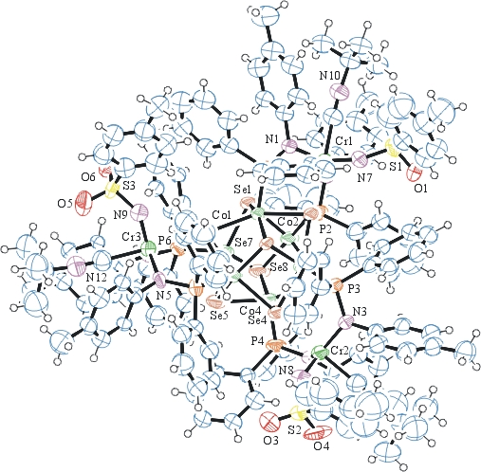
Figure 1. ORTEP of the structure with thermal ellipsoids at the 50% probability level. Disorder omitted for clarity. Solvent squeezed.

Table 1: Crystallographic data for the structures provided.
Empirical formula C150 H150 Co6 Cr3 N12 O6 P6 S3 Se8
Formula weight 3640.07
Temperature 100(2) K
Wavelength 0.71073 Å
Crystal system Triclinic
Space group P ‾1
Unit cell dimensions a = 18.5695(14) Å α= 112.899(5)°.
b = 24.0006(15) Å β= 103.803(5)°.
c = 24.270(3) Å γ = 106.371(4)°.
Volume 8786.6(13) Å3
Z 2
Density (calculated) 1.376 Mg/m3
Absorption coefficient 2.526 mm-1
F(000) 3652
Crystal size 0.300 x 0.150 x 0.130 mm3
Theta range for data collection 1.232 to 25.350°.
Index ranges -22<=h<=22, -28<=k<=28, -29<=l<=29
Reflections collected 64080
Independent reflections 32127 [R(int) = 0.0614]
Completeness to theta = 25.000° 99.8 %
Refinement method Full-matrix least-squares on F2
Data / restraints / parameters 32127 / 3415 / 2073
Goodness-of-fit on F2 1.009
Final R indices [I>2sigma(I)] R1 = 0.1140, wR2 = 0.2244
R indices (all data) R1 = 0.2287, wR2 = 0.3063
Largest diff. peak and hole 1.590 and -1.229 e.Å-3

Bruker (2007) APEX2 (Version 2.1-4), SAINT (version 7.34A), SADABS (version 2007/4), BrukerAXS Inc, Madison, Wisconsin, USA.
Sheldrick GM. (2015) SHELXT - Integrated space-group and crystal-structure determination. Acta Cryst. A71, 3-8.
(a) Altomare A, Burla C, Camalli M, Cascarano G L, Giacovazzo C, Guagliardi A, Moliterni AGG, Polidori G, Spagna R. (1999) SIR97: a new tool for crystal structure determination and refinement Journal of Applied Crystallography, 32, 115-119. (b) Altomare A, Cascarano G L, Giacovazzo C, Guagliardi A. (1993) Completion and refinement of crystal structures with SIR 92. Journal of Applied Crystallography, 26, 343-350.
(a) Sheldrick GM. (1997) SHELXL-97, Program for the Refinement of Crystal Structures. University of Göttingen, Germany. (b) Sheldrick GM. (2015) Crystal structure refinement with SHELXL. Acta Cryst. (2015). C71, 3–8
Mackay, S.; Edwards, C.; Henderson, A.; Gilmore, C.; Stewart, N.; Shankland, K.; Donald, A. (1997) MaXus: a computer program for the solution and refinement of crystal structures from diffraction data. University of Glasgow, Scotland,.
Waasmaier, D.; Kirfel, A. (1995) New Analytical Scattering Factor Functions for Free Atoms and Ions. Acta Crystallographica A., 51, 416-430.
(a) A. Spek, J. Appl. Cryst. (2003), 36, 7-13; (b) P. van der Sluis & A. L. Spek, Acta Cryst. (1990). A46, 194-201. (c) Spek, A. L. (2009). Acta. Cryst. D65, 148-155.
Farrugia LJ. (1997) Ortep-3 for Windows. Journal of Applied Crystallography, 30, 565

