Crystal Structure Report for
Sei-Hum Jang
by Werner Kaminsky
Sample ID – JANGNMA01
X-ray Crystallography Laboratory
University of Washington
31. July 2026

Data Collection started: 6/16/2020
Documentation finished: 6/19/2020

Data backup accessibly through http:
URL: http://cad4.cpac.washington.edu/structures

W.Kaminsky: tel. (206) 543 7585
(x-ray lab): tel. (206) 543 0210
Email: kaminsky@chem.washington.edu

Understanding crystallographic information is not trivial. If you discuss a structure in a publication, please let the crystallographers proof-read the final draft of that manuscript before you submit it.
For many structures it is true that crystallography is an intellectual performance (like synthesis or elucidation of mechanisms) and not a routine job. In these cases, particularly when the structures contribute significantly to the content of the publication, the crystallographers should be co-authors. Do not think this is not necessary because you pay for structures.
A colorless plate, measuring 0.07 x 0.05 x 0.03 mm³ was mounted on a loop with oil. Data was collected at -173ºC on a Nonius Kappa CCD FR590 single crystal X-ray diffractometer, Mo-radiation.

Crystal-to-detector distance was 34 mm and exposure time was 150 seconds per degree for all sets. The scan width was 1º. Data collection was 99.9% complete to 25º in ϑ. A total of 88381 full and partial reflections were collected covering the indices, -15<=h<=14, -15<=k<=14, -34<=l<=33. A total of 12757 merged and 7626 symmetry independent reflections with R_{int} = 0.0844 were collected. Indexing and unit cell refinement indicated a C-centered monoclinic lattice. The space group was found to be Cc (No.9).

The data was integrated and scaled using hkl-SCALEPACK. This program applies a multiplicative correction factor (S) to the observed intensities (I) and has the following form:

S is calculated from the scale and the B factor determined for each frame and is then applied to I to give the corrected intensity (I_{corr}).

Solution by direct methods (SHELXT or SIR97) produced a complete heavy atom phasing model consistent with the proposed structure. The structure was completed by difference Fourier synthesis with SHELXL., Scattering factors are from Waasmair and Kirfel. Hydrogen atoms were placed in geometrically idealised positions and constrained to ride on their parent atoms with C---H distances in the range 0.95-1.00 Angstrom. Isotropic thermal parameters U_{eq} were fixed such that they were 1.2U_{eq} of their parent atom Ueq for CH's and 1.5U_{eq} of their parent atom U_{eq} in case of methyl groups. All non-hydrogen atoms were refined anisotropically by full-matrix least-squares.

The crystal showed a small amount (ca. 5%) of merohedral twinning via twin matrix (0 1 0, 1 0 0, -0.5 -0.5 -1). Furthermore, the structure is non-centrosymmetric – non-chiral, with flack enantiopole parameter -0.010(9), thus showing no acentric twinning.

All organic molecules in the asymmetric unit are disordered ratios close to 1:1 (this is not a sign of crystal quality or any possible decomposition).

The structure is of high quality and ready for publication. Table 1 summarizes the data collection details. Figure 1 shows an ORTEP of the asymmetric unit.

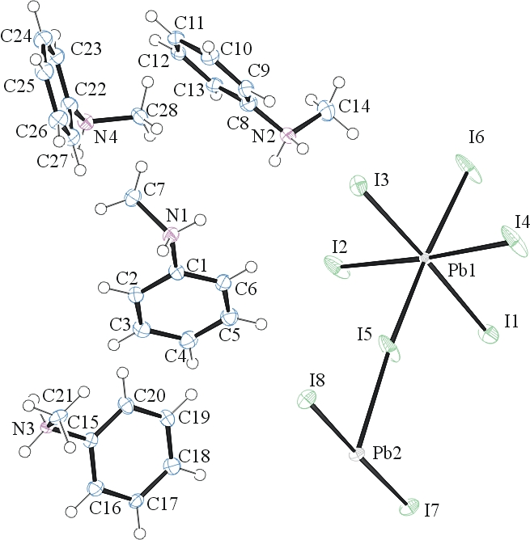
Figure 1. ORTEP of the structure with thermal ellipsoids at the 50% probability level. Disorder omitted for clarity.

Table 1: Crystallographic data for the structures provided.
Empirical formula C28 H40 I8 N4 Pb2
Formula weight 1862.22
Temperature 100(2) K
Wavelength 0.71073 Å
Crystal system Monoclinic
Space group C c
Unit cell dimensions a = 12.6777(6) Å α= 90°.
b = 12.6801(6) Å β= 102.791(2)°.
c = 28.6177(16) Å γ = 90°.
Volume 4486.3(4) Å3
Z 4
Density (calculated) 2.757 Mg/m3
Absorption coefficient 13.023 mm-1
F(000) 3296
Crystal size 0.070 x 0.050 x 0.030 mm3
Theta range for data collection 0.730 to 25.186°.
Index ranges -15<=h<=14, -15<=k<=14, -34<=l<=33
Reflections collected 12757
Independent reflections 7626 [R(int) = 0.0844]
Completeness to theta = 25.000° 99.9 %
Refinement method Full-matrix least-squares on F2
Data / restraints / parameters 7626 / 1022 / 488
Goodness-of-fit on F2 1.016
Final R indices [I>2sigma(I)] R1 = 0.0561, wR2 = 0.1249
R indices (all data) R1 = 0.0805, wR2 = 0.1362
Absolute structure parameter -0.010(9)
Largest diff. peak and hole 3.289 and -2.738 e.Å-3

Otwinowsky, Z.; Minor, W. In: Methods in Enzymology; Carter, C. W., Jr., Sweet, R. M., Eds.; Academic Press: New York, 1997, 276, 307-326.
Sheldrick GM. (2015) SHELXT - Integrated space-group and crystal-structure determination. Acta Cryst. A71, 3-8.
(a) Altomare A, Burla C, Camalli M, Cascarano G L, Giacovazzo C, Guagliardi A, Moliterni AGG, Polidori G, Spagna R. (1999) SIR97: a new tool for crystal structure determination and refinement Journal of Applied Crystallography, 32, 115-119. (b) Altomare A, Cascarano G L, Giacovazzo C, Guagliardi A. (1993) Completion and refinement of crystal structures with SIR 92. Journal of Applied Crystallography, 26, 343-350.
(a) Sheldrick GM. (1997) SHELXL-97, Program for the Refinement of Crystal Structures. University of Göttingen, Germany. (b) Sheldrick GM. (2015) Crystal structure refinement with SHELXL. Acta Cryst. (2015). C71, 3–8
Mackay, S.; Edwards, C.; Henderson, A.; Gilmore, C.; Stewart, N.; Shankland, K.; Donald, A. (1997) MaXus: a computer program for the solution and refinement of crystal structures from diffraction data. University of Glasgow, Scotland,.
Waasmaier, D.; Kirfel, A. Acta Crystallogr. A. 1995, 51, 416.
Farrugia, L. J. Appl. Cryst. 1997, 30, 565

