Crystal Structure Report for
Sei-Hum Jang
by Werner Kaminsky
Sample ID – JANGNMA04RT
X-ray Crystallography Laboratory
University of Washington
28. July 2026

Data Collection started: 6/25/2020
Documentation finished: 6/26/2020

Data backup accessibly through http:
URL: http://cad4.cpac.washington.edu/structures

W.Kaminsky: tel. (206) 543 7585
(x-ray lab): tel. (206) 543 0210
Email: kaminsky@chem.washington.edu

Understanding crystallographic information is not trivial. If you discuss a structure in a publication, please let the crystallographers proof-read the final draft of that manuscript before you submit it.
For many structures it is true that crystallography is an intellectual performance (like synthesis or elucidation of mechanisms) and not a routine job. In these cases, particularly when the structures contribute significantly to the content of the publication, the crystallographers should be co-authors. Do not think this is not necessary because you pay for structures.
An orange plate, measuring 0.25 x 0.10 x 0.02 mm³ was mounted on a loop with oil. Data was collected at 21ºC on a Nonius Kappa CCD FR590 single crystal X-ray diffractometer, Mo-radiation.

Crystal-to-detector distance was 40 mm and exposure time was 60 seconds per degree for all sets. The scan width was 1º. Data collection was 98.9% complete to 25º in ϑ. A total of 63102 partial and complete reflections were collected covering the indices, -11<=h<=11, -12<=k<=12, -22<=l<=22. A total of 5935 merged and 3131 symmetry independent reflections with R_{int} = 0.0517 were collected. Indexing and unit cell refinement indicated a primitive monoclinic lattice. The space group was found to be P 2₁/a (No.14).

The data was integrated and scaled using hkl-SCALEPACK. This program applies a multiplicative correction factor (S) to the observed intensities (I) and has the following form:

S is calculated from the scale and the B factor determined for each frame and is then applied to I to give the corrected intensity (I_{corr}).

Solution by direct methods (SHELXT or SIR97) produced a complete heavy atom phasing model consistent with the proposed structure. The structure was completed by difference Fourier synthesis with SHELXL., Scattering factors are from Waasmair and Kirfel. Hydrogen atoms were placed in geometrically idealised positions and constrained to ride on their parent atoms with C---H distances in the range 0.95-1.00 Angstrom. Isotropic thermal parameters U_{eq} were fixed such that they were 1.2U_{eq} of their parent atom Ueq for CH's and 1.5U_{eq} of their parent atom U_{eq} in case of methyl groups. All non-hydrogen atoms were refined anisotropically by full-matrix least-squares.

The structure appears to be pseudo-C-centered orthorhombic, but no solution refined stably in any of the tried orthorhombic symmetries. Instead a stably refining, yet with three-fold disordered organic molecules at ratios 1:1:1 was found.

The crystals undergo a reversible structural phase transition upon cooling.

The structure is of high quality and ready for publication. Table 1 summarizes the data collection details. Figure 1 shows an ORTEP of the asymmetric unit.

a) 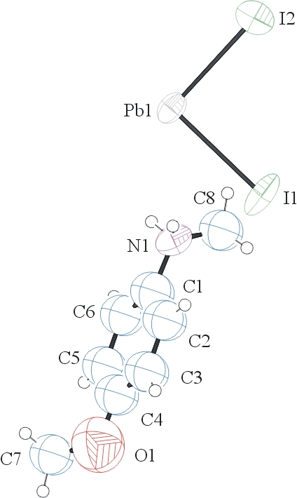 b)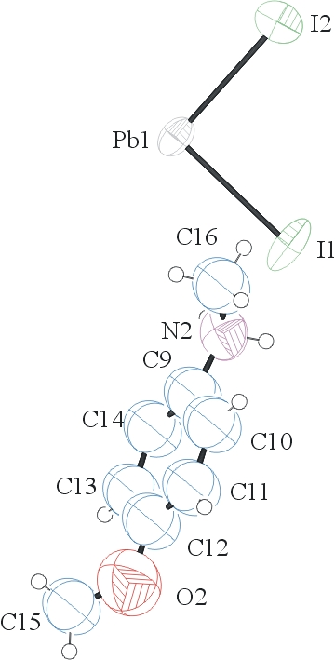 c)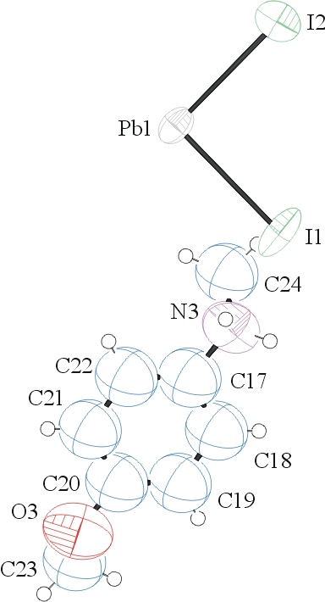

Figure 1 a-c. ORTEPs of the asymmetric units showing each of three conformations with thermal ellipsoids at the 50% probability level.

Table 1: Crystallographic data for the structures provided.
Empirical formula C16 H24 I4 N2 O2 Pb
Formula weight 991.16
Temperature 294(2) K
Wavelength 0.71073 Å
Crystal system Monoclinic
Space group P2₁/a
Unit cell dimensions a = 8.8147(2) Å α= 90°.
b = 9.1047(2) Å β= 105.0310(10)°.
c = 17.0022(5) Å γ = 90°.
Volume 1317.83(6) Å3
Z 2
Density (calculated) 2.498 Mg/m3
Absorption coefficient 11.098 mm-1
F(000) 888
Crystal size 0.250 x 0.100 x 0.020 mm3
Theta range for data collection 2.558 to 28.245°.
Index ranges -11<=h<=11, -12<=k<=12, -22<=l<=22
Reflections collected 5935
Independent reflections 3131 [R(int) = 0.0517]
Completeness to theta = 25.000° 98.9 %
Refinement method Full-matrix least-squares on F2
Data / restraints / parameters 3131 / 276 / 136
Goodness-of-fit on F2 0.943
Final R indices [I>2sigma(I)] R1 = 0.0465, wR2 = 0.1152
R indices (all data) R1 = 0.0935, wR2 = 0.1381
Largest diff. peak and hole 1.496 and -1.857 e.Å-3

Otwinowsky, Z.; Minor, W. In: Methods in Enzymology; Carter, C. W., Jr., Sweet, R. M., Eds.; Academic Press: New York, 1997, 276, 307-326.
Sheldrick GM. (2015) SHELXT - Integrated space-group and crystal-structure determination. Acta Cryst. A71, 3-8.
(a) Altomare A, Burla C, Camalli M, Cascarano G L, Giacovazzo C, Guagliardi A, Moliterni AGG, Polidori G, Spagna R. (1999) SIR97: a new tool for crystal structure determination and refinement Journal of Applied Crystallography, 32, 115-119. (b) Altomare A, Cascarano G L, Giacovazzo C, Guagliardi A. (1993) Completion and refinement of crystal structures with SIR 92. Journal of Applied Crystallography, 26, 343-350.
(a) Sheldrick GM. (1997) SHELXL-97, Program for the Refinement of Crystal Structures. University of Göttingen, Germany. (b) Sheldrick GM. (2015) Crystal structure refinement with SHELXL. Acta Cryst. (2015). C71, 3–8
Mackay, S.; Edwards, C.; Henderson, A.; Gilmore, C.; Stewart, N.; Shankland, K.; Donald, A. (1997) MaXus: a computer program for the solution and refinement of crystal structures from diffraction data. University of Glasgow, Scotland,.
Waasmaier, D.; Kirfel, A. Acta Crystallogr. A. 1995, 51, 416.
Farrugia, L. J. Appl. Cryst. 1997, 30, 565

