Crystal Structure Report for Gojko Lalic
by Sarah Flowers & Werner Kaminsky
Sample Submitted by Julia Nguyen
ID – JHN_2_128
X-ray Crystallography Laboratory
University of Washington
31. July 2026

Data Collection started: 2/17/2016
Documentation finished: 3/2/2016

Data backup accessibly through http:
URL: http://cad4.cpac.washington.edu/structures

W.Kaminsky: tel. (206) 543 7585
(x-ray lab): tel. (206) 543 0210
Email: kaminsky@chem.washington.edu

Understanding crystallographic information is not trivial. If you discuss a structure in a publication, please let the crystallographers proof-read the final draft of that manuscript before you submit it.
For many structures it is true that crystallography is an intellectual performance (like synthesis or elucidation of mechanisms) and not a routine job. In these cases, particularly when the structures contribute significantly to the content of the publication, the crystallographers should be co-authors. Do not think this is not necessary because you pay for structures.
A colorless prism, measuring 0.27 x 0.13 x 0.10 mm³ was mounted on a loop with oil. Data was collected at -173ºC on a Bruker APEX II single crystal X-ray diffractometer, Mo-radiation.

Crystal-to-detector distance was 40 mm and exposure time was 10 seconds per frame for all sets. The scan width was 0.5º. Data collection was 96.7% complete to 25º in ϑ. A total of 382218 reflections were collected covering the indices, -27<=h<=27, -29<=k<=29, -28<=l<=28. 26012 reflections were symmetry independent and the R_{int} = 0.1045 indicated a large unit cell and some problems with the sample exhibiting striations shortly after extraction from solution. Indexing and unit cell refinement indicated a primitive monoclinic lattice. The space group was found to be P 2₁/c (No. 14).

The data was integrated and scaled using SAINT, SADABS within the APEX2 software package by Bruker.

Solution by direct methods (SHELXS, SIR97) produced a complete heavy atom phasing model consistent with the proposed structure. The structure was completed by difference Fourier synthesis with SHELXL97., Scattering factors are from Waasmair and Kirfel. Hydrogen atoms were placed in geometrically idealised positions and constrained to ride on their parent atoms with C---H distances in the range 0.95-1.00 Angstrom. Isotropic thermal parameters U_{eq} were fixed such that they were 1.2U_{eq} of their parent atom Ueq for CH's and 1.5U_{eq} of their parent atom U_{eq} in case of methyl groups. All non-hydrogen atoms were refined anisotropically by full-matrix least-squares.

The asymmetric unit consists of two Au-Au-complexes, each accompanied by an OTF anion. However, the complexes exhibit multiple disordered moieties and one of the two OTF anions as well as several benzene solvents filling the voids are disordered as well (see image below)
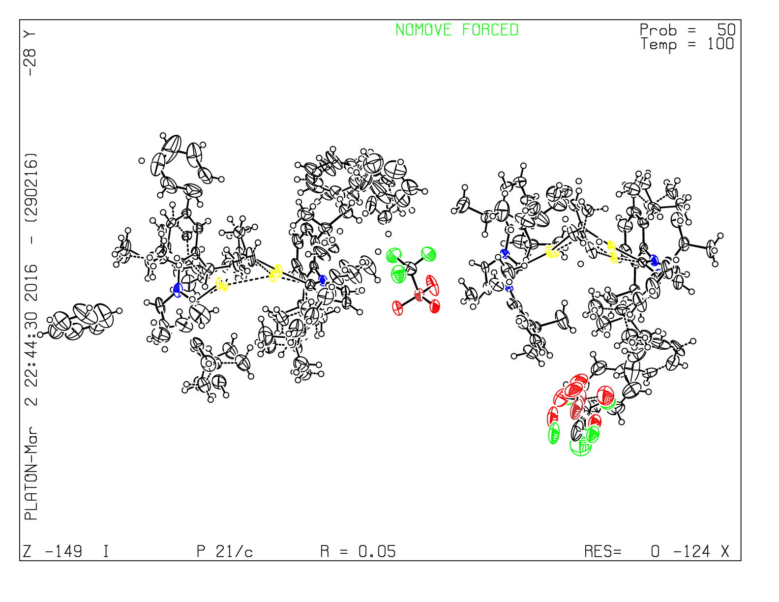
The structure is of high quality and ready for publication. Table 1 summarizes the data collection details. Figure 2 shows an ORTEP of the asymmetric unit.

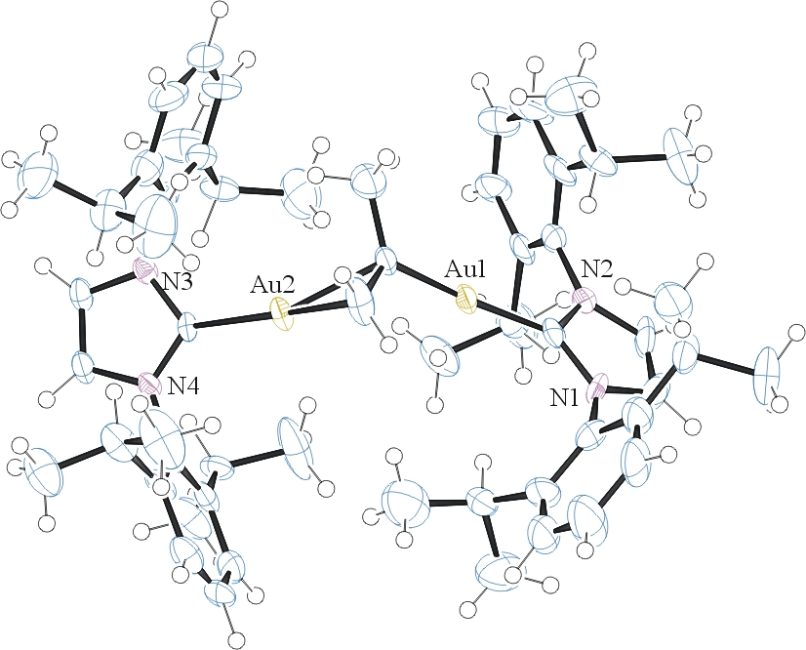

Figure 2. ORTEP of the structure with thermal ellipsoids at the 50% probability level. Only one Au-Au-complex is shown, and disorder, anions, and solvent are omitted for clarity.

Table 1: Crystallographic data for the structures provided.
Empirical formula C76 H95 Au2 F3 N4 O3 S
Formula weight 1595.55
Temperature 100(2) K
Wavelength 0.71073 Å
Crystal system Monoclinic
Space group P 2₁/c
Unit cell dimensions a = 22.8460(12) Å α= 90°.
b = 28.316(2) Å β= 102.663(2)°.
c = 23.2877(11) Å γ = 90°.
Volume 14698.4(15) Å3
Z 8
Density (calculated) 1.442 Mg/m3
Absorption coefficient 4.071 mm-1
F(000) 6432
Crystal size 0.27 x 0.13 x 0.10 mm3
Theta range for data collection 1.34 to 25.41°.
Index ranges -27<=h<=27, -29<=k<=29, -28<=l<=28
Reflections collected 382218
Independent reflections 26012 [R(int) = 0.1045]
Completeness to theta = 25.00° 96.7 %
Max. and min. transmission 0.6863 and 0.4061
Refinement method Full-matrix least-squares on F2
Data / restraints / parameters 26012 / 1051 / 1836
Goodness-of-fit on F2 1.038
Final R indices [I>2sigma(I)] R1 = 0.0460, wR2 = 0.0894
R indices (all data) R1 = 0.0940, wR2 = 0.1124
Largest diff. peak and hole 1.956 and -1.571 e.Å-3

Bruker (2007) APEX2 (Version 2.1-4), SAINT (version 7.34A), SADABS (version 2007/4), BrukerAXS Inc, Madison, Wisconsin, USA.
(a) Altomare A, Burla C, Camalli M, Cascarano G L, Giacovazzo C, Guagliardi A, Moliterni AGG, Polidori G, Spagna R. (1999) SIR97: a new tool for crystal structure determination and refinement Journal of Applied Crystallography, 32, 115-119. (b) Altomare A, Cascarano G L, Giacovazzo C, Guagliardi A. (1993) Completion and refinement of crystal structures with SIR 92. Journal of Applied Crystallography, 26, 343-350.
(a) Sheldrick GM. (1997) SHELXL-97, Program for the Refinement of Crystal Structures. University of Göttingen, Germany. (b) Sheldrick GM. (2013) Crystal structure refinement with SHELXL. Acta Cryst. (2015). C71, 3-8.
Mackay, S.; Edwards, C.; Henderson, A.; Gilmore, C.; Stewart, N.; Shankland, K.; Donald, A. (1997) MaXus: a computer program for the solution and refinement of crystal structures from diffraction data. University of Glasgow, Scotland,.
Waasmaier, D.; Kirfel, A. (1995) New Analytical Scattering Factor Functions for Free Atoms and Ions. Acta Crystallographica A., 51, 416-430.
Farrugia LJ. (1997) Ortep-3 for Windows. Journal of Applied Crystallography, 30, 565

