Crystal Structure Report for M. Heinekey
by Werner Kaminsky
Sample Submitted by Jonathan Goldberg
ID – JMG_B_65
X-ray Crystallography Laboratory
University of Washington
28. July 2026

Data Collection started: 1/20/2015
Documentation finished: 1/29/2015

Data backup accessibly through http:
URL: http://cad4.cpac.washington.edu/structures

W.Kaminsky: tel. (206) 543 7585
(x-ray lab): tel. (206) 543 0210
Email: kaminsky@chem.washington.edu

Understanding crystallographic information is not trivial. If you discuss a structure in a publication, please let the crystallographers proof-read the final draft of that manuscript before you submit it.
For many structures it is true that crystallography is an intellectual performance (like synthesis or elucidation of mechanisms) and not a routine job. In these cases, particularly when the structures contribute significantly to the content of the publication, the crystallographers should be co-authors. Do not think this is not necessary because you pay for structures. Even I have to pay for my own structures for my research.
A yellow piece, measuring 0.30 x 0.15 x 0.13 mm³ was mounted on a loop with oil. Data was collected at -183ºC on a Bruker APEX II single crystal X-ray diffractometer, Mo-radiation.

Crystal-to-detector distance was 40 mm and exposure time was 10 seconds per frame for all sets. The scan width was 0.5º. Data collection was 99.2% complete to 25º in ϑ. A total of 207338 reflections were collected covering the indices, h = -18 to 18, k = -37 to 37, l = -23 to 23. 16859 reflections were symmetry independent and the R_{int} = 0.0758 indicated that the data was of average quality. Indexing and unit cell refinement indicated a primitive orthorhombic lattice. The space group was found to be P c a 2₁ (No. 29).

The data was integrated and scaled using SAINT, SADABS within the APEX2 software package by Bruker.

Solution by direct methods (SHELXS, SIR97) produced a complete heavy atom phasing model consistent with the proposed structure. The structure was completed by difference Fourier synthesis with SHELXL97., Scattering factors are from Waasmair and Kirfel. Hydrogen atoms were placed in geometrically idealised positions and constrained to ride on their parent atoms with C---H distances in the range 0.95-1.00 Angstrom. Isotropic thermal parameters U_{eq} were fixed such that they were 1.2U_{eq} of their parent atom Ueq for CH's and 1.5U_{eq} of their parent atom U_{eq} in case of methyl groups. All non-hydrogen atoms were refined anisotropically by full-matrix least-squares.

The crystal may have been twinned, however, despite many efforts, no twin law was discovered. Thus the structure is not as such publishable despite acceptable statistical estimates. Two molecules with different amounts of iodine and chlorine were found in the asymmetric unit. The disorder observed may be partially due to that twinning, partially intrinsic mixing of chlorine and iodine. The latter may also result in severe disorder of the structure that could be responsible for the high level of remaining electron density.

The structure is of high quality and ready for publication. Table 1 summarizes the data collection details. Figure 1 shows an ORTEP of the asymmetric unit.

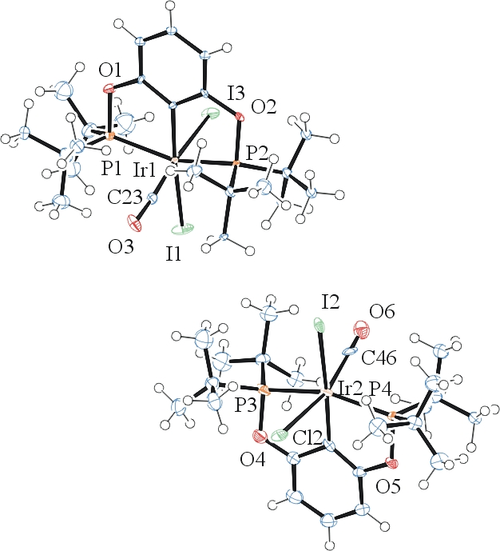
Figure 1. ORTEP of the structure with thermal ellipsoids at the 50% probability level. Disorder omitted for clarity.

Table 1: Crystallographic data for the structures provided.
Empirical formula C46 H78 Cl0.81 I3.19 Ir2 O6 P4
Formula weight 1668.66
Temperature 90(2) K
Wavelength 0.71073 Å
Crystal system Orthorhombic
Space group P c a 2₁
Unit cell dimensions a = 13.0809(9) Å α= 90°.
b = 25.9865(18) Å β= 90°.
c = 16.2057(12) Å γ = 90°.
Volume 5508.8(7) Å3
Z 4
Density (calculated) 2.012 Mg/m3
Absorption coefficient 6.811 mm-1
F(000) 3195
Crystal size 0.30 x 0.15 x 0.13 mm3
Theta range for data collection 2.15 to 30.67°.
Index ranges -18<=h<=18, -37<=k<=37, -23<=l<=23
Reflections collected 207338
Independent reflections 16859 [R(int) = 0.0758]
Completeness to theta = 25.00° 99.2 %
Max. and min. transmission 0.4713 and 0.2344
Refinement method Full-matrix least-squares on F2
Data / restraints / parameters 16859 / 352 / 552
Goodness-of-fit on F2 1.169
Final R indices [I>2sigma(I)] R1 = 0.0738, wR2 = 0.1409
R indices (all data) R1 = 0.0846, wR2 = 0.1460
Absolute structure parameter 0.178(12)
Largest diff. peak and hole 5.918 and -8.442 e.Å-3

Bruker (2007) APEX2 (Version 2.1-4), SAINT (version 7.34A), SADABS (version 2007/4), BrukerAXS Inc, Madison, Wisconsin, USA.
(a) Altomare A, Burla C, Camalli M, Cascarano G L, Giacovazzo C, Guagliardi A, Moliterni AGG, Polidori G, Spagna R. (1999) SIR97: a new tool for crystal structure determination and refinement Journal of Applied Crystallography, 32, 115-119. (b) Altomare A, Cascarano G L, Giacovazzo C, Guagliardi A. (1993) Completion and refinement of crystal structures with SIR 92. Journal of Applied Crystallography, 26, 343-350.
Sheldrick GM. (1997) SHELXL-97, Program for the Refinement of Crystal Structures. University of Göttingen, Germany.
Mackay, S.; Edwards, C.; Henderson, A.; Gilmore, C.; Stewart, N.; Shankland, K.; Donald, A. (1997) MaXus: a computer program for the solution and refinement of crystal structures from diffraction data. University of Glasgow, Scotland,.
Waasmaier, D.; Kirfel, A. (1995) New Analytical Scattering Factor Functions for Free Atoms and Ions. Acta Crystallographica A., 51, 416-430.
Farrugia LJ. (1997) Ortep-3 for Windows. Journal of Applied Crystallography, 30, 565

