Crystal Structure Report for Dianne Xiao
by Werner Kaminsky
Sample by Jiahoo Wan (Bobby)
ID – JW_155
X-ray Crystallography Laboratory
University of Washington
30. July 2026

Data Collection started: 11/9/2020
Documentation finished: 11/12/2020

Data backup accessibly through http:
URL: http://cad4.cpac.washington.edu/structures

W.Kaminsky: tel. (206) 543 7585
(x-ray lab): tel. (206) 543 0210
Email: kaminsky@chem.washington.edu

Understanding crystallographic information is not trivial. If you discuss a structure in a publication, please let the crystallographers proof-read the final draft of that manuscript before you submit it.
For many structures it is true that crystallography is an intellectual performance (like synthesis or elucidation of mechanisms) and not a routine job. In these cases, particularly when the structures contribute significantly to the content of the publication, the crystallographers should be co-authors.
A colorless prism, measuring 0.30 x 0.05 x 0.05 mm³ was mounted on a loop with oil. Data was collected at -183ºC on a Nonius Kappa CCD FR590 single crystal X-ray diffractometer, Mo-radiation.

Crystal-to-detector distance was 40 mm and exposure time was 60 seconds per degree for all sets. The scan width was 1º. Data collection was 97.5% complete to 25º in ϑ. A total of 8309 merged reflections were collected covering the indices, -33<=h<=33, -33<=k<=33, 0<=l<=7. 4399 reflections were symmetry independent and the R_{int} = 0.0657 indicated that the data was average quality. Indexing and unit cell refinement indicated a triclinic lattice. The space group was found to be C 2/m (No.12).

The data was integrated and scaled using SAINT, SADABS within the APEX2 software package by Bruker.

The contribution of disordered solvent to the diffraction pattern was removed with SQUEEZE

Solution by direct methods (SHELXT or SIR) produced a complete heavy atom phasing model consistent with the proposed structure. The structure was completed by difference Fourier synthesis with SHELXL., Scattering factors are from Waasmair and Kirfel. Hydrogen atoms were placed in geometrically idealised positions and constrained to ride on their parent atoms with C---H distances in the range 0.95-1.00 Angstrom. Isotropic thermal parameters U_{eq} were fixed such that they were 1.2U_{eq} of their parent atom Ueq for CH's and 1.5U_{eq} of their parent atom U_{eq} in case of methyl groups. All non-hydrogen atoms were refined anisotropically by full-matrix least-squares.

The structure shows total disordere via the crystallographic mirror symmetry.

The structure is of high quality and ready for publication. Table 1 summarizes the data collection details. Figure 1 shows an ORTEP of the asymmetric unit.

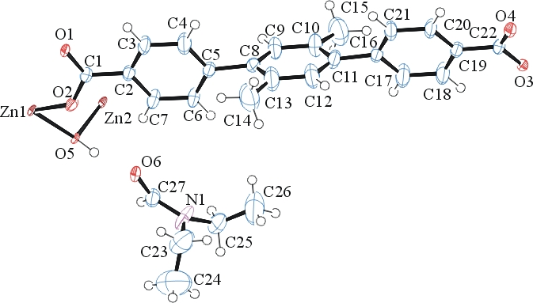

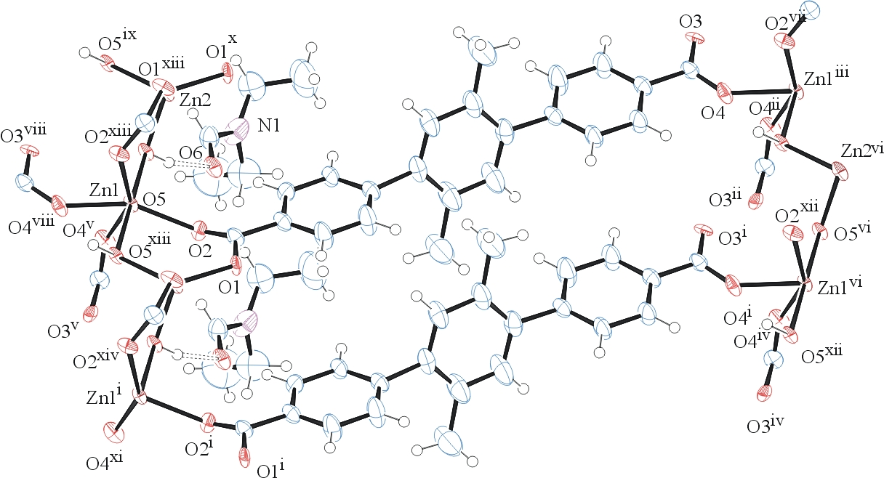

Figure 1. ORTEPs of the asymmetric unit and packing in cell with thermal ellipsoids at the 50% probability level. Disorder and some solvent omitted for clarity.

Table 1: Crystallographic data for the structures provided.
Empirical formula C54 H56 N2 O12 Zn3
Formula weight 1121.11
Temperature 90(2) K
Wavelength 0.71073 Å
Crystal system Monoclinic
Space group C 2/m
Unit cell dimensions a = 26.935(5) Å α= 90°.
b = 27.352(5) Å β= 101.305(5)°.
c = 6.0469(10) Å γ = 90°.
Volume 4368.6(14) Å3
Z 2
Density (calculated) 0.852 Mg/m3
Absorption coefficient 0.855 mm-1
F(000) 1160
Crystal size 0.300 x 0.050 x 0.050 mm3
Theta range for data collection 1.489 to 26.372°.
Index ranges -33<=h<=33, -33<=k<=33, 0<=l<=7
Reflections collected 8309
Independent reflections 4399 [R(int) = 0.0657]
Completeness to theta = 25.000° 97.5 %
Refinement method Full-matrix least-squares on F2
Data / restraints / parameters 4399 / 296 / 248
Goodness-of-fit on F2 0.965
Final R indices [I>2sigma(I)] R1 = 0.0661, wR2 = 0.1719
R indices (all data) R1 = 0.1171, wR2 = 0.1985
Extinction coefficient 0.0024(6)
Largest diff. peak and hole 1.645 and -1.374 e.Å-3

Bruker (2007) APEX2 (Version 2.1-4), SAINT (version 7.34A), SADABS (version 2007/4), BrukerAXS Inc, Madison, Wisconsin, USA.
(a) A. Spek, J. Appl. Cryst. (2003), 36, 7-13; (b) P. van der Sluis & A. L. Spek, Acta Cryst. (1990). A46, 194-201. (c) Spek, A. L. (2009). Acta. Cryst. D65, 148-155.
Sheldrick GM. (2015) SHELXT - Integrated space-group and crystal-structure determination. Acta Cryst. A71, 3-8.
(a) Altomare A, Burla C, Camalli M, Cascarano G L, Giacovazzo C, Guagliardi A, Moliterni AGG, Polidori G, Spagna R. (1999) SIR97: a new tool for crystal structure determination and refinement Journal of Applied Crystallography, 32, 115-119. (b) Altomare A, Cascarano G L, Giacovazzo C, Guagliardi A. (1993) Completion and refinement of crystal structures with SIR 92. Journal of Applied Crystallography, 26, 343-350.
(a) Sheldrick GM. (1997) SHELXL-97, Program for the Refinement of Crystal Structures. University of Göttingen, Germany. (b) Sheldrick GM. (2015) Crystal structure refinement with SHELXL. Acta Cryst. (2015). C71, 3–8
Mackay, S.; Edwards, C.; Henderson, A.; Gilmore, C.; Stewart, N.; Shankland, K.; Donald, A. (1997) MaXus: a computer program for the solution and refinement of crystal structures from diffraction data. University of Glasgow, Scotland,.
Waasmaier, D.; Kirfel, A. Acta Crystallogr. A. 1995, 51, 416.
Farrugia, L. J. Appl. Cryst. 1997, 30, 565

