Crystal Structure Report for Dianne Xiao
by Werner Kaminsky
Sample by Jiahoo Wan (Bobby)
ID – JW_163
X-ray Crystallography Laboratory
University of Washington
30. July 2026

Data Collection started: 12/7/2020
Documentation finished: 12/10/2020

Data backup accessibly through http:
URL: http://cad4.cpac.washington.edu/structures

W.Kaminsky: tel. (206) 543 7585
(x-ray lab): tel. (206) 543 0210
Email: kaminsky@chem.washington.edu

Understanding crystallographic information is not trivial. If you discuss a structure in a publication, please let the crystallographers proof-read the final draft of that manuscript before you submit it.
For many structures it is true that crystallography is an intellectual performance (like synthesis or elucidation of mechanisms) and not a routine job. In these cases, particularly when the structures contribute significantly to the content of the publication, the crystallographers should be co-authors. Do not think this is not necessary because you pay for structures.
A thin colorless rectangular plate, measuring 0.20 x 0.20 x 0.05mm³ was mounted on a loop with oil. To clarify the crystal system for the probe, prior to mounting, the sample plate was investigated under the microscope with crossed polarizers in conoscopic seting. The image shown in Figure 1 identifies the sample as being uniaxial, with the optic axis (c-axis) normal to the plate surface which is identified as a (001) face. Data was collected at -173ºC on a Bruker APEX II single crystal X-ray diffractometer, Mo-radiation, and additionally at room-temperature on a Nonius-Kappa CCD machine.
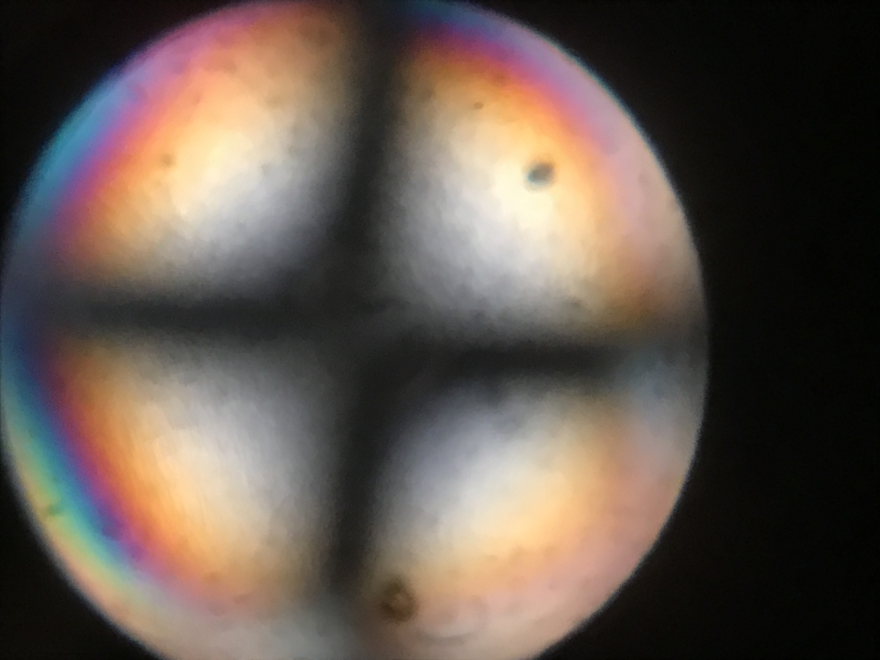
Figure 1. Conoscopic image with crossed polars of the sample plate.

Crystal-to-detector distance for data collection was 40 mm and exposure time was 120 seconds per frame for all sets. The scan width was 1º. Data collection was 99.7% complete to 25º in ϑ. A total of 17610 reflections were collected covering the indices, 0<=h<=25, 0<=k<=25, -25<=l<=25. 8964 reflections were symmetry independent and the R_{int} = 0.1362 indicated that the data was of appropriate quality, but rapidly decreasing spot intensities at larger diffraction angles indicated a high degree of disorder.

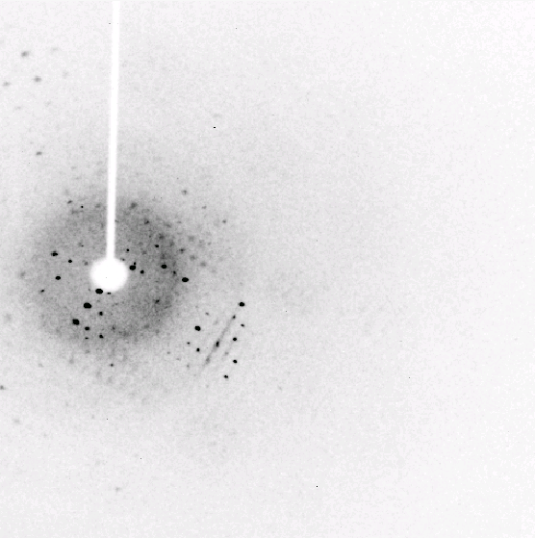
Figure 2. Sample diffraction image.

Indexing and unit cell refinement indicated a pseudo-cubic tetragonal lattice (room-temperature: a=21.476, c=21.485, 100K: a= 21.368, c=21.329). The space group was found to be P 4/n (No.85).

Between room-temperature and 100K the sample will assume cubic lattice parameters while lacking cubic symmetry.

The data was integrated and scaled using SAINT, SADABS within the APEX2 software package by Bruker.

Solution by direct methods (SHELXT or SIR97) produced a partial heavy atom phasing model consistent with the proposed structure. The structure was completed by difference Fourier synthesis with SHELXL., Scattering factors are from Waasmair and Kirfel. Hydrogen atoms were placed in geometrically idealised positions and constrained to ride on their parent atoms with C---H distances in the range 0.95-1.00 Angstrom. Isotropic thermal parameters U_{eq} were fixed such that they were 1.2U_{eq} of their parent atom Ueq for CH's and 1.5U_{eq} of their parent atom U_{eq} in case of methyl groups. All non-hydrogen atoms were refined anisotropically by full-matrix least-squares.

The structure appeared heavily disordered as expected from the diffraction pattern. While one DEF solvent was identified, solvent accessible voids contained additional solvent. The contribution of disordered solvent to the diffraction pattern was removed with SQUEEZE.

Four Zn atoms are coordinated with twelve oxygen atoms from deprotonated carboxylic acid moieties plus one central oxygen.

The ‘linker’ appears for-fold disordered and disordered with a DEF solvent.

Because of the total disorder, stability of the model required extensive application of positional and thermal restraints.

The structure is of sufficient quality for publication. Table 1 summarizes the data collection details. Figure 3 shows an ORTEP of the asymmetric unit.

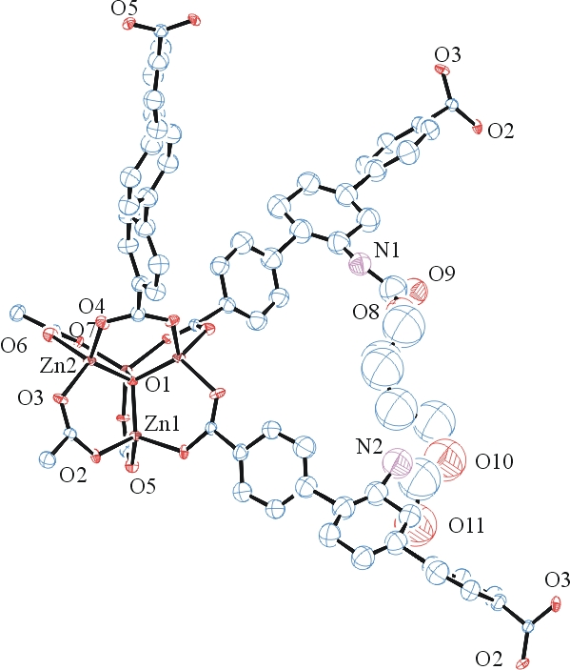
Figure 3. ORTEP of the extended asymmetric unit with thermal ellipsoids at the 15% probability level. Disorder, solvent, and hydrogen atoms omitted for clarity.

Table 1: Crystallographic data for the structures provided.
Empirical formula C72 H57 N3 O18 Zn4
Formula weight 1513.68
Temperature 100(2) K
Wavelength 0.71073 Å
Crystal system Tetragonal
Space group P 4/n
Unit cell dimensions a = 21.368(5) Å α= 90°.
b = 21.368(5) Å β= 90°.
c = 21.329(5) Å γ = 90°.
Volume 9739(5) Å3
Z 2
Density (calculated) 0.516 Mg/m3
Absorption coefficient 0.512 mm-1
F(000) 1548
Crystal size 0.200 x 0.200 x 0.050 mm3
Theta range for data collection 1.652 to 25.463°.
Index ranges 0<=h<=25, 0<=k<=25, -25<=l<=25
Reflections collected 17610
Independent reflections 8964 [R(int) = 0.1362]
Completeness to theta = 25.000° 99.7 %
Refinement method Full-matrix least-squares on F2
Data / restraints / parameters 8964 / 403 / 361
Goodness-of-fit on F2 1.010
Final R indices [I>2sigma(I)] R1 = 0.1934, wR2 = 0.3745
R indices (all data) R1 = 0.3334, wR2 = 0.4516
Largest diff. peak and hole 1.309 and -0.796 e.Å-3

Bruker (2007) APEX2 (Version 2.1-4), SAINT (version 7.34A), SADABS (version 2007/4), BrukerAXS Inc, Madison, Wisconsin, USA.
Sheldrick GM. (2015) SHELXT - Integrated space-group and crystal-structure determination. Acta Cryst. A71, 3-8.
(a) Altomare A, Burla C, Camalli M, Cascarano G L, Giacovazzo C, Guagliardi A, Moliterni AGG, Polidori G, Spagna R. (1999) SIR97: a new tool for crystal structure determination and refinement Journal of Applied Crystallography, 32, 115-119. (b) Altomare A, Cascarano G L, Giacovazzo C, Guagliardi A. (1993) Completion and refinement of crystal structures with SIR 92. Journal of Applied Crystallography, 26, 343-350.
(a) Sheldrick GM. (1997) SHELXL-97, Program for the Refinement of Crystal Structures. University of Göttingen, Germany. (b) Sheldrick GM. (2015) Crystal structure refinement with SHELXL. Acta Cryst. (2015). C71, 3–8
Mackay, S.; Edwards, C.; Henderson, A.; Gilmore, C.; Stewart, N.; Shankland, K.; Donald, A. (1997) MaXus: a computer program for the solution and refinement of crystal structures from diffraction data. University of Glasgow, Scotland,.
Waasmaier, D.; Kirfel, A. (1995) New Analytical Scattering Factor Functions for Free Atoms and Ions. Acta Crystallographica A., 51, 416-430.
(a) A. Spek, J. Appl. Cryst. (2003), 36, 7-13; (b) P. van der Sluis & A. L. Spek, Acta Cryst. (1990). A46, 194-201. (c) Spek, A. L. (2009). Acta. Cryst. D65, 148-155.
Farrugia LJ. (1997) Ortep-3 for Windows. Journal of Applied Crystallography, 30, 565

