Crystal Structure Report for Karen Goldberg
by Maike Blakely & Werner Kaminsky
Sample Submitted by Karena Smoll
ID – KAS_III_28B
X-ray Crystallography Laboratory
University of Washington
29. July 2026

Data Collection started: 10/20/2016
Documentation finished: 11/03/2016

Data backup accessibly through http:
URL: http://cad4.cpac.washington.edu/structures

W.Kaminsky: tel. (206) 543 7585
(x-ray lab): tel. (206) 543 0210
Email: kaminsky@chem.washington.edu

Understanding crystallographic information is not trivial. If you discuss a structure in a publication, please let the crystallographers proof-read the final draft of that manuscript before you submit it.
For many structures it is true that crystallography is an intellectual performance (like synthesis or elucidation of mechanisms) and not a routine job. In these cases, particularly when the structures contribute significantly to the content of the publication, the crystallographers should be co-authors. Do not think this is not necessary because you pay for structures.
An orange prism, measuring 0.22 x 0.16 x 0.16 mm³ was mounted on a loop with oil. Data was collected at -173ºC on a Bruker APEX II single crystal X-ray diffractometer, Mo-radiation.

Crystal-to-detector distance was 40 mm and exposure time was 240 seconds per frame for all sets. The scan width was 1º. Data collection was 99.5% complete to 25º in ϑ. A total of 73535 reflections were collected covering the indices, -19<=h<=19, -19<=k<=19, -23<=l<=23. 2743 reflections were symmetry independent and the R_{int} = 0.0510 indicated that the data was of good quality. Indexing and unit cell refinement indicated a hexagonal lattice. The space group was found to be P 6₅ 2 2 (No. 179).

The data was integrated and scaled using SAINT, SADABS within the APEX2 software package by Bruker.

Solution by direct methods (SHELXS, SIR97) produced a complete heavy atom phasing model consistent with the proposed structure. The structure was completed by difference Fourier synthesis with SHELXL97., Scattering factors are from Waasmair and Kirfel. Hydrogen atoms were placed in geometrically idealised positions and constrained to ride on their parent atoms with C---H distances in the range 0.95-1.00 Angstrom. Isotropic thermal parameters U_{eq} were fixed such that they were 1.2U_{eq} of their parent atom Ueq for CH's and 1.5U_{eq} of their parent atom U_{eq} in case of methyl groups. All non-hydrogen atoms were refined anisotropically by full-matrix least-squares.

The hexagonal structure exhibits infinite channels along the c axis, filled with disordered solvent (benzene-d₆, pentane). The contribution of that disordered solvent to the diffraction pattern was removed with SQUEEZE.

The structure is of high quality and ready for publication. Table 1 summarizes the data collection details. Figure 1 shows an ORTEP of the molecular unit.

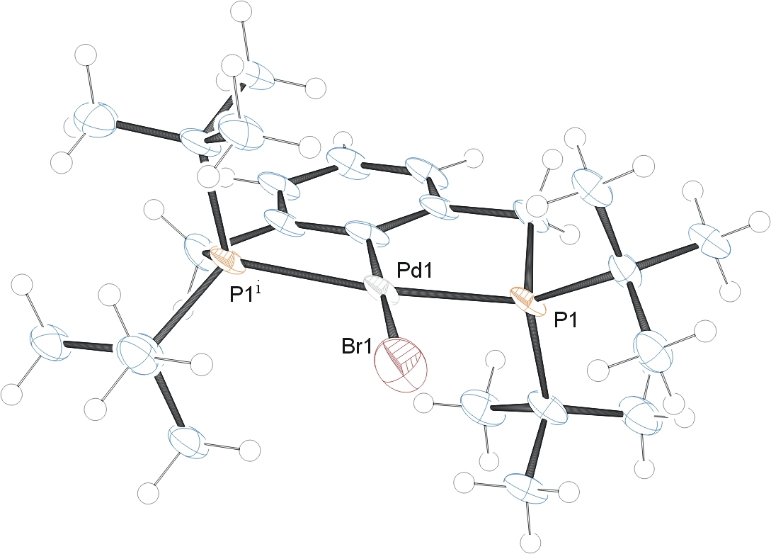

Figure 1. ORTEP of the structure with thermal ellipsoids at the 50% probability level.

Table 1: Crystallographic data for the structures provided.
Empirical formula C24 H43 Br P2 Pd
Formula weight 579.83
Temperature 100(2) K
Wavelength 0.71073 Å
Crystal system Hexagonal
Space group P 6₅ 2 2
Unit cell dimensions a = 16.3457(10) Å alpha = 90 ̊
b = 16.3457(10) Å beta = 90 ̊
c = 19.2133(17) Å gamma = 120 ̊
Volume 4445.7(7) Å³
Z, Calculated density 6, 1.299 Mg/m³
Absorption coefficient 2.090 mm⁻¹
F(000) 1788
Crystal size 0.220 x 0.160 x 0.160 mm
Theta range for data collection 1.438 to 25.457 ̊
Limiting indices -19<=h<=19, -19<=k<=19, -23<=l<=22
Reflections collected / unique 73535 / 2743 [R(int) = 0.0510]
Completeness to theta = 25.000 ̊ 99.5 %
Refinement method Full-matrix least-squares on F²
Data / restraints / parameters 2743 / 0 / 130
Goodness-of-fit on F^2 1.127
Final R indices [I>2sigma(I)] R1 = 0.0507, wR2 = 0.1387
R indices (all data) R1 = 0.0547, wR2 = 0.1414
Absolute structure parameter 0.12(4)
Largest diff. peak and hole 0.639 and -2.226 e. Å ⁻³

Bruker (2007) APEX2 (Version 2.1-4), SAINT (version 7.34A), SADABS (version 2007/4), BrukerAXS Inc, Madison, Wisconsin, USA.
(a) Altomare A, Burla C, Camalli M, Cascarano G L, Giacovazzo C, Guagliardi A, Moliterni AGG, Polidori G, Spagna R. (1999) SIR97: a new tool for crystal structure determination and refinement Journal of Applied Crystallography, 32, 115-119. (b) Altomare A, Cascarano G L, Giacovazzo C, Guagliardi A. (1993) Completion and refinement of crystal structures with SIR 92. Journal of Applied Crystallography, 26, 343-350.
(a) Sheldrick GM. (1997) SHELXL-97, Program for the Refinement of Crystal Structures. University of Göttingen, Germany. (b) Sheldrick GM. (2013) Crystal structure refinement with SHELXL. Acta Cryst. (2015). C71, 3-8.
Mackay, S.; Edwards, C.; Henderson, A.; Gilmore, C.; Stewart, N.; Shankland, K.; Donald, A. (1997) MaXus: a computer program for the solution and refinement of crystal structures from diffraction data. University of Glasgow, Scotland,.
Waasmaier, D.; Kirfel, A. (1995) New Analytical Scattering Factor Functions for Free Atoms and Ions. Acta Crystallographica A., 51, 416-430.
A. Spek, J. Appl. Cryst. (2003), 36, 7-13; P. van der Sluis & A. L. Spek, Acta Cryst. (1990). A46, 194-201.
Farrugia LJ. (1997) Ortep-3 for Windows. Journal of Applied Crystallography, 30, 565

