Crystal Structure Report for K. Goldberg
by Sarah Flowers & Werner Kaminsky
Sample Submitted by Karena Smoll
ID – KAS_11_95b
X-ray Crystallography Laboratory
University of Washington
31. July 2026

Data Collection started: 12/15/2015
Documentation finished: 1/4/2016

Data backup accessibly through http:
URL: http://cad4.cpac.washington.edu/structures

W.Kaminsky: tel. (206) 543 7585
(x-ray lab): tel. (206) 543 0210
Email: kaminsky@chem.washington.edu

Understanding crystallographic information is not trivial. If you discuss a structure in a publication, please let the crystallographers proof-read the final draft of that manuscript before you submit it.
For many structures it is true that crystallography is an intellectual performance (like synthesis or elucidation of mechanisms) and not a routine job. In these cases, particularly when the structures contribute significantly to the content of the publication, the crystallographers should be co-authors. Do not think this is not necessary because you pay for structures. Even I have to pay for my own structures for my research.
A yellow piece, measuring 0.08 x 0.06 x 0.06 mm³ was mounted on a loop with oil. Data was collected at -173ºC on a Bruker APEX II single crystal X-ray diffractometer, Mo-radiation.

Crystal-to-detector distance was 40 mm and exposure time was 30 seconds per frame for all sets. The scan width was 0.5º. Data collection was 100% complete to 25º in ϑ. A total of 72058 reflections were collected covering the indices, -10<=h<=10, -41<=k<=41, -15<=l<=15. 7065 reflections were symmetry independent and the slightly elevated R_{int} = 0.0847 related to the small sample size. Indexing and unit cell refinement indicated a primitive monoclinic lattice. The space group was found to be P 2₁/c (No.14).

The data was integrated and scaled using SAINT, SADABS within the APEX2 software package by Bruker.

Solution by direct methods (SHELXS, SIR97) produced a complete heavy atom phasing model consistent with the proposed structure. The structure was completed by difference Fourier synthesis with SHELXL97., Scattering factors are from Waasmair and Kirfel. Hydrogen atoms were placed in geometrically idealised positions and constrained to ride on their parent atoms with C---H distances in the range 0.95-1.00 Angstrom. Isotropic thermal parameters U_{eq} were fixed such that they were 1.2U_{eq} of their parent atom Ueq for CH's and 1.5U_{eq} of their parent atom U_{eq} in case of methyl groups. All non-hydrogen atoms were refined anisotropically by full-matrix least-squares.

Solvent analysis revealed disordered CH2Cl2 solvent or similar, the contribution of which to the diffraction pattern being removed with the help of SQUEEZE. Concomitant with solvent disorder are split positions of t-butyls and terminal chlorine.

The structure is of high quality and ready for publication. Table 1 summarizes the data collection details. Figure 1 shows an ORTEP of the asymmetric unit.

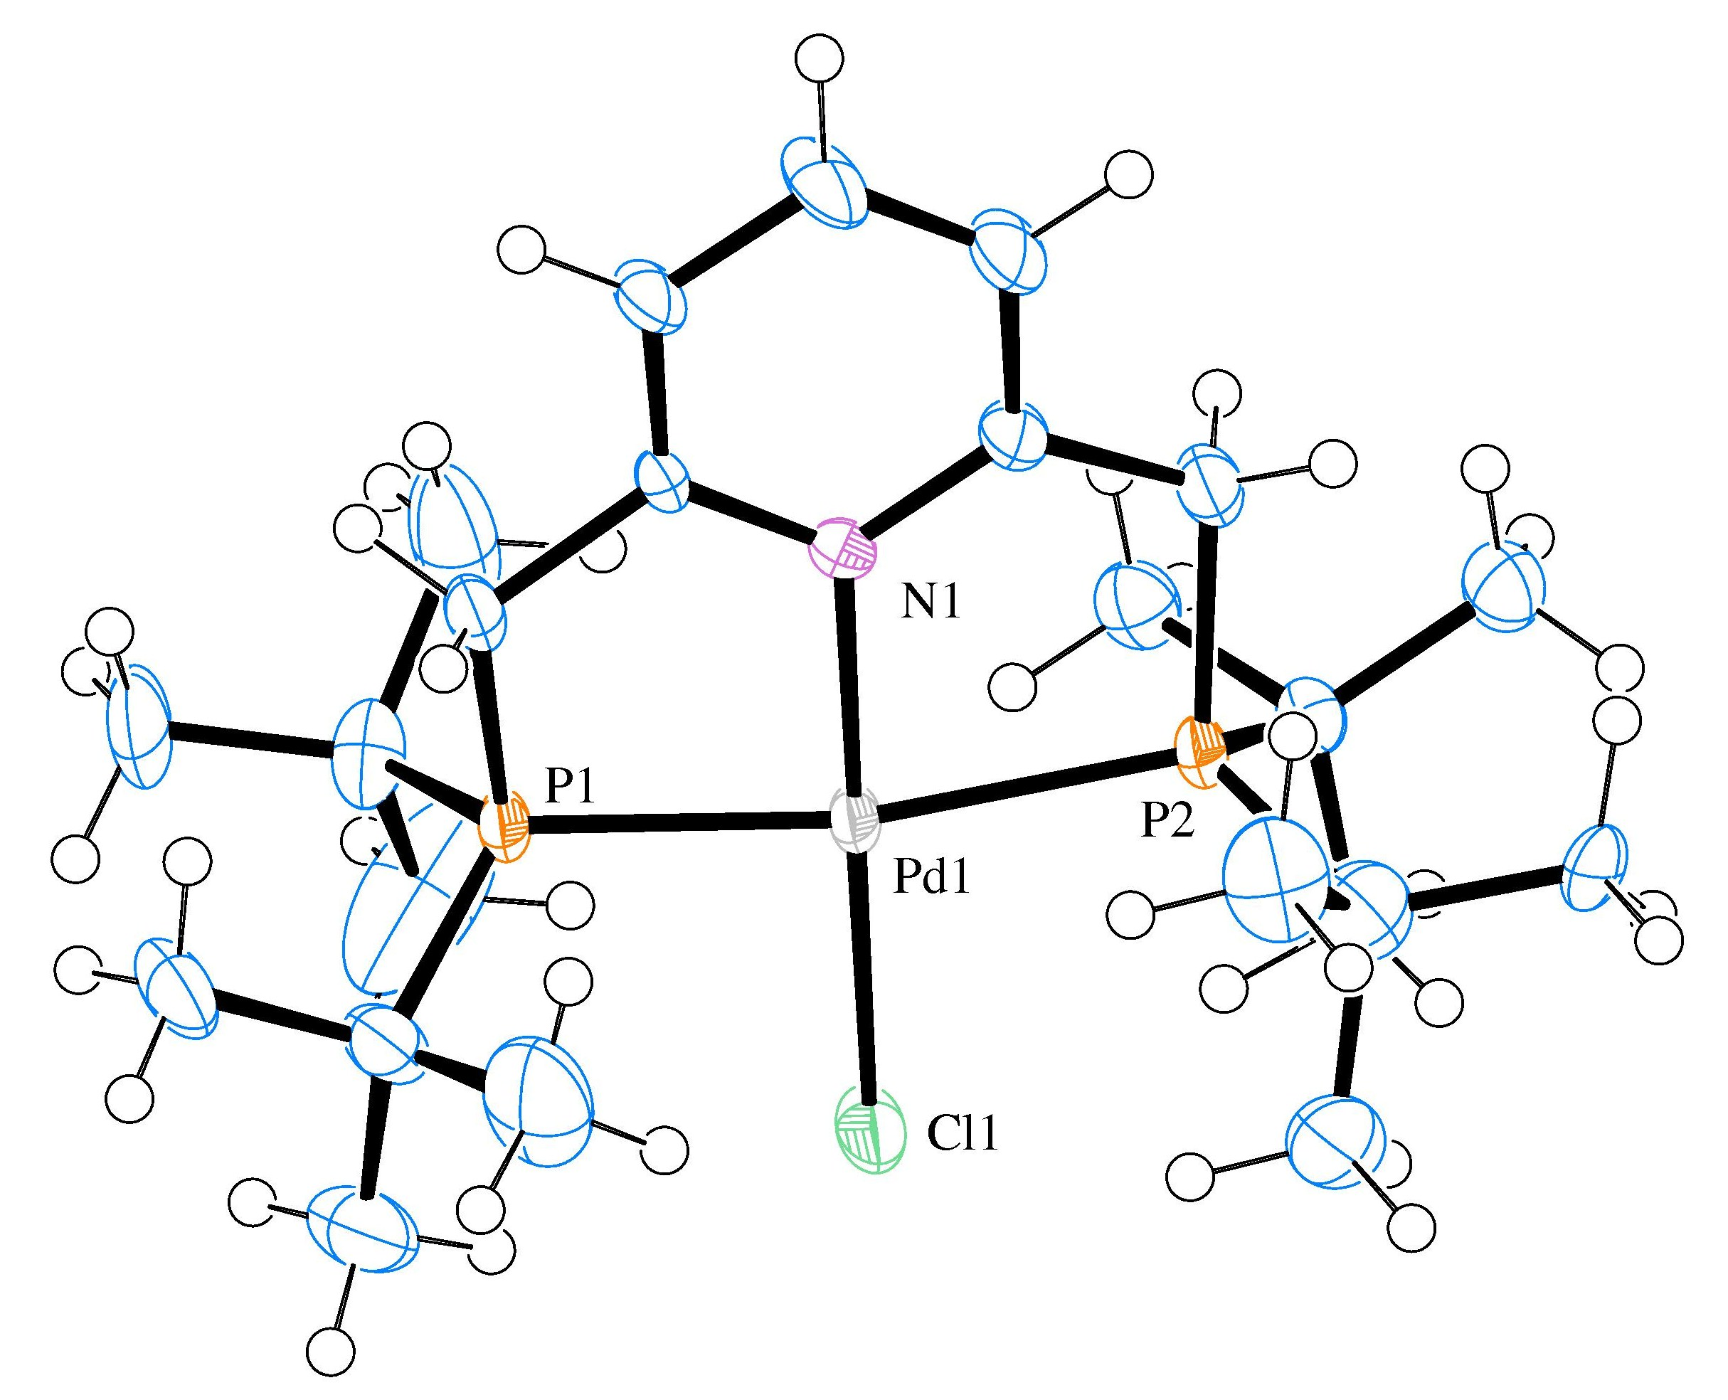

Figure 1. ORTEP of the structure with thermal ellipsoids at the 50% probability level. Disorder omitted for clarity.

Table 1: Crystallographic data for the structures provided.
Empirical formula C23 H43 Cl N P2 Pd
Formula weight 537.37
Temperature 100(2) K
Wavelength 0.71073 Å
Crystal system Monoclinic
Space group P 21/c
Unit cell dimensions a = 8.0077(4) Å α= 90°.
b = 31.1304(17) Å β= 107.753(3)°.
c = 11.9254(6) Å γ = 90°.
Volume 2831.2(3) Å3
Z 4
Density (calculated) 1.261 Mg/m3
Absorption coefficient 0.872 mm-1
F(000) 1124
Crystal size 0.08 x 0.06 x 0.06 mm3
Theta range for data collection 1.31 to 28.37°.
Index ranges -10<=h<=10, -41<=k<=41, -15<=l<=15
Reflections collected 72058
Independent reflections 7065 [R(int) = 0.0874]
Completeness to theta = 25.00° 100.0 %
Max. and min. transmission 0.9496 and 0.9335
Refinement method Full-matrix least-squares on F2
Data / restraints / parameters 7065 / 120 / 350
Goodness-of-fit on F2 1.141
Final R indices [I>2sigma(I)] R1 = 0.0822, wR2 = 0.1532
R indices (all data) R1 = 0.1195, wR2 = 0.1642
Largest diff. peak and hole 1.083 and -2.221 e.Å-3

Bruker (2007) APEX2 (Version 2.1-4), SAINT (version 7.34A), SADABS (version 2007/4), BrukerAXS Inc, Madison, Wisconsin, USA.
(a) Altomare A, Burla C, Camalli M, Cascarano G L, Giacovazzo C, Guagliardi A, Moliterni AGG, Polidori G, Spagna R. (1999) SIR97: a new tool for crystal structure determination and refinement Journal of Applied Crystallography, 32, 115-119. (b) Altomare A, Cascarano G L, Giacovazzo C, Guagliardi A. (1993) Completion and refinement of crystal structures with SIR 92. Journal of Applied Crystallography, 26, 343-350.
(a) Sheldrick GM. (1997) SHELXL-97, Program for the Refinement of Crystal Structures. University of Göttingen, Germany. (b) Sheldrick GM. (2013) Crystal structure refinement with SHELXL. Acta Cryst. (2015). C71, 3-8.
Mackay, S.; Edwards, C.; Henderson, A.; Gilmore, C.; Stewart, N.; Shankland, K.; Donald, A. (1997) MaXus: a computer program for the solution and refinement of crystal structures from diffraction data. University of Glasgow, Scotland,.
Waasmaier, D.; Kirfel, A. (1995) New Analytical Scattering Factor Functions for Free Atoms and Ions. Acta Crystallographica A., 51, 416-430.
A. Spek, J. Appl. Cryst. (2003), 36, 7-13; P. van der Sluis & A. L. Spek, Acta Cryst. (1990). A46, 194-201.
Farrugia LJ. (1997) Ortep-3 for Windows. Journal of Applied Crystallography, 30, 565

