Crystal Structure Report for D. Reed
by W. Kaminsky & S. Krajewski
Sample Submitted by Jay Lee
ID – KL_04_005
X-ray Crystallography Laboratory
University of Washington
30. July 2026

Data Collection started: 4/18/2025
Documentation finished: 5/8/2025

Data backup accessibly through http:
URL: http://cad4.cpac.washington.edu/structures

W.Kaminsky: tel. (206) 543 7585
(x-ray lab): tel. (206) 543 0210
Email: kaminsky@chem.washington.edu

Understanding crystallographic information is not trivial. If you discuss a structure in a publication, please let the crystallographers proof-read the final draft of that manuscript before you submit it.
For many structures it is true that crystallography is an intellectual performance (like synthesis or elucidation of mechanisms) and not a routine job. In these cases, particularly when the structures contribute significantly to the content of the publication, the crystallographers should be co-authors. Do not think this is not necessary because you pay for structures.
A green shard, measuring 0.20 x 0.20 x 0.14 mm³ was mounted on a loop with oil. Data was collected at -173ºC on a Bruker APEX II single crystal X-ray diffractometer, Mo-radiation, equipped with a Miracol X-ray optical collimator.

Crystal-to-detector distance was xx mm and exposure time was 60 seconds per frame for all sets. The scan width was 0.75º. Data collection was 99.9% complete to 18.848º in ϑ. A total of 78255 reflections were collected covering the indices, -29<=h<=29, -29<=k<=29, -42<=l<=42. 19620 reflections were symmetry independent and the R_{int} = 0.1708 reflects the weakness of data (see below). Indexing and unit cell refinement indicated a body-centered tetragonal lattice. The space group was found to be I 4 (No. 79).

The data was integrated and scaled using SAINT, SADABS within the APEX2 software package by Bruker.

The contribution of disordered solvent to the diffraction pattern was removed with SQUEEZE

Solution by direct methods (SHELXT or SIR97) produced a complete heavy atom phasing model consistent with the proposed structure. The structure was completed by difference Fourier synthesis with SHELXL. Scattering factors are from Waasmair and Kirfel. Hydrogen atoms were placed in geometrically idealised positions and constrained to ride on their parent atoms with C---H distances in the range 0.95-1.00 Angstrom. Isotropic thermal parameters U_{eq} were fixed such that they were 1.2U_{eq} of their parent atom Ueq for CH's and 1.5U_{eq} of their parent atom U_{eq} in case of methyl groups. All non-hydrogen atoms were refined anisotropically by full-matrix least-squares.

The large spherical complex encapsulates large voids filled with disordered solvent. Almost all Cu-bonded ligands are disordered as well. As a result, the structure scatters similar to a 'hot' structure, where it is known that diffraction intensities decrease at larger Bragg angles and the diffusion background increases. Thus, even prolonged exposure to X-Rays will not increase the resolution. Thus, only data to a resolution of 1.1 Angstrom was observed and used for the refinement. However, we believe to
have derived a valid model of the molecule.

The structure appeared not to have a higher symmetry, however, 1:1 enantiomorphic twinning (or twinning via mirror on the c-axis) was observed.

The structure is of lower quality but may be publishable. Table 1 summarizes the data collection details. Figure 1 shows an ORTEP of the asymmetric unit.

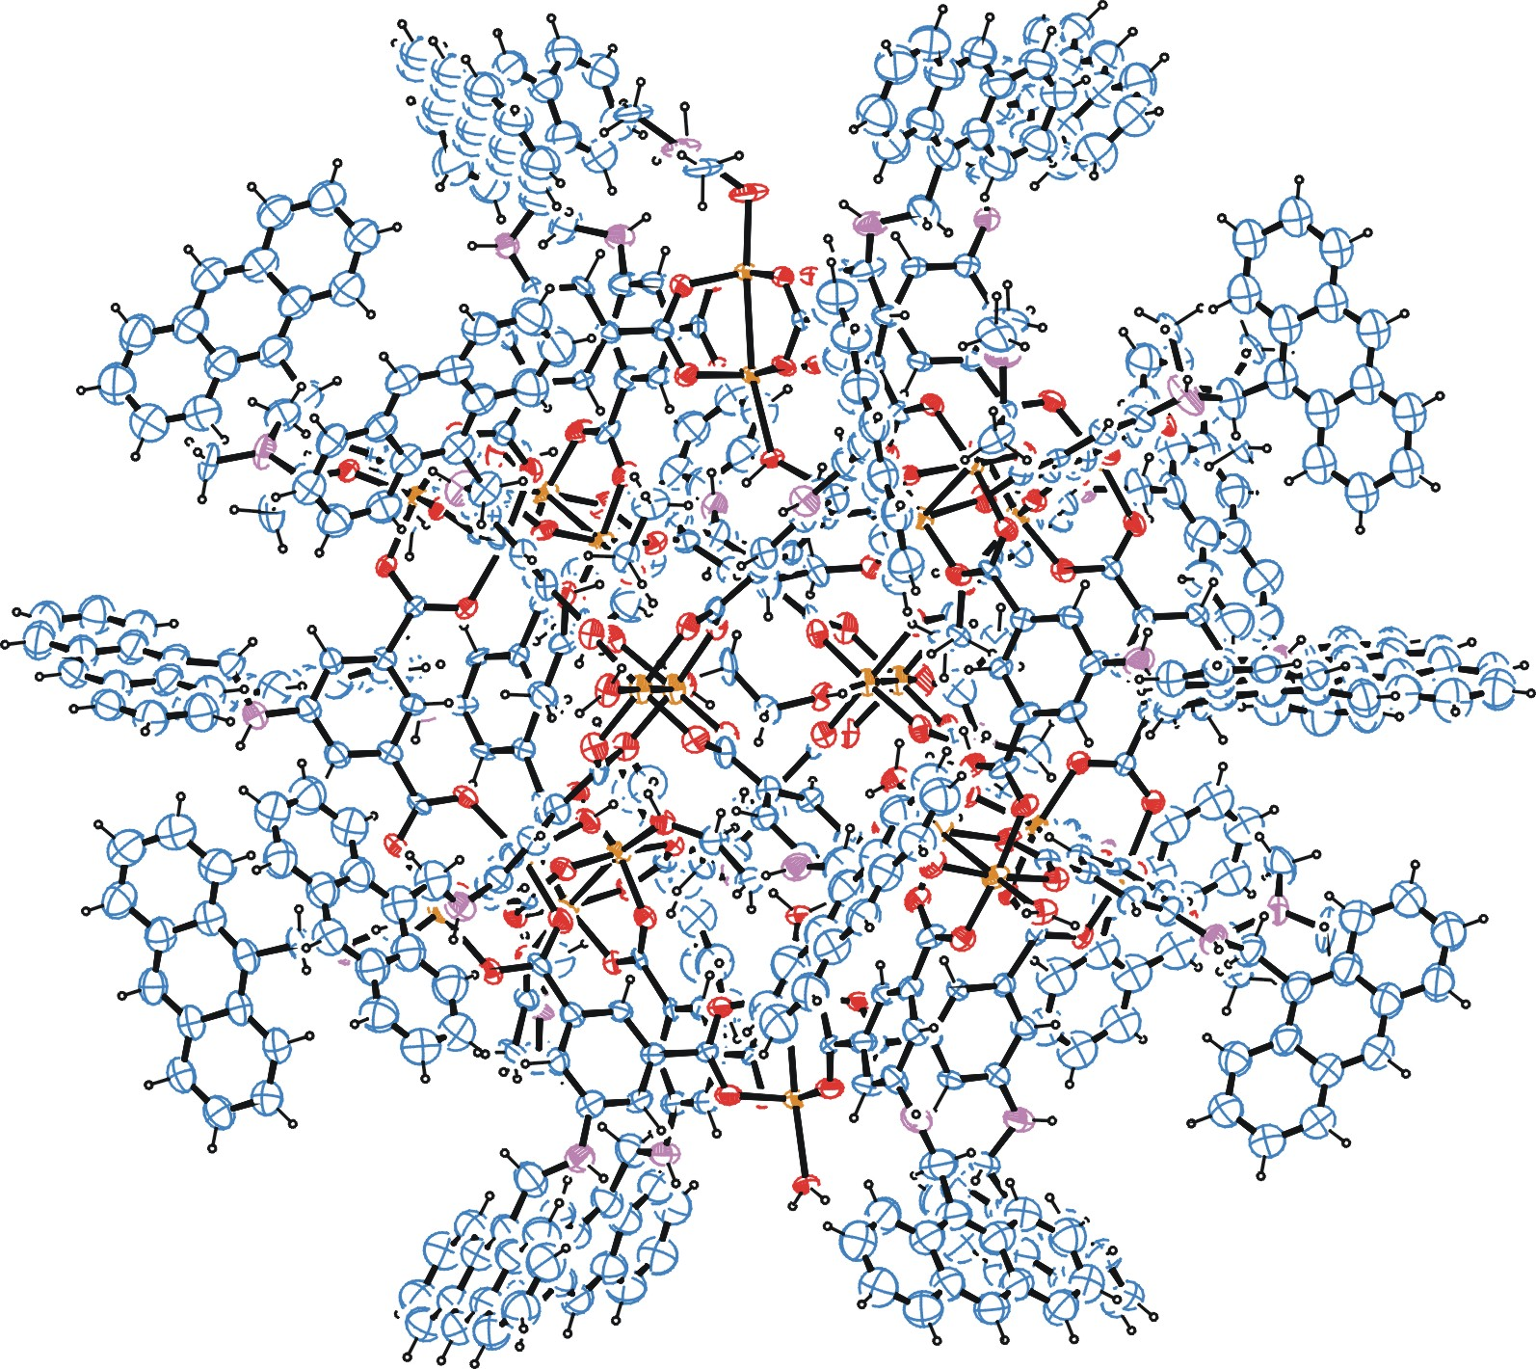

Figure 1. ORTEP of the structure with thermal ellipsoids at the 15% probability level. Disorder and some solvent omitted for clarity.

Table 1: Crystallographic data for the structures provided.
Empirical formula C604 H504 Cu24 N32 O120
Formula weight 11655.32
Temperature 100(2) K
Wavelength 0.71073 Å
Crystal system Tetragonal
Space group I 4
Unit cell dimensions a = 32.440(3) Å α= 90°.
b = 32.440(3) Å β= 90°.
c = 47.314(5) Å γ = 90°.
Volume 49791(12) Å3
Z 2
Density (calculated) 0.777 Mg/m3
Absorption coefficient 0.547 mm-1
F(000) 12016
Crystal size 0.200 x 0.200 x 0.140 mm3
Theta range for data collection 1.236 to 18.848°.
Index ranges -29<=h<=29, -29<=k<=29, -42<=l<=42
Reflections collected 78255
Independent reflections 19620 [R(int) = 0.1708]
Completeness to theta = 18.848° 99.9 %
Refinement method Full-matrix least-squares on F2
Data / restraints / parameters 19620 / 5293 / 1919
Goodness-of-fit on F2 1.128
Final R indices [I>2sigma(I)] R1 = 0.0924, wR2 = 0.1845
R indices (all data) R1 = 0.1980, wR2 = 0.2196
Absolute structure parameter 0.49(5)
Largest diff. peak and hole 0.329 and -0.456 e.Å-3

Bruker (2007) APEX2 (Version 2.1-4), SAINT (version 7.34A), SADABS (version 2007/4), BrukerAXS Inc, Madison, Wisconsin, USA.
(a) A. Spek, J. Appl. Cryst. (2003), 36, 7-13; (b) P. van der Sluis & A. L. Spek, Acta Cryst. (1990). A46, 194-201. (c) Spek, A. L. (2009). Acta. Cryst. D65, 148-155.
(a) Sheldrick GM. (2008) A short history of SHELX. Acta Cryst. A64, 112-122. (b) Sheldrick GM. (2015) SHELXT - Integrated space-group and crystal-structure determination. Acta Cryst. A71, 3-8.
(a) Altomare A, Burla C, Camalli M, Cascarano G L, Giacovazzo C, Guagliardi A, Moliterni AGG, Polidori G, Spagna R. (1999) SIR97: a new tool for crystal structure determination and refinement Journal of Applied Crystallography, 32, 115-119. (b) Altomare A, Cascarano G L, Giacovazzo C, Guagliardi A. (1993) Completion and refinement of crystal structures with SIR 92. Journal of Applied Crystallography, 26, 343-350.
(a) Sheldrick GM. (1997) SHELXL-97, Program for the Refinement of Crystal Structures. University of Göttingen, Germany. (b) Sheldrick GM. (2015) Crystal structure refinement with SHELXL. Acta Cryst. C71, 3–8
Waasmaier, D.; Kirfel, A. (1995) New Analytical Scattering Factor Functions for Free Atoms and Ions. Acta Crystallographica A., 51, 416-430.
Farrugia LJ. (1997) Ortep-3 for Windows. Journal of Applied Crystallography, 30, 565

