Crystal Structure Report for D. Reed
by Sebastian Krajewski and
Werner Kaminsky
Sample Submitted by Jay Lee
ID – KL_2_64
X-ray Crystallography Laboratory
University of Washington
28. July 2026

Data Collection started: 3/1/2024
Documentation finished: 3/7/2024

Data backup accessibly through http:
URL: http://cad4.cpac.washington.edu/structures

W.Kaminsky: tel. (206) 543 7585
(x-ray lab): tel. (206) 543 0210
Email: kaminsky@chem.washington.edu

Understanding crystallographic information is not trivial. If you discuss a structure in a publication, please let the crystallographers proof-read the final draft of that manuscript before you submit it.
For many structures it is true that crystallography is an intellectual performance (like synthesis or elucidation of mechanisms) and not a routine job. In these cases, particularly when the structures contribute significantly to the content of the publication, the crystallographers should be co-authors. Do not think this is not necessary because you pay for structures.
A green block, measuring 0.600 x 0.150 x 0.110 mm³ was mounted on a loop with oil. Data was collected at -173ºC on a Bruker APEX II single crystal X-ray diffractometer, Mo-radiation, equipped with a Miracol X-ray optical collimator.

Crystal-to-detector distance was 45 mm and exposure time was 120 seconds per frame for all sets. The scan width was 0.5º. Data collection was 99.5% complete to 25º in ϑ. A total of 72947 merged reflections were collected covering the indices, -49<=h<=0, 0<=k<=49, 0<=l<=50. 37044 reflections were symmetry independent and the R_{int} = 0.2619 reflects that the data vanished bejond a resolution of 1.4Å. Indexing and unit cell refinement indicated a trigonal lattice. The space group was found to be P‾31c (No.163).

The data was integrated and scaled using SAINT, SADABS within the APEX2 software package by Bruker.

The contribution of disordered solvent to the diffraction pattern was removed with SQUEEZE

Solution by direct methods (SHELXT or SIR97) produced a complete heavy atom phasing model consistent with the proposed structure. The structure was completed by difference Fourier synthesis with SHELXL. Scattering factors are from Waasmair and Kirfel. Hydrogen atoms were placed in geometrically idealised positions and constrained to ride on their parent atoms with C---H distances in the range 0.95-1.00 Angstrom. Isotropic thermal parameters U_{eq} were fixed such that they were 1.2U_{eq} of their parent atom Ueq for CH's and 1.5U_{eq} of their parent atom U_{eq} in case of methyl groups. All non-hydrogen atoms were refined anisotropically by full-matrix least-squares.

Due to large degree of thermal motion of the tetrathiofulvalenes, a significant amount of diffuse scattering causes to 'swallow' weeker diffraction maxima at higher diffraction angles. Because this effect is in proportion to the X-ray beam intensity, longer exposure times do not improve the situation and the data is all together very week bejond a resolution of 1.4, effectively disappearing (hot crystal syndrom, since large displacement parameters are also observed in structures at high temperatures). However, we have high confidence in the structure model derived from this data.

The structure is of sufficient quality for publication. Table 1 summarizes the data collection details. Figure 1 shows an ORTEP of the asymmetric unit.

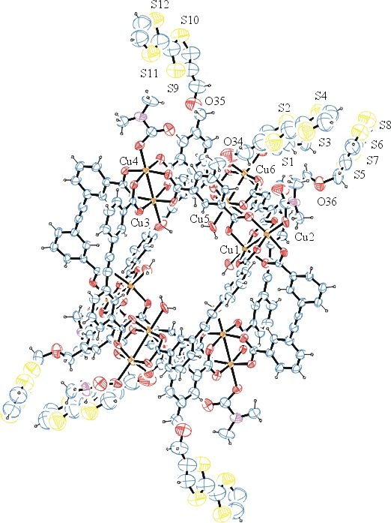
Figure 1. ORTEP of the structure with thermal ellipsoids at the 15% probability level.

Table 1: Crystallographic data for the structures provided.
Empirical formula C210 H156 Cu12 N6 O72 S24
Formula weight 5447.32
Temperature 100(2) K
Wavelength 0.71073 Å
Crystal system Trigonal
Space group P -3 1 c
Unit cell dimensions a = 42.432(2) Å α= 90°.
b = 42.432(2) Å β= 90°.
c = 43.459(3) Å γ = 120°.
Volume 67762(8) Å3
Z 6
Density (calculated) 0.801 Mg/m3
Absorption coefficient 0.707 mm-1
F(000) 16596
Crystal size 0.600 x 0.150 x 0.110 mm3
Theta range for data collection 0.937 to 24.407°.
Index ranges -49<=h<=0, 0<=k<=49, 0<=l<=50
Reflections collected 72947
Independent reflections 37044 [R(int) = 0.2619]
Completeness to theta = 24.407° 99.5 %
Refinement method Full-matrix least-squares on F2
Data / restraints / parameters 37044 / 2326 / 1327
Goodness-of-fit on F2 1.267
Final R indices [I>2sigma(I)] R1 = 0.1966, wR2 = 0.3421
R indices (all data) R1 = 0.4091, wR2 = 0.3923
Largest diff. peak and hole 0.697 and -1.021 e.Å-3

Bruker (2007) APEX2 (Version 2.1-4), SAINT (version 7.34A), SADABS (version 2007/4), BrukerAXS Inc, Madison, Wisconsin, USA.
(a) A. Spek, J. Appl. Cryst. (2003), 36, 7-13; (b) P. van der Sluis & A. L. Spek, Acta Cryst. (1990). A46, 194-201. (c) Spek, A. L. (2009). Acta. Cryst. D65, 148-155.
(a) Sheldrick GM. (2008) A short history of SHELX. Acta Cryst. A64, 112-122. (b) Sheldrick GM. (2015) SHELXT - Integrated space-group and crystal-structure determination. Acta Cryst. A71, 3-8.
(a) Altomare A, Burla C, Camalli M, Cascarano G L, Giacovazzo C, Guagliardi A, Moliterni AGG, Polidori G, Spagna R. (1999) SIR97: a new tool for crystal structure determination and refinement Journal of Applied Crystallography, 32, 115-119. (b) Altomare A, Cascarano G L, Giacovazzo C, Guagliardi A. (1993) Completion and refinement of crystal structures with SIR 92. Journal of Applied Crystallography, 26, 343-350.
(a) Sheldrick GM. (1997) SHELXL-97, Program for the Refinement of Crystal Structures. University of Göttingen, Germany. (b) Sheldrick GM. (2015) Crystal structure refinement with SHELXL. Acta Cryst. C71, 3–8
Waasmaier, D.; Kirfel, A. (1995) New Analytical Scattering Factor Functions for Free Atoms and Ions. Acta Crystallographica A., 51, 416-430.
Farrugia LJ. (1997) Ortep-3 for Windows. Journal of Applied Crystallography, 30, 565

