Crystal Structure Report for D. Reed
by Sebastian Krajewski and
Werner Kaminsky
Sample Submitted by Jay Lee
ID – KL_2_72_1_Et2O
X-ray Crystallography Laboratory
University of Washington
31. July 2026

Data Collection started: 3/15/2024
Documentation finished: 3/21/2024

Data backup accessibly through http:
URL: http://cad4.cpac.washington.edu/structures

W.Kaminsky: tel. (206) 543 7585
(x-ray lab): tel. (206) 543 0210
Email: kaminsky@chem.washington.edu

Understanding crystallographic information is not trivial. If you discuss a structure in a publication, please let the crystallographers proof-read the final draft of that manuscript before you submit it.
For many structures it is true that crystallography is an intellectual performance (like synthesis or elucidation of mechanisms) and not a routine job. In these cases, particularly when the structures contribute significantly to the content of the publication, the crystallographers should be co-authors. Do not think this is not necessary because you pay for structures.
A blue pice, measuring 0.05 x 0.04 x 0.03 mm³ was mounted on a loop with oil. Data was collected at -173ºC on a Bruker APEX II single crystal X-ray diffractometer, Mo-radiation, equipped with a Miracol X-ray optical collimator.

Crystal-to-detector distance was 40 mm and exposure time was 120 seconds per frame for all sets. The scan width was 0.5º. Data collection was 99.9% complete to 25º in ϑ. A total of 14,119 reflections out of 414,404 full and partial ones were collected covering the indices, -34<=h<=34, -34<=k<=34, -20<=l<=20. 7,293 reflections were symmetry independent and the elavated R_{int} = 0.1638 reflex the small sample size (average 0.07). Indexing and unit cell refinement indicated a primitive cubic lattice. The space group was found to be P n‾3 (No.201).

The data was integrated and scaled using SAINT, SADABS within the APEX2 software package by Bruker.

Solution by direct methods (SHELXT or SIR97) produced a complete heavy atom phasing model consistent with the proposed structure. The structure was completed by difference Fourier synthesis with SHELXL. Scattering factors are from Waasmair and Kirfel. Hydrogen atoms were placed in geometrically idealised positions and constrained to ride on their parent atoms with C---H distances in the range 0.95-1.00 Angstrom. Isotropic thermal parameters U_{eq} were fixed such that they were 1.2U_{eq} of their parent atom Ueq for CH's and 1.5U_{eq} of their parent atom U_{eq} in case of methyl groups. All non-hydrogen atoms were refined anisotropically by full-matrix least-squares.

The asymmetric unit shown below shows two only copper atoms between the organic glue that forms the cage structure out of 24 symmetry operations (including identity).
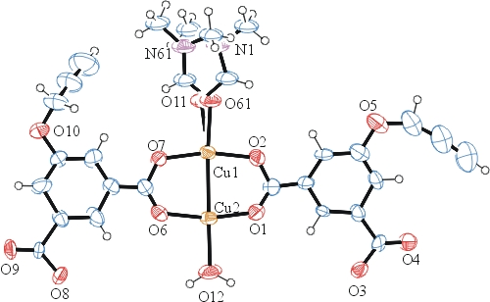
Figure 1. ORTEP of the content of the asymmetric unit with thermal ellipsoids at the 15% probability level. Note the disorder of the DMF on Cu1.

Due to disorder, the true nature of ligand to Cu2 could not be revealed and was approximated with water O12.

The contribution of all that disordered solvent inside and outside the cage structure (Figure 2) to the diffraction pattern was removed with SQUEEZE

The structure is of high quality and ready for publication. Table 1 summarizes the data collection details. Figure 1 shows an ORTEP of the asymmetric unit.

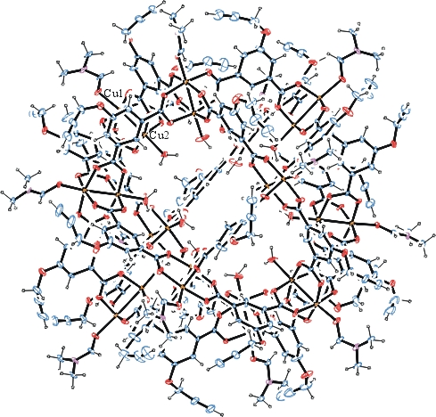
Figure 2. ORTEP of the cage structure (one cage per unit cell) with thermal ellipsoids at the 15% probability level. Disorder omitted for clarity.

Table 1: Crystallographic data for the structures provided.
Empirical formula C300 H252 Cu24 N12 O144
Formula weight 7854.08
Temperature 100(2) K
Wavelength 0.71073 Å
Crystal system Cubic
Space group P n‾3
Unit cell dimensions a = 29.851(4) Å α= 90°.
b = 29.851(4) Å β= 90°.
c = 29.851(8) Å γ = 90°.
Volume 26600(11) Å3
Z 2
Density (calculated) 0.981 Mg/m3
Absorption coefficient 0.999 mm-1
F(000) 7968
Crystal size 0.050 x 0.040 x 0.030 mm3
Theta range for data collection 0.965 to 24.398°.
Index ranges 1<=h<=34, 0<=k<=34, -20<=l<=20
Reflections collected 14119
Independent reflections 7293 [R(int) = 0.1638]
Completeness to theta = 24.398° 99.9 %
Refinement method Full-matrix least-squares on F2
Data / restraints / parameters 7293 / 348 / 406
Goodness-of-fit on F2 0.823
Final R indices [I>2sigma(I)] R1 = 0.0958, wR2 = 0.2825
R indices (all data) R1 = 0.2879, wR2 = 0.3559
Largest diff. peak and hole 1.388 and -0.859 e.Å-3

Bruker (2007) APEX2 (Version 2.1-4), SAINT (version 7.34A), SADABS (version 2007/4), BrukerAXS Inc, Madison, Wisconsin, USA.
(a) Sheldrick GM. (2008) A short history of SHELX. Acta Cryst. A64, 112-122. (b) Sheldrick GM. (2015) SHELXT - Integrated space-group and crystal-structure determination. Acta Cryst. A71, 3-8.
(a) Altomare A, Burla C, Camalli M, Cascarano G L, Giacovazzo C, Guagliardi A, Moliterni AGG, Polidori G, Spagna R. (1999) SIR97: a new tool for crystal structure determination and refinement Journal of Applied Crystallography, 32, 115-119. (b) Altomare A, Cascarano G L, Giacovazzo C, Guagliardi A. (1993) Completion and refinement of crystal structures with SIR 92. Journal of Applied Crystallography, 26, 343-350.
(a) Sheldrick GM. (1997) SHELXL-97, Program for the Refinement of Crystal Structures. University of Göttingen, Germany. (b) Sheldrick GM. (2015) Crystal structure refinement with SHELXL. Acta Cryst. C71, 3–8
Waasmaier, D.; Kirfel, A. (1995) New Analytical Scattering Factor Functions for Free Atoms and Ions. Acta Crystallographica A., 51, 416-430.
(a) A. Spek, J. Appl. Cryst. (2003), 36, 7-13; (b) P. van der Sluis & A. L. Spek, Acta Cryst. (1990). A46, 194-201. (c) Spek, A. L. (2009). Acta. Cryst. D65, 148-155.
Farrugia LJ. (1997) Ortep-3 for Windows. Journal of Applied Crystallography, 30, 565

