Crystal Structure Report for
Mohan Rao Kollipara
by Werner Kaminsky
Sample ID
KMR_SA_29_RT
X-ray Crystallography Laboratory
University of Washington
31. July 2026

Data Collection started: 9/5/2017
Documentation finished: 9/7/2017

Data backup accessibly through http:
URL: http://cad4.cpac.washington.edu/structures

W.Kaminsky: tel. (206) 543 7585
(x-ray lab): tel. (206) 543 0210
Email: kaminsky@chem.washington.edu

Understanding crystallographic information is not trivial. If you discuss a structure in a publication, please let the crystallographers proof-read the final draft of that manuscript before you submit it.
For many structures it is true that crystallography is an intellectual performance (like synthesis or elucidation of mechanisms) and not a routine job. In these cases, particularly when the structures contribute significantly to the content of the publication, the crystallographers should be co-authors. Do not think this is not necessary because you pay for structures.
An orange prism, measuring 0.22 x 0.19 x 0.07 mm³ was mounted on a loop with oil. Data was collected at 19ºC on a Nonius Kappa CCD FR590 single crystal X-ray diffractometer, Mo-radiation.

Crystal-to-detector distance was 30 mm and exposure time was 100 seconds per degree for all sets. The scan width was 1.8º. Data collection was 99.2% complete to 25º in ϑ. A total of 69590 partial and complete reflections were collected covering the indices, -15<=h<=15, -24<=k<=23, -17<=l<=17. 6171 reflections were symmetry independent and the R_{int} = 0.1090 indicated that the data was o.k. . Indexing and unit cell refinement indicated a primitive monoclinic lattice. The space group was found to be P 2₁/n (No. 14).

The data was integrated and scaled using hkl-SCALEPACK. This program applies a multiplicative correction factor (S) to the observed intensities (I) and has the following form:

S is calculated from the scale and the B factor determined for each frame and is then applied to I to give the corrected intensity (I_{corr}).

Solution by direct methods (SHELXS, SIR97) produced a complete heavy atom phasing model consistent with the proposed structure. The structure was completed by difference Fourier synthesis with SHELXL97., Scattering factors are from Waasmair and Kirfel. Hydrogen atoms were placed in geometrically idealised positions and constrained to ride on their parent atoms with C---H distances in the range 0.95-1.00 Angstrom. Isotropic thermal parameters U_{eq} were fixed such that they were 1.2U_{eq} of their parent atom Ueq for CH's and 1.5U_{eq} of their parent atom U_{eq} in case of methyl groups. All non-hydrogen atoms were refined anisotropically by full-matrix least-squares.

The structure is of high quality and ready for publication. Table 1 summarizes the data collection details. Figure 1 shows an ORTEP of the asymmetric unit.

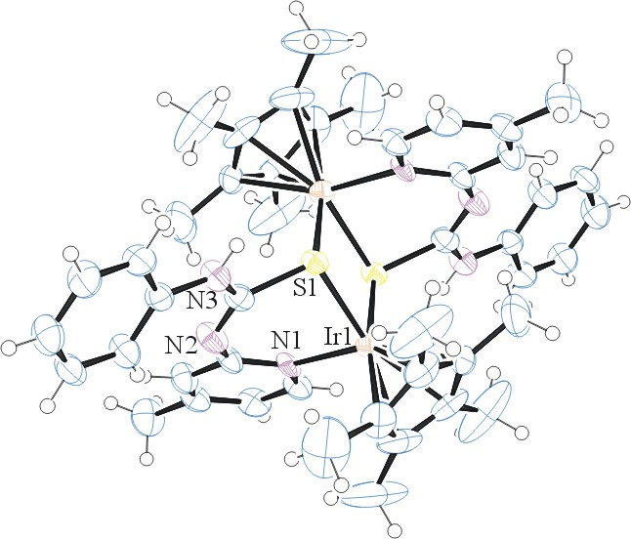
Figure 1. ORTEP of the structure with thermal ellipsoids at the 50% probability level.

Table 1: Crystallographic data for the structures provided.
Empirical formula C46 H54 F12 Ir2 N6 P2 S2
Formula weight 1429.41
Temperature 292(2) K
Wavelength 0.71073 Å
Crystal system Monoclinic
Space group P 2₁/n
Unit cell dimensions a = 11.3318(5) Å α= 90°.
b = 18.0239(7) Å β= 110.620(2)°.
c = 13.3064(5) Å γ = 90°.
Volume 2543.63(18) Å3
Z 2
Density (calculated) 1.866 Mg/m3
Absorption coefficient 5.455 mm-1
F(000) 1392
Crystal size 0.220 x 0.190 x 0.070 mm3
Theta range for data collection 2.790 to 28.280°.
Index ranges -15<=h<=15, -24<=k<=23, -17<=l<=17
Reflections collected 12062
Independent reflections 6171 [R(int) = 0.1090]
Completeness to theta = 25.000° 99.2 %
Refinement method Full-matrix least-squares on F2
Data / restraints / parameters 6171 / 0 / 323
Goodness-of-fit on F2 0.924
Final R indices [I>2sigma(I)] R1 = 0.0448, wR2 = 0.0817
R indices (all data) R1 = 0.1208, wR2 = 0.1048
Extinction coefficient 0.0010(2)
Largest diff. peak and hole 1.851 and -1.921 e.Å-3

Otwinowsky, Z.; Minor, W. In: Methods in Enzymology; Carter, C. W., Jr., Sweet, R. M., Eds.; Academic Press: New York, 1997, 276, 307-326.
(a) Altomare, A.; Burla, C.; Camalli M.; Cascarano L.; Giacovazzo C.; Guagliardi A.; Moliterni A.G.G.; Polidori G.; Spagna R. J. Appl. Cryst. 1999, 32, 115-119; (b) Altomare, A., Cascarano, G., Giacovazzo, C., Guagliardi, A., J. Appl. Cryst. 1993, 26, 343.
Sheldrick GM. (2013) Crystal structure refinement with SHELXL. Acta Cryst. (2015). C71, 3-8.
Mackay, S.; Edwards, C.; Henderson, A.; Gilmore, C.; Stewart, N.; Shankland, K.; Donald, A.; MaXus: a computer program for the solution and refinement of crystal structures from diffraction data. University of Glasgow, Scotland, 1997.
Waasmaier, D.; Kirfel, A. Acta Crystallogr. A. 1995, 51, 416.
Farrugia, L. J. Appl. Cryst. 1997, 30, 565

