Crystal Structure Report for A. Velian
by Dylan Rogers & Werner Kaminsky
Sample Submitted by Jon Kephart
ID – KS30a_90K
X-ray Crystallography Laboratory
University of Washington
29. September 2020

Data Collection started: 9/26/2020
Documentation finished: 9/29/2020

Data backup accessibly through http:
URL: http://cad4.cpac.washington.edu/structures

W.Kaminsky: tel. (206) 543 7585
(x-ray lab): tel. (206) 543 0210
Email: kaminsky@chem.washington.edu

Understanding crystallographic information is not trivial. If you discuss a structure in a publication, please let the crystallographers proof-read the final draft of that manuscript before you submit it.
For many structures it is true that crystallography is an intellectual performance (like synthesis or elucidation of mechanisms) and not a routine job. In these cases, particularly when the structures contribute significantly to the content of the publication, the crystallographers should be co-authors.
A blck prism, measuring 0.20 x 0.07 x 0.07 mm³ was mounted on a loop with oil. Data was collected at -183ºC on a Nonius Kappa CCD FR590 single crystal X-ray diffractometer, Mo-radiation.

Crystal-to-detector distance was 40 mm and exposure time was 150 seconds per degree for all sets. The scan width was 1º. Data collection was 99.2% complete to 25º in ϑ. A total of 53271 merged reflections were collected covering the indices, -21<=h<=21, -23<=k<=23, -29<=l<=29. 27722 reflections were symmetry independent and the R_{int} = 0.1582 indicated that the data was acceptable. Indexing and unit cell refinement indicated a triclinic lattice. The space group was found to be P‾1 (No.2).

The data was integrated and scaled using SAINT, SADABS within the APEX2 software package by Bruker.

Solution by direct methods (SHELXT or SIR) produced a complete heavy atom phasing model consistent with the proposed structure. The structure was completed by difference Fourier synthesis with SHELXL., Scattering factors are from Waasmair and Kirfel. Hydrogen atoms were placed in geometrically idealised positions and constrained to ride on their parent atoms with C---H distances in the range 0.95-1.00 Angstrom. Isotropic thermal parameters U_{eq} were fixed such that they were 1.2U_{eq} of their parent atom Ueq for CH's and 1.5U_{eq} of their parent atom U_{eq} in case of methyl groups. All non-hydrogen atoms were refined anisotropically by full-matrix least-squares.

Except for one DCM solvent molecule that was disordered with a toluene of the complex, contribution to the diffraction pattern of about 19 further DCM molecules in the unit cell was removed with SQUEEZE. The structure required a number of constraints and restraints. All phenyls were optimized with AFIX 66 … AFIX 0 loops. All complex motives P(Ph)2Ntol were related with the SAME command. Similarly, all pyridines within 4,4’bipyridines were coupled with SAME. The C-Cl distances of the disordered DCM were related via the SADI command and several toluenes and pyridine required FLAT restraints. Overall, an ISOR for carbons and nitrogens and a DELU card including carbons, nitrogens and phosphorous was needed. Two toluenes and one bipyridine were disordered, requiring EADP displacement linking for each disordered atom pair, and 45 bad reflections were removed. The structure builds a 2D-dim nano sheet, where Mn of the complexes are linked via bypyridines. No PF₆⁻ was found. The structure is of high quality and ready for publication.
Table 1 summarizes the data collection details. Figure 1 shows an ORTEP of the asymmetric unit.
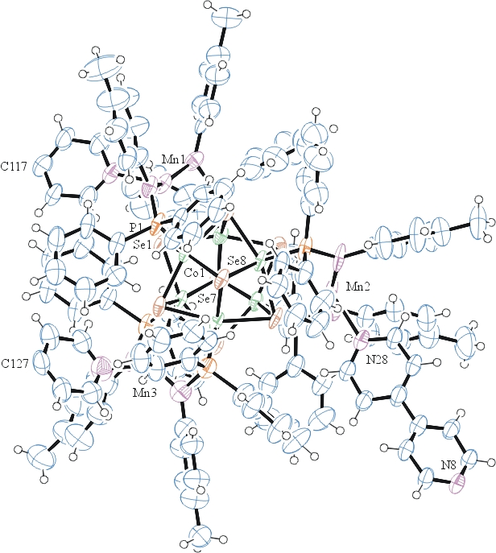
Figure 1. ORTEP of the structure with thermal ellipsoids at the 50% probability level. Disorder and solvent omitted for clarity.

Table 1: Crystallographic data for the structures provided.
Empirical formula C259 H230 Cl2 Co12 Mn6 N18 P12 Se16
Formula weight 6337.30
Temperature 90(2) K
Wavelength 0.71073 Å
Crystal system Triclinic
Space group P -1
Unit cell dimensions a = 17.9736(15) Å α= 88.531(3)°.
b = 19.3810(17) Å β= 80.078(3)°.
c = 24.468(2) Å γ = 70.603(3)°.
Volume 7914.8(12) Å3
Z 1
Density (calculated) 1.330 Mg/m3
Absorption coefficient 2.802 mm-1
F(000) 3142
Crystal size 0.200 x 0.070 x 0.070 mm3
Theta range for data collection 1.220 to 25.027°.
Index ranges -21<=h<=21, -23<=k<=23, -29<=l<=29
Reflections collected 53271
Independent reflections 27722 [R(int) = 0.1582]
Completeness to theta = 25.000° 99.2 %
Refinement method Full-matrix least-squares on F2
Data / restraints / parameters 27722 / 2525 / 1306
Goodness-of-fit on F2 1.037
Final R indices [I>2sigma(I)] R1 = 0.1101, wR2 = 0.2638
R indices (all data) R1 = 0.2463, wR2 = 0.3279
Largest diff. peak and hole 1.829 and -0.819 e.Å-3

Bruker (2007) APEX2 (Version 2.1-4), SAINT (version 7.34A), SADABS (version 2007/4), BrukerAXS Inc, Madison, Wisconsin, USA.
Sheldrick GM. (2015) SHELXT - Integrated space-group and crystal-structure determination. Acta Cryst. A71, 3-8.
(a) Altomare A, Burla C, Camalli M, Cascarano G L, Giacovazzo C, Guagliardi A, Moliterni AGG, Polidori G, Spagna R. (1999) SIR97: a new tool for crystal structure determination and refinement Journal of Applied Crystallography, 32, 115-119. (b) Altomare A, Cascarano G L, Giacovazzo C, Guagliardi A. (1993) Completion and refinement of crystal structures with SIR 92. Journal of Applied Crystallography, 26, 343-350.
(a) Sheldrick GM. (1997) SHELXL-97, Program for the Refinement of Crystal Structures. University of Göttingen, Germany. (b) Sheldrick GM. (2015) Crystal structure refinement with SHELXL. Acta Cryst. (2015). C71, 3–8
Mackay, S.; Edwards, C.; Henderson, A.; Gilmore, C.; Stewart, N.; Shankland, K.; Donald, A. (1997) MaXus: a computer program for the solution and refinement of crystal structures from diffraction data. University of Glasgow, Scotland,.
Waasmaier, D.; Kirfel, A. Acta Crystallogr. A. 1995, 51, 416.
(a) A. Spek, J. Appl. Cryst. (2003), 36, 7-13; (b) P. van der Sluis & A. L. Spek, Acta Cryst. (1990). A46, 194-201. (c) Spek, A. L. (2009). Acta. Cryst. D65, 148-155.
Farrugia, L. J. Appl. Cryst. 1997, 30, 565

