Crystal Structure Report for S Jenekhe
by Werner Kaminsky
Sample Submitted by Xiaomei Ding
ID – LTX_hd
X-ray Crystallography Laboratory
University of Washington
31. July 2026

Data Collection started: 4/12/2021
Documentation finished: 5/10/2021

Data backup accessibly through http:
URL: http://cad4.cpac.washington.edu/structures

W.Kaminsky: tel. (206) 543 7585
(x-ray lab): tel. (206) 543 0210
Email: kaminsky@chem.washington.edu

Understanding crystallographic information is not trivial. If you discuss a structure in a publication, please let the crystallographers proof-read the final draft of that manuscript before you submit it.
For many structures it is true that crystallography is an intellectual performance (like synthesis or elucidation of mechanisms) and not a routine job. In these cases, particularly when the structures contribute significantly to the content of the publication, the crystallographers should be co-authors. Do not think this is not necessary because you pay for structures.
A black prism, measuring 0.30 x 0.25 x 0.10 mm³ was mounted on a loop with oil. Data was collected at -173ºC on a Bruker APEX II single crystal X-ray diffractometer, Mo-radiation.

Crystal-to-detector distance was 40 mm and exposure time was 150 seconds per frame for all sets. The scan width was 0.75º. Data collection was 100% complete to 20.816º in ϑ. A total of 13825 reflections were collected covering the indices, -35<=h<=30, 0<=k<=66, 0<=l<=22, R_{int} = 0.1893 indicated that the data was very weak. Indexing and unit cell refinement indicated a C-centered monoclinic lattice. The space group was found to be Cc (No. 9).

The data was integrated and scaled using SAINT, SADABS within the APEX2 software package by Bruker.

The contribution of disordered solvent to the diffraction pattern was removed with SQUEEZE

Solution by direct methods (SHELXT or SIR97) produced a complete heavy atom phasing model consistent with the proposed structure. The structure was completed by difference Fourier synthesis with SHELXL., Scattering factors are from Waasmair and Kirfel. Hydrogen atoms were placed in geometrically idealised positions and constrained to ride on their parent atoms with C---H distances in the range 0.95-1.00 Angstrom. Isotropic thermal parameters U_{eq} were fixed such that they were 1.2U_{eq} of their parent atom Ueq for CH's and 1.5U_{eq} of their parent atom U_{eq} in case of methyl groups. All non-hydrogen atoms were refined anisotropically by full-matrix least-squares.

The side chains appear to be close and disordered, which was not resolvable due to the weakness of the data.

The structure is of such limited quality that publication is only possible with a reclaimer that the data provided ocan only be used to confirm connectivity.

Table 1 summarizes the data collection details. Figure 1 shows an ORTEP of the asymmetric unit.

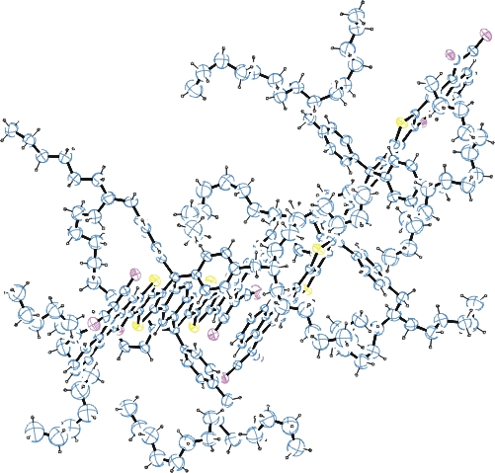
Figure 1. ORTEP of the structure with thermal ellipsoids at the 5% probability level. Disorder omitted for clarity.

Table 1: Crystallographic data for the structures provided.
Empirical formula C134 H160 N6 S4
Formula weight 1982.91
Temperature 100(2) K
Wavelength 0.71073 Å
Crystal system Monoclinic
Space group C c
Unit cell dimensions a = 29.872(4) Å α= 90°.
b = 55.816(9) Å β= 122.556(7)°.
c = 18.769(2) Å γ = 90°.
Volume 26377(7) Å3
Z 8
Density (calculated) 0.999 Mg/m3
Absorption coefficient 0.118 mm-1
F(000) 8560
Crystal size 0.300 x 0.150 x 0.100 mm3
Theta range for data collection 1.361 to 20.816°.
Index ranges -35<=h<=30, 0<=k<=66, 0<=l<=22
Reflections collected 13825
Independent reflections 13825 [R(int) = 0.1893]
Completeness to theta = 20.816° 100.0 %
Refinement method Full-matrix least-squares on F2
Data / restraints / parameters 13825 / 6861 / 2449
Goodness-of-fit on F2 1.082
Final R indices [I>2sigma(I)] R1 = 0.2014, wR2 = 0.4160
R indices (all data) R1 = 0.4699, wR2 = 0.5770
Absolute structure parameter 0.8(6)
Largest diff. peak and hole 0.592 and -0.446 e.Å-3

Bruker (2007) APEX2 (Version 2.1-4), SAINT (version 7.34A), SADABS (version 2007/4), BrukerAXS Inc, Madison, Wisconsin, USA.
(a) A. Spek, J. Appl. Cryst. (2003), 36, 7-13; (b) P. van der Sluis & A. L. Spek, Acta Cryst. (1990). A46, 194-201. (c) Spek, A. L. (2009). Acta. Cryst. D65, 148-155.
Sheldrick GM. (2015) SHELXT - Integrated space-group and crystal-structure determination. Acta Cryst. A71, 3-8.
(a) Altomare A, Burla C, Camalli M, Cascarano G L, Giacovazzo C, Guagliardi A, Moliterni AGG, Polidori G, Spagna R. (1999) SIR97: a new tool for crystal structure determination and refinement Journal of Applied Crystallography, 32, 115-119. (b) Altomare A, Cascarano G L, Giacovazzo C, Guagliardi A. (1993) Completion and refinement of crystal structures with SIR 92. Journal of Applied Crystallography, 26, 343-350.
(a) Sheldrick GM. (1997) SHELXL-97, Program for the Refinement of Crystal Structures. University of Göttingen, Germany. (b) Sheldrick GM. (2015) Crystal structure refinement with SHELXL. Acta Cryst. (2015). C71, 3–8
Mackay, S.; Edwards, C.; Henderson, A.; Gilmore, C.; Stewart, N.; Shankland, K.; Donald, A. (1997) MaXus: a computer program for the solution and refinement of crystal structures from diffraction data. University of Glasgow, Scotland,.
Waasmaier, D.; Kirfel, A. (1995) New Analytical Scattering Factor Functions for Free Atoms and Ions. Acta Crystallographica A., 51, 416-430.
Farrugia LJ. (1997) Ortep-3 for Windows. Journal of Applied Crystallography, 30, 565

