Crystal Structure Report for A Jen
by Werner Kaminsky
Sample Submitted by ZongLong Zhu
ID – MASn75Pb25I3
X-ray Crystallography Laboratory
University of Washington
28. July 2026

Data Collection started: 10/28/2016
Documentation finished: 11/1/2016

Data backup accessibly through http:
URL: http://cad4.cpac.washington.edu/structures

W.Kaminsky: tel. (206) 543 7585
(x-ray lab): tel. (206) 543 0210
Email: kaminsky@chem.washington.edu

Understanding crystallographic information is not trivial. If you discuss a structure in a publication, please let the crystallographers proof-read the final draft of that manuscript before you submit it.
For many structures it is true that crystallography is an intellectual performance (like synthesis or elucidation of mechanisms) and not a routine job. In these cases, particularly when the structures contribute significantly to the content of the publication, the crystallographers should be co-authors. Do not think this is not necessary because you pay for structures.
A black prism, measuring 0.06 x 0.04 x 0.04 mm³ was mounted on a loop with oil. Data was collected at -173ºC on a Bruker APEX II single crystal X-ray diffractometer, Mo-radiation.

Crystal-to-detector distance was 40 mm and exposure time was 10 seconds per frame for all sets. The scan width was 1º. Data collection was 98.0 % complete to 25º in ϑ. A total of 13402 reflections were collected covering the indices, -11<=h<=11, -11<=k<=11, -16<=l<=16. xxx reflections were symmetry independent and the R_{int} = 0.0349 indicated that the data was of excellent quality. Indexing and unit cell refinement indicated a body centered tetragonal lattice. The space group was found to be I‾4 c 2 (No.120).

The data was integrated and scaled using SAINT, SADABS within the APEX2 software package by Bruker.

Solution by direct methods (SHELXS, SIR97) produced a complete heavy atom phasing model consistent with the proposed structure. The structure was completed by difference Fourier synthesis with SHELXL97., Scattering factors are from Waasmair and Kirfel. Hydrogen atoms were placed in geometrically idealised positions and constrained to ride on their parent atoms with C---H distances in the range 0.95-1.00 Angstrom. Isotropic thermal parameters U_{eq} were fixed such that they were 1.2U_{eq} of their parent atom Ueq for CH's and 1.5U_{eq} of their parent atom U_{eq} in case of methyl groups. All non-hydrogen atoms were refined anisotropically by full-matrix least-squares.

Merohedral twinning is (mostly) resolved via matrix (-½ -½ -½,-½ -½ ½, -1 1 0) in addition to 90-degree rotation twinning about the c-axis, which mimics a pseudo-cubic symmetry and 4-fold disordered CH3NH3. One of the iodines is disordered over two slightly displaced locations.
The amount of tin versus lead was refined to 87(3)%.

The structure is of high quality and ready for publication. Table 1 summarizes the data collection details. Figure 1 shows an ORTEP of the asymmetric unit.

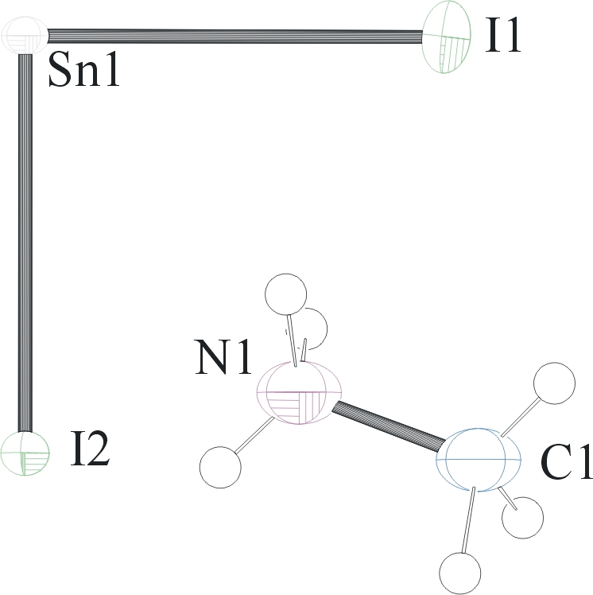
Figure 1. ORTEP of the structure with thermal ellipsoids at the 50% probability level. Disorder omitted for clarity.

Table 1: Crystallographic data for the structures provided.
Empirical formula C H6 I3 N Pb0.14 Sn0.86
Formula weight 544.07
Temperature 100(2) K
Wavelength 0.71073 Å
Crystal system Tetragonal
Space group I -4 c 2
Unit cell dimensions a = 8.7418(9) Å α= 90°.
b = 8.7418(9) Å β= 90°.
c = 12.4354(14) Å γ = 90°.
Volume 950.30(17) Å3
Z 4
Density (calculated) 3.803 Mg/m3
Absorption coefficient 14.494 mm-1
F(000) 930
Crystal size 0.06 x 0.04 x 0.04 mm3
Theta range for data collection 2.85 to 28.32°.
Index ranges -11<=h<=11, -11<=k<=11, -16<=l<=16
Reflections collected 13402
Independent reflections 620 [R(int) = 0.0349]
Completeness to theta = 25.00° 98.0 %
Max. and min. transmission 0.5948 and 0.4767
Refinement method Full-matrix least-squares on F2
Data / restraints / parameters 620 / 26 / 22
Goodness-of-fit on F2 1.111
Final R indices [I>2sigma(I)] R1 = 0.0685, wR2 = 0.1787
R indices (all data) R1 = 0.0698, wR2 = 0.1808
Absolute structure parameter 0.00
Largest diff. peak and hole 3.078 and -3.064 e.Å-3

Bruker (2007) APEX2 (Version 2.1-4), SAINT (version 7.34A), SADABS (version 2007/4), BrukerAXS Inc, Madison, Wisconsin, USA.
(a) Altomare A, Burla C, Camalli M, Cascarano G L, Giacovazzo C, Guagliardi A, Moliterni AGG, Polidori G, Spagna R. (1999) SIR97: a new tool for crystal structure determination and refinement Journal of Applied Crystallography, 32, 115-119. (b) Altomare A, Cascarano G L, Giacovazzo C, Guagliardi A. (1993) Completion and refinement of crystal structures with SIR 92. Journal of Applied Crystallography, 26, 343-350.
(a) Sheldrick GM. (1997) SHELXL-97, Program for the Refinement of Crystal Structures. University of Göttingen, Germany. (b) Sheldrick GM. (2013) Crystal structure refinement with SHELXL. Acta Cryst. (2015). C71, 3-8.
Mackay, S.; Edwards, C.; Henderson, A.; Gilmore, C.; Stewart, N.; Shankland, K.; Donald, A. (1997) MaXus: a computer program for the solution and refinement of crystal structures from diffraction data. University of Glasgow, Scotland,.
Waasmaier, D.; Kirfel, A. (1995) New Analytical Scattering Factor Functions for Free Atoms and Ions. Acta Crystallographica A., 51, 416-430.
Farrugia LJ. (1997) Ortep-3 for Windows. Journal of Applied Crystallography, 30, 565

