Crystal Structure Report for K Goldberg
by Werner Kaminsky
Sample Submitted by M Johnson
ID – MJ253
X-ray Crystallography Laboratory
University of Washington
31. July 2026

Data Collection started: 4/14/2015
Documentation finished: 4/22/2015

Data backup accessibly through http:
URL: http://cad4.cpac.washington.edu/structures

W.Kaminsky: tel. (206) 543 7585
(x-ray lab): tel. (206) 543 0210
Email: kaminsky@chem.washington.edu

Understanding crystallographic information is not trivial. If you discuss a structure in a publication, please let the crystallographers proof-read the final draft of that manuscript before you submit it.
For many structures it is true that crystallography is an intellectual performance (like synthesis or elucidation of mechanisms) and not a routine job. In these cases, particularly when the structures contribute significantly to the content of the publication, the crystallographers should be co-authors. Do not think this is not necessary because you pay for structures. Even I have to pay for my own structures for my research.
A yellow piece, measuring 0.16 x 0.14 x 0.10 mm³ was mounted on a loop with oil. Data was collected at -183ºC on a Bruker APEX II single crystal X-ray diffractometer, Mo-radiation.

Crystal-to-detector distance was 40 mm and exposure time was 10 seconds per frame for all sets. The scan width was 0.5º. Data collection was 92.4 % complete to 25º in ϑ. A total of 104506 reflections were collected covering the indices, h = -23 to 23, k = -23to 23, l = -21 to 21. 3120 reflections were symmetry independent and the R_{int} = 0.0689 indicated that the data was of average quality 0.07. Indexing and unit cell refinement indicated a body centered tetragonal lattice. The space group was found to be I 4₁ m d (No.109).

The data was integrated and scaled using SAINT, SADABS within the APEX2 software package by Bruker.

Solution by direct methods (SHELXS, SIR97) produced a complete heavy atom phasing model consistent with the proposed structure. The structure was completed by difference Fourier synthesis with SHELXL97., Scattering factors are from Waasmair and Kirfel. Hydrogen atoms were placed in geometrically idealised positions and constrained to ride on their parent atoms with C---H distances in the range 0.95-1.00 Angstrom. Isotropic thermal parameters U_{eq} were fixed such that they were 1.2U_{eq} of their parent atom Ueq for CH's and 1.5U_{eq} of their parent atom U_{eq} in case of methyl groups. All non-hydrogen atoms were refined anisotropically by full-matrix least-squares.

The crystals tend to grow as merohedral penetration twins, with invisible boundaries. Thus, it was difficult to find an untwinned sample. Void analysis discovered delocalized solvent (18 electrons per 72 Å³ in 4 voids of the unit cell), presumably water, and that contribution to the diffraction pattern was removed with SQEEZE. The molecule exhibits mirror symmetry through the Rh and phenyl. Elongated displacement ellipsoids especially of the methoxy group indicate some librative motion, indistinguishable from positional disorder. The chloroform hydrogen bonds to Cl2, the disordered methyl hydrogens on C15 ‘face’ the chlorides of the chloroform, with distances narrowly outside hydrogen bonding.

The structure is of high quality and ready for publication. Table 1 summarizes the data collection details. Figure 1 shows an ORTEP of the asymmetric unit.

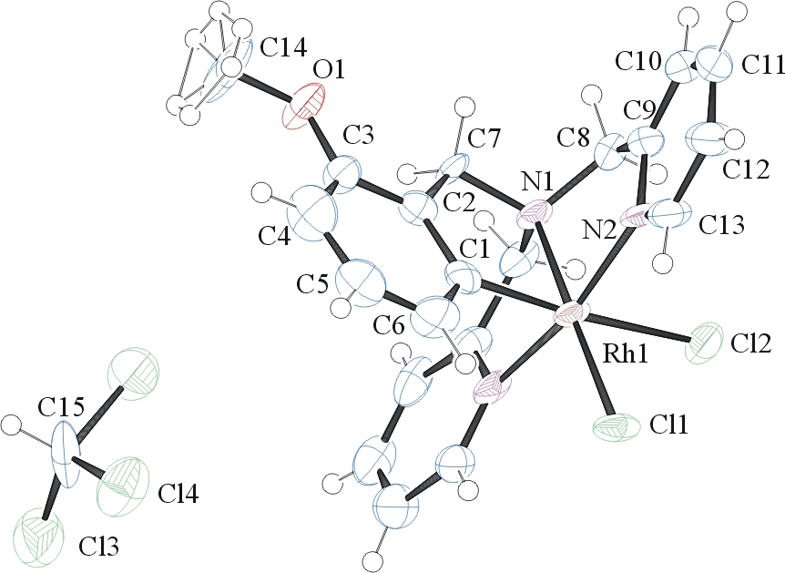

Figure 1. ORTEP of the structure with thermal ellipsoids at the 50% probability level.

Table 1: Crystallographic data for the structures provided.
Empirical formula C21 H21 Cl5 N3 O Rh
Formula weight 611.57
Temperature 296(2) K
Wavelength 0.71073 Å
Crystal system Tetragonal
Space group I 41 m d
Unit cell dimensions a = 17.8815(8) Å α= 90°.
b = 17.8815(8) Å β= 90°.
c = 16.0054(11) Å γ = 90°.
Volume 5117.7(5) Å3
Z 8
Density (calculated) 1.587 Mg/m3
Absorption coefficient 1.208 mm-1
F(000) 2448
Crystal size 0.16 x 0.14 x 0.10 mm3
Theta range for data collection 1.71 to 28.37°.
Index ranges -23<=h<=23, -23<=k<=23, -21<=l<=21
Reflections collected 104506
Independent reflections 3120 [R(int) = 0.0689]
Completeness to theta = 25.00° 92.4 %
Max. and min. transmission 0.8888 and 0.8302
Refinement method Full-matrix least-squares on F2
Data / restraints / parameters 3120 / 1 / 163
Goodness-of-fit on F2 1.062
Final R indices [I>2sigma(I)] R1 = 0.0526, wR2 = 0.1325
R indices (all data) R1 = 0.0544, wR2 = 0.1342
Absolute structure parameter -0.06(6)
Largest diff. peak and hole 2.164 and -1.610 e.Å-3

Bruker (2007) APEX2 (Version 2.1-4), SAINT (version 7.34A), SADABS (version 2007/4), BrukerAXS Inc, Madison, Wisconsin, USA.
(a) Altomare A, Burla C, Camalli M, Cascarano G L, Giacovazzo C, Guagliardi A, Moliterni AGG, Polidori G, Spagna R. (1999) SIR97: a new tool for crystal structure determination and refinement Journal of Applied Crystallography, 32, 115-119. (b) Altomare A, Cascarano G L, Giacovazzo C, Guagliardi A. (1993) Completion and refinement of crystal structures with SIR 92. Journal of Applied Crystallography, 26, 343-350.
Sheldrick GM. (1997) SHELXL-97, Program for the Refinement of Crystal Structures. University of Göttingen, Germany.
Mackay, S.; Edwards, C.; Henderson, A.; Gilmore, C.; Stewart, N.; Shankland, K.; Donald, A. (1997) MaXus: a computer program for the solution and refinement of crystal structures from diffraction data. University of Glasgow, Scotland,.
Waasmaier, D.; Kirfel, A. (1995) New Analytical Scattering Factor Functions for Free Atoms and Ions. Acta Crystallographica A., 51, 416-430.
A. Spek, J. Appl. Cryst. (2003), 36, 7-13; P. van der Sluis & A. L. Spek, Acta Cryst. (1990). A46, 194-201.
Farrugia LJ. (1997) Ortep-3 for Windows. Journal of Applied Crystallography, 30, 565

