Crystal Structure Report for D. Reed
by W. Kaminsky & S. Krajewski
Sample Submitted by Jay Lee
ID – MK_6_13E_MeOH
X-ray Crystallography Laboratory
University of Washington
29. July 2026

Data Collection started: 4/3/2025
Documentation finished: 5/15/2025

Data backup accessibly through http:
URL: http://cad4.cpac.washington.edu/structures

W.Kaminsky: tel. (206) 543 7585
(x-ray lab): tel. (206) 543 0210
Email: kaminsky@chem.washington.edu

Understanding crystallographic information is not trivial. If you discuss a structure in a publication, please let the crystallographers proof-read the final draft of that manuscript before you submit it.
For many structures it is true that crystallography is an intellectual performance (like synthesis or elucidation of mechanisms) and not a routine job. In these cases, particularly when the structures contribute significantly to the content of the publication, the crystallographers should be co-authors. Do not think this is not necessary because you pay for structures.
A tiny green prism, measuring 0.10 x 0.09 x 0.06 mm³ was mounted on a loop with oil. Data was collected at -173ºC on a Bruker APEX II single crystal X-ray diffractometer, Mo-radiation, equipped with a Miracol X-ray optical collimator.

Crystal-to-detector distance was 40 mm and exposure time was 120 seconds per frame for all sets. The scan width was 0.6º. Data collection was 100% complete to 18.843º in ϑ. A total of 17942 unique reflections were collected covering the indices, -28<=h<=28, -28<=k<=28, -49<=l<=49 with R_{int} = 0.1682 indicated that the data problematic to say the least (average quality 0.07). Indexing and unit cell refinement indicated a body centered tetragonal lattice. The space group was found to be I 4 (No. 79).

The data was integrated and scaled using SAINT, SADABS within the APEX2 software package by Bruker.

Solution by direct methods (SHELXT or SIR97) produced a complete heavy atom phasing model consistent with the proposed structure. The structure was completed by difference Fourier synthesis with SHELXL. Scattering factors are from Waasmair and Kirfel. Hydrogen atoms were placed in geometrically idealised positions and constrained to ride on their parent atoms with C---H distances in the range 0.95-1.00 Angstrom. Isotropic thermal parameters U_{eq} were fixed such that they were 1.2U_{eq} of their parent atom Ueq for CH's and 1.5U_{eq} of their parent atom U_{eq} in case of methyl groups. All non-hydrogen atoms were refined anisotropically by full-matrix least-squares.

The presence of racemic (almost) 1:1 twinning caused problems in finding the correct space group, however, I 4/m was not solving at all, so we settled on I4 with above-described twinning. The data is very weak, thus the molecular model required intensive restraining and additional disorder modelling was not possible.

The large spherical complex encapsulates large voids filled with disordered solvent. Almost all Cu-bonded ligands are disordered as well. As a result, the structure scatters similar to a 'hot' structure, where it is known that diffraction intensities decrease at larger Bragg angles and the diffusion background increases. Thus, even prolonged exposure to X-Rays will not increase the resolution. Thus, only data to a resolution of 1.1 Angstrom was observed and used for the refinement. However, we believe to have derived a valid model of the molecule.
The contribution of disordered solvent to the diffraction pattern was removed with SQUEEZE

The structure is of lower quality but may be publishable. Table 1 summarizes the data collection details. Figure 1 shows an ORTEP of the asymmetric unit.

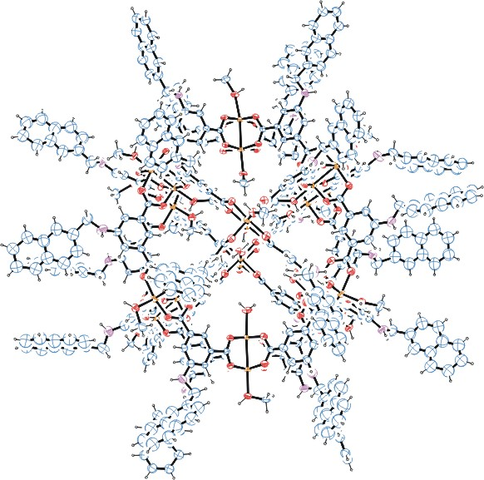
Figure 1. ORTEP of the structure with thermal ellipsoids at the 15% probability level.

Table 1: Crystallographic data for the structures provided.
Empirical formula C476 H400 Cu24 N24 O120
Formula weight 9901.14
Temperature 100(2) K
Wavelength 0.71073 Å
Crystal system Tetragonal
Space group I 4
Unit cell dimensions a = 29.746(4) Å α= 90°.
b = 29.746(4) Å β= 90°.
c = 51.467(7) Å γ = 90°.
Volume 45540(12) Å3
Z 2
Density (calculated) 0.722 Mg/m3
Absorption coefficient 0.590 mm-1
F(000) 10160
Crystal size 0.100 x 0.090 x 0.060 mm3
Theta range for data collection 0.791 to 18.843°.
Index ranges -28<=h<=28, -28<=k<=28, -49<=l<=49
Reflections collected 17942
Independent reflections 17942 [R(int) = 0.1682]
Completeness to theta = 18.843° 100.0 %
Refinement method Full-matrix least-squares on F2
Data / restraints / parameters 17942 / 2387 / 1307
Goodness-of-fit on F2 0.817
Final R indices [I>2sigma(I)] R1 = 0.1016, wR2 = 0.2477
R indices (all data) R1 = 0.2590, wR2 = 0.3132
Absolute structure parameter 0.53(5)
Largest diff. peak and hole 0.632 and -0.384 e.Å-3

Bruker (2007) APEX2 (Version 2.1-4), SAINT (version 7.34A), SADABS (version 2007/4), BrukerAXS Inc, Madison, Wisconsin, USA.
(a) Sheldrick GM. (2008) A short history of SHELX. Acta Cryst. A64, 112-122. (b) Sheldrick GM. (2015) SHELXT - Integrated space-group and crystal-structure determination. Acta Cryst. A71, 3-8.
(a) Altomare A, Burla C, Camalli M, Cascarano G L, Giacovazzo C, Guagliardi A, Moliterni AGG, Polidori G, Spagna R. (1999) SIR97: a new tool for crystal structure determination and refinement Journal of Applied Crystallography, 32, 115-119. (b) Altomare A, Cascarano G L, Giacovazzo C, Guagliardi A. (1993) Completion and refinement of crystal structures with SIR 92. Journal of Applied Crystallography, 26, 343-350.
(a) Sheldrick GM. (1997) SHELXL-97, Program for the Refinement of Crystal Structures. University of Göttingen, Germany. (b) Sheldrick GM. (2015) Crystal structure refinement with SHELXL. Acta Cryst. C71, 3–8
Waasmaier, D.; Kirfel, A. (1995) New Analytical Scattering Factor Functions for Free Atoms and Ions. Acta Crystallographica A., 51, 416-430.
(a) A. Spek, J. Appl. Cryst. (2003), 36, 7-13; (b) P. van der Sluis & A. L. Spek, Acta Cryst. (1990). A46, 194-201. (c) Spek, A. L. (2009). Acta. Cryst. D65, 148-155.
Farrugia LJ. (1997) Ortep-3 for Windows. Journal of Applied Crystallography, 30, 565

