Crystal Structure Report for D. Reed
by Sebastian Krajewski and
Werner Kaminsky
Sample Submitted by Jay Lee
ID – MK_6_7A
X-ray Crystallography Laboratory
University of Washington
30. July 2026

Data Collection started: 3/6/2025
Documentation finished: 3/20/2025

Data backup accessibly through http:
URL: http://cad4.cpac.washington.edu/structures

W.Kaminsky: tel. (206) 543 7585
(x-ray lab): tel. (206) 543 0210
Email: kaminsky@chem.washington.edu

Understanding crystallographic information is not trivial. If you discuss a structure in a publication, please let the crystallographers proof-read the final draft of that manuscript before you submit it.
For many structures it is true that crystallography is an intellectual performance (like synthesis or elucidation of mechanisms) and not a routine job. In these cases, particularly when the structures contribute significantly to the content of the publication, the crystallographers should be co-authors. Do not think this is not necessary because you pay for structures.
A green block, measuring 0.25 x 0.19 x 0.18 mm³ was mounted on a loop with oil. Data was collected at -173ºC on a Bruker APEX II single crystal X-ray diffractometer, Mo-radiation, equipped with a Miracol X-ray optical collimator.

Crystal-to-detector distance was 40 mm and exposure time was 60 seconds per frame for all sets. The scan width was 0.5º. Data collection was 99.6% complete to 25º in ϑ. A total of 38969 merged reflections were collected covering the indices, 0<=h<=34, 0<=k<=34, -63<=l<=64. 19741 reflections were symmetry independent and the R_{int} = 0.2183 indicated that the data was challenging. Indexing and unit cell refinement indicated a body centered tetragonal lattice. The space group was found to be I 4/m (No. 87).

The data was integrated and scaled using SAINT, SADABS within the APEX2 software package by Bruker.

Solution by direct methods (SHELXT or SIR97) produced a complete heavy atom phasing model consistent with the proposed structure. The structure was completed by difference Fourier synthesis with SHELXL. Scattering factors are from Waasmair and Kirfel. Hydrogen atoms were placed in geometrically idealised positions and constrained to ride on their parent atoms with C---H distances in the range 0.95-1.00 Angstrom. Isotropic thermal parameters U_{eq} were fixed such that they were 1.2U_{eq} of their parent atom Ueq for CH's and 1.5U_{eq} of their parent atom U_{eq} in case of methyl groups. All non-hydrogen atoms were refined anisotropically by full-matrix least-squares.

The molecule exhibits massive disorder and contains liquid solvent. As a result, diffuse scattering is high and high theta angle diffraction data becomes invisible, regardles of exposure time and beam intensity. Thus high angle diffraction data is mostly missing.

The full molecule is generated from the content of the asymmetric unit via four symmetry operations. Several CO2 groups are brought into bonding to Cu via space group symmetries, thus, symmetry operations are needed to get some Oxygen atoms into a bonding position.

The contribution of some disordered solvent to the diffraction pattern was removed with SQUEEZE

The structure is of lower quality and the explanation given above should be given in the supplementary if being published. Table 1 summarizes the data collection details. Figure 1 shows an ORTEP of the asymmetric unit.

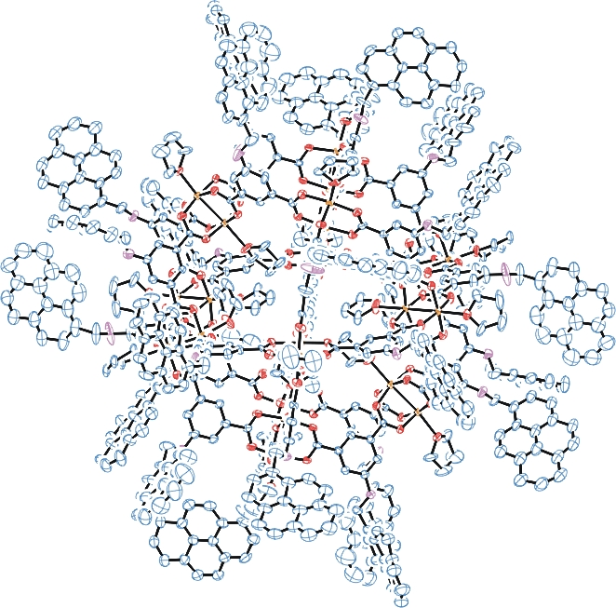
Figure 1. ORTEP of the structure with thermal ellipsoids at the 5% probability level. Hydrogen atoms, disorder and solvent omitted for clarity.

Table 1: Crystallographic data for the structures provided.
Empirical formula C696 H552 Cu24 N24 O120
Formula weight 12696.54
Temperature 100(2) K
Wavelength 0.71073 Å
Crystal system Tetragonal
Space group I 4/m
Unit cell dimensions a = 28.5637(17) Å α= 90°.
b = 28.5637(17) Å β= 90°.
c = 53.726(4) Å γ = 90°.
Volume 43834(6) Å3
Z 2
Density (calculated) 0.962 Mg/m3
Absorption coefficient 0.625 mm-1
F(000) 13104
Crystal size 0.250 x 0.190 x 0.180 mm3
Theta range for data collection 0.758 to 25.119°.
Index ranges 0<=h<=34, 0<=k<=34, -63<=l<=64
Reflections collected 38969
Independent reflections 19741 [R(int) = 0.2183]
Completeness to theta = 25.119° 99.6 %
Refinement method Full-matrix least-squares on F2
Data / restraints / parameters 19741 / 2608 / 1217
Goodness-of-fit on F2 0.881
Final R indices [I>2sigma(I)] R1 = 0.1347, wR2 = 0.3330
R indices (all data) R1 = 0.3535, wR2 = 0.4282
Largest diff. peak and hole 0.959 and -0.734 e.Å-3

Bruker (2007) APEX2 (Version 2.1-4), SAINT (version 7.34A), SADABS (version 2007/4), BrukerAXS Inc, Madison, Wisconsin, USA.
(a) Sheldrick GM. (2008) A short history of SHELX. Acta Cryst. A64, 112-122. (b) Sheldrick GM. (2015) SHELXT - Integrated space-group and crystal-structure determination. Acta Cryst. A71, 3-8.
(a) Altomare A, Burla C, Camalli M, Cascarano G L, Giacovazzo C, Guagliardi A, Moliterni AGG, Polidori G, Spagna R. (1999) SIR97: a new tool for crystal structure determination and refinement Journal of Applied Crystallography, 32, 115-119. (b) Altomare A, Cascarano G L, Giacovazzo C, Guagliardi A. (1993) Completion and refinement of crystal structures with SIR 92. Journal of Applied Crystallography, 26, 343-350.
(a) Sheldrick GM. (1997) SHELXL-97, Program for the Refinement of Crystal Structures. University of Göttingen, Germany. (b) Sheldrick GM. (2015) Crystal structure refinement with SHELXL. Acta Cryst. C71, 3–8
Waasmaier, D.; Kirfel, A. (1995) New Analytical Scattering Factor Functions for Free Atoms and Ions. Acta Crystallographica A., 51, 416-430.
(a) A. Spek, J. Appl. Cryst. (2003), 36, 7-13; (b) P. van der Sluis & A. L. Spek, Acta Cryst. (1990). A46, 194-201. (c) Spek, A. L. (2009). Acta. Cryst. D65, 148-155.
Farrugia LJ. (1997) Ortep-3 for Windows. Journal of Applied Crystallography, 30, 565

