Crystal Structure Report for J Kovacs
by Sebastian Krajewski &
Werner Kaminsky
Sample Submitted by Maike Blakely
ID – MB1050_2
X-ray Crystallography Laboratory
University of Washington
28. July 2026

Data Collection started:
Documentation finished:

Data backup accessibly through http:
URL: http://cad4.cpac.washington.edu/structures

W.Kaminsky: tel. (206) 543 7585
(x-ray lab): tel. (206) 543 0210
Email: kaminsky@chem.washington.edu

Understanding crystallographic information is not trivial. If you discuss a structure in a publication, please let the crystallographers proof-read the final draft of that manuscript before you submit it.
For many structures it is true that crystallography is an intellectual performance (like synthesis or elucidation of mechanisms) and not a routine job. In these cases, particularly when the structures contribute significantly to the content of the publication, the crystallographers should be co-authors. Do not think this is not necessary because you pay for structures.
A green shard, measuring 0.09 x 0.04 x 0.02 mm³ was mounted on a loop with oil. Data was collected at -173ºC on a Bruker APEX II single crystal X-ray diffractometer, Mo-radiation, equipped with a Miracol X-ray optical collimator.

Crystal-to-detector distance was 40 mm and exposure time was 120 seconds per frame for all sets. The scan width was 0.5º. Data collection was 99.8 % complete to 25º in ϑ. A total of 7393 merged reflections were collected covering the indices, -12<=h<=12, -13<=k<=13, -12<=l<=12. 3721 reflections were symmetry independent and the R_{int} = 0.1058 indicated that there were some problemse (average quality 0.07). Indexing and unit cell refinement indicated a triclinic lattice. The space group was found to be P‾1 (No. 2).

The data appeared twinned via 180 degrees about [0 0 1] (CELL_NOW) and after multi-domain integration (SAINT, SADABS within the APEX2 software package by Bruker) the data was merged utilizing twinabs.

Solution by direct methods (SHELXT or SIR97) produced a complete heavy atom phasing model consistent with the proposed structure. The structure was completed by difference Fourier synthesis with SHELXL. Scattering factors are from Waasmair and Kirfel. Hydrogen atoms were placed in geometrically idealised positions and constrained to ride on their parent atoms with C---H distances in the range 0.95-1.00 Angstrom. Isotropic thermal parameters U_{eq} were fixed such that they were 1.2U_{eq} of their parent atom Ueq for CH's and 1.5U_{eq} of their parent atom U_{eq} in case of methyl groups. All non-hydrogen atoms were refined anisotropically by full-matrix least-squares.

The detail surrounding N3 is twofold disordered. Some small rest electron density between the two sulfurs may indicate some chemical disorder.

The structure is of high quality and ready for publication. Table 1 summarizes the data collection details. Figure 1 shows an ORTEP of the asymmetric unit.

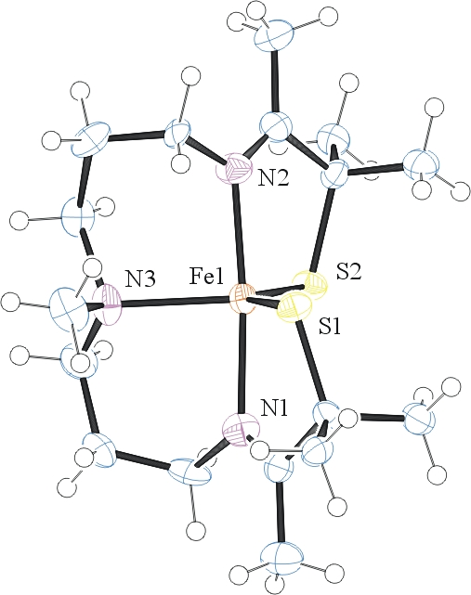
Figure 1. ORTEP of the structure with thermal ellipsoids at the 50% probability level. Disorder omitted for clarity.

Table 1: Crystallographic data for the structures provided.
Empirical formula C17 H33 Fe N3 S2
Formula weight 399.43
Temperature 100(2) K
Wavelength 0.71073 Å
Crystal system Triclinic
Space group P -1
Unit cell dimensions a = 9.999(3) Å α= 77.71(2)°.
b = 11.053(3) Å β= 75.02(2)°.
c = 10.033(3) Å γ = 101.955(19)°.
Volume 1005.4(5) Å3
Z 2
Density (calculated) 1.319 Mg/m3
Absorption coefficient 0.961 mm-1
F(000) 428
Crystal size 0.090 x 0.040 x 0.020 mm3
Theta range for data collection 1.963 to 25.602°.
Index ranges -12<=h<=12, -13<=k<=13, -12<=l<=12
Reflections collected 7393
Independent reflections 3721 [R(int) = 0.1058]
Completeness to theta = 25.242° 99.8 %
Refinement method Full-matrix least-squares on F2
Data / restraints / parameters 3721 / 193 / 276
Goodness-of-fit on F2 1.032
Final R indices [I>2sigma(I)] R1 = 0.0771, wR2 = 0.1425
R indices (all data) R1 = 0.1569, wR2 = 0.1662
Largest diff. peak and hole 0.513 and -0.495 e.Å-3

Sheldrick, G. M. (2005). CELL_NOW. University of Goettingen, Germany.
Bruker (2007) APEX2 (Version 2.1-4), SAINT (version 7.34A), SADABS (version 2007/4), BrukerAXS Inc, Madison, Wisconsin, USA.
Sheldrick, G. M. (2007). TWINABS. University of Goettingen, Germany.
(a) Sheldrick GM. (2008) A short history of SHELX. Acta Cryst. A64, 112-122. (b) Sheldrick GM. (2015) SHELXT - Integrated space-group and crystal-structure determination. Acta Cryst. A71, 3-8.
(a) Altomare A, Burla C, Camalli M, Cascarano G L, Giacovazzo C, Guagliardi A, Moliterni AGG, Polidori G, Spagna R. (1999) SIR97: a new tool for crystal structure determination and refinement Journal of Applied Crystallography, 32, 115-119. (b) Altomare A, Cascarano G L, Giacovazzo C, Guagliardi A. (1993) Completion and refinement of crystal structures with SIR 92. Journal of Applied Crystallography, 26, 343-350.
(a) Sheldrick GM. (1997) SHELXL-97, Program for the Refinement of Crystal Structures. University of Göttingen, Germany. (b) Sheldrick GM. (2015) Crystal structure refinement with SHELXL. Acta Cryst. C71, 3–8
Waasmaier, D.; Kirfel, A. (1995) New Analytical Scattering Factor Functions for Free Atoms and Ions. Acta Crystallographica A., 51, 416-430.
Farrugia LJ. (1997) Ortep-3 for Windows. Journal of Applied Crystallography, 30, 565

