Crystal Structure Report for G. Lalic
by Maike Blakely & Werner Kaminsky
Sample Submitted by Mitchell Lee
ID – MTL_02_148_SIPrIPr
X-ray Crystallography Laboratory
University of Washington
30. July 2026

Data Collection started: 5/1/2017
Documentation finished: 5/25/2017

Data backup accessibly through http:
URL: http://cad4.cpac.washington.edu/structures

W.Kaminsky: tel. (206) 543 7585
(x-ray lab): tel. (206) 543 0210
Email: kaminsky@chem.washington.edu

Understanding crystallographic information is not trivial. If you discuss a structure in a publication, please let the crystallographers proof-read the final draft of that manuscript before you submit it.
For many structures it is true that crystallography is an intellectual performance (like synthesis or elucidation of mechanisms) and not a routine job. In these cases, particularly when the structures contribute significantly to the content of the publication, the crystallographers should be co-authors. Do not think this is not necessary because you pay for structures.
A quite small colorless prism, measuring 0.16 x 0.09 x 0.05 mm³ was mounted on a loop with oil. Data was collected at -173ºC on a Bruker APEX II single crystal X-ray diffractometer, Mo-radiation.

Crystal-to-detector distance was 40 mm and exposure time was 240 seconds per frame for all sets. The scan width was 1º. Data collection was 99.2% complete to 25º in ϑ. A total of 107550 reflections were collected covering the indices, -16<=h<=16, -30<=k<=30, -24<=l<=23. 12760 reflections were symmetry independent and the elevated R_{int} = 0.1544 reflected the small sample size. Indexing and unit cell refinement indicated a primitive monoclinic lattice. The space group was found to be P 2₁/c (No.14).

The data was integrated and scaled using SAINT, SADABS within the APEX2 software package by Bruker.

Solution by direct methods (SHELXS, SIR97) produced a complete heavy atom phasing model consistent with the proposed structure. The structure was completed by difference Fourier synthesis with SHELXL97., Scattering factors are from Waasmair and Kirfel. Hydrogen atoms were placed in geometrically idealised positions and constrained to ride on their parent atoms with C---H distances in the range 0.95-1.00 Angstrom. Isotropic thermal parameters U_{eq} were fixed such that they were 1.2U_{eq} of their parent atom Ueq for CH's and 1.5U_{eq} of their parent atom U_{eq} in case of methyl groups. All non-hydrogen atoms were refined anisotropically by full-matrix least-squares.

The structure appeared disordered, with a major configuration (83.1(4)%) of asymmetrically bonded Cu, whereas the remainder shows a symmetric configuration. Because of disorder, restraints were needed to stabilize the refinement. Hydrogen atoms were mostly visible in the electron density map. Notable, C63 and C64 appeared as aromatic atoms, C2 and C3 as well as C29 and C30 appeared as methylene with equal electron density on the hydrogen positions similar to all other hydrogen atoms. The minor configuration was tested for a shorter C-C bond between C29B and C30B, but the result was inconclusive and hydrogens were assigned as methylene as well. The OTF appears disordered, mostly in response to disordered ethyl ether, of which the contribution to the diffraction pattern was removed from the structure via SQUEEZE.

The structure is of high quality and ready for publication. Table 1 summarizes the data collection details. Figure 1 and 2 show ORTEPs of the asymmetric unit of the major and minor configuration, disordered solvent not shown.

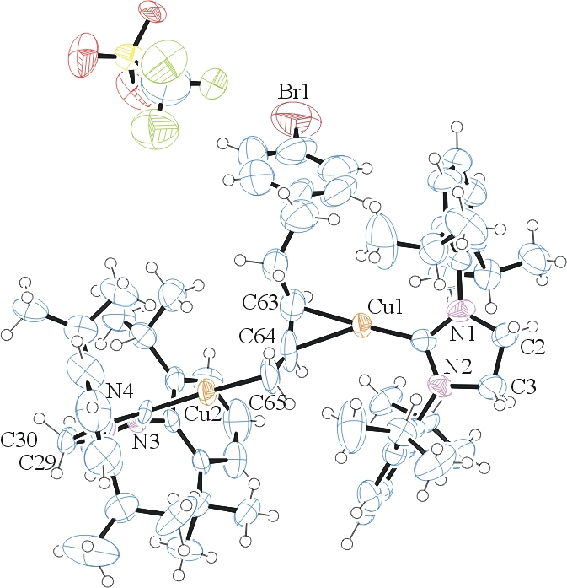
Figure 1. ORTEP of the major configuration with thermal ellipsoids at the 50% probability level.

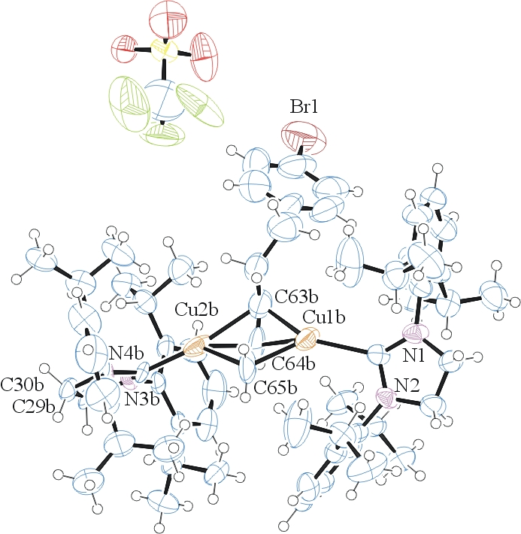Figure 2. ORTEP of the minor configuration with thermal ellipsoids at the 50% probability level.

Table 1: Crystallographic data for the structures provided.
Empirical formula C66 H88 Br Cu2 F3 N4 O3 S
Formula weight 1281.45
Temperature 100(2) K
Wavelength 0.71073 Å
Crystal system Monoclinic
Space group P 2₁/c
Unit cell dimensions a = 14.095(5) Å α= 90.000(5)°.
b = 25.360(5) Å β= 102.528(5)°.
c = 20.126(5) Å γ = 90.000(5)°.
Volume 7023(3) Å3
Z 4
Density (calculated) 1.212 Mg/m3
Absorption coefficient 1.255 mm-1
F(000) 2688
Crystal size 0.16 x 0.09 x 0.05 mm3
Theta range for data collection 1.31 to 25.35°.
Index ranges -16<=h<=16, -30<=k<=30, -24<=l<=23
Reflections collected 107550
Independent reflections 12760 [R(int) = 0.1544]
Completeness to theta = 25.00° 99.2 %
Max. and min. transmission 0.9399 and 0.8244
Refinement method Full-matrix least-squares on F2
Data / restraints / parameters 12760 / 167 / 907
Goodness-of-fit on F2 0.980
Final R indices [I>2sigma(I)] R1 = 0.0974, wR2 = 0.2090
R indices (all data) R1 = 0.2232, wR2 = 0.2579
Largest diff. peak and hole 0.477 and -0.871 e.Å-3

Bruker (2007) APEX2 (Version 2.1-4), SAINT (version 7.34A), SADABS (version 2007/4), BrukerAXS Inc, Madison, Wisconsin, USA.
(a) Altomare A, Burla C, Camalli M, Cascarano G L, Giacovazzo C, Guagliardi A, Moliterni AGG, Polidori G, Spagna R. (1999) SIR97: a new tool for crystal structure determination and refinement Journal of Applied Crystallography, 32, 115-119. (b) Altomare A, Cascarano G L, Giacovazzo C, Guagliardi A. (1993) Completion and refinement of crystal structures with SIR 92. Journal of Applied Crystallography, 26, 343-350.
(a) Sheldrick GM. (1997) SHELXL-97, Program for the Refinement of Crystal Structures. University of Göttingen, Germany. (b) Sheldrick GM. (2013) Crystal structure refinement with SHELXL. Acta Cryst. (2015). C71, 3-8.
Mackay, S.; Edwards, C.; Henderson, A.; Gilmore, C.; Stewart, N.; Shankland, K.; Donald, A. (1997) MaXus: a computer program for the solution and refinement of crystal structures from diffraction data. University of Glasgow, Scotland,.
Waasmaier, D.; Kirfel, A. (1995) New Analytical Scattering Factor Functions for Free Atoms and Ions. Acta Crystallographica A., 51, 416-430.
A. Spek, J. Appl. Cryst. (2003), 36, 7-13; P. van der Sluis & A. L. Spek, Acta Cryst. (1990). A46, 194-201.
Farrugia LJ. (1997) Ortep-3 for Windows. Journal of Applied Crystallography, 30, 565

