Crystal Structure Report for J. Kovacs
by Werner Kaminsky
Sample Submitted by Maks Dedushko
ID – Maks1_O2_5days
X-ray Crystallography Laboratory
University of Washington
28. July 2026

Data Collection started: 7/24/2020
Documentation finished: 8/7/2020

Data backup accessibly through http:
URL: http://cad4.cpac.washington.edu/structures

W.Kaminsky: tel. (206) 543 7585
(x-ray lab): tel. (206) 543 0210
Email: kaminsky@chem.washington.edu

Understanding crystallographic information is not trivial. If you discuss a structure in a publication, please let the crystallographers proof-read the final draft of that manuscript before you submit it.
For many structures it is true that crystallography is an intellectual performance (like synthesis or elucidation of mechanisms) and not a routine job. In these cases, particularly when the structures contribute significantly to the content of the publication, the crystallographers should be co-authors. Do not think this is not necessary because you pay for structures.
A red prism, measuring 0.26 x 0.24 x 0.23 mm³ was exposed to O2 under pressure for 5 days which changed its color to black. It was then mounted on a loop with oil. Data was collected at -173ºC on a Bruker APEX II single crystal X-ray diffractometer, Mo-radiation.

Crystal-to-detector distance was 40 mm and exposure time was 60 seconds per frame for all sets. The scan width was 1º. Data collection was 99.9% complete to 25º in ϑ. A total of 27011 reflections were collected covering the indices, -14<=h<=14, -20<=k<=20, -22<=l<=23. 13800 reflections were symmetry independent and the R_{int} = 0.0855 indicated that the data was acceptable. Indexing and unit cell refinement indicated a pseudo monoclinic triclinic lattice. The space group was found to be P‾1 (No. 2).

The data was integrated and scaled using SAINT, SADABS within the APEX2 software package by Bruker.

Solution by direct methods (SHELXT or SIR97) produced a complete heavy atom phasing model consistent with the proposed structure. The structure was completed by difference Fourier synthesis with SHELXL., Scattering factors are from Waasmair and Kirfel. Hydrogen atoms were placed in geometrically idealised positions and constrained to ride on their parent atoms with C---H distances in the range 0.95-1.00 Angstrom. Isotropic thermal parameters U_{eq} were fixed such that they were 1.2U_{eq} of their parent atom Ueq for CH's and 1.5U_{eq} of their parent atom U_{eq} in case of methyl groups. All non-hydrogen atoms were refined anisotropically by full-matrix least-squares.

The oxygen exposure changed the lattice parameters of the virgin crystal from (see report ‘Maks1’)

a = 11.4965(3) Å / α= 90.7330(10)°.
b = 16.4387(4) Å / β= 90.2660(10)°.
c = 17.7388(5) Å / γ = 102.329(2)°.
Volume 3274.74(15) Å3

To

a = 11.3060(6) Å / α = 90.120(3)°.
b = 16.4874(9) Å / β = 90.020(3)°.
c = 18.4389(10) Å / γ = 100.081(3)°.
Volume 3384.1(3) Å3

The structure was solved with two chemically disordered components, which included two disordered Ph4B-, the structure from ‘Maks1’ as minor component (10.5%, Figure 1) and a new structure featuring two different oxidization products at 89.5% (Figure 2), with one (Fe2B, Fe2B’) bridged with a single oxygen (O6B). The other three molecules also exhibit N-H…S bridged dimerization.

The structure is of sufficient quality ready for publication. Table 1 summarizes the data collection details.
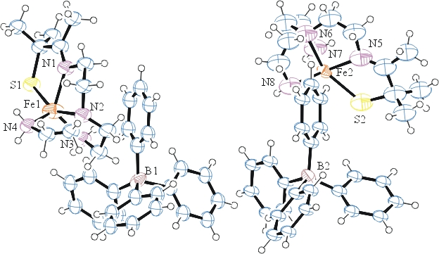
Figure 1. ORTEP of the minor phase similar to ‘Maks1’ with thermal ellipsoids at the 50% probability level.
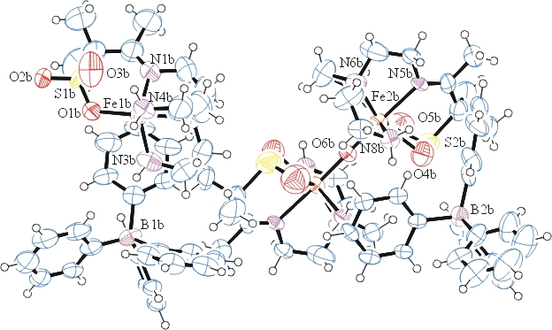
Figure 2. ORTEP of the major phase with thermal ellipsoids at the 50% probability level.

Table 1: Crystallographic data for the structures provided.
Empirical formula C35 H45 B Fe N4 O2.46 S
Formula weight 659.83
Temperature 100(2) K
Wavelength 0.71073 Å
Crystal system Triclinic
Space group P -1
Unit cell dimensions a = 11.3060(6) Å α= 90.120(3)°.
b = 16.4874(9) Å β= 90.020(3)°.
c = 18.4389(10) Å γ = 100.081(3)°.
Volume 3384.1(3) Å3
Z 4
Density (calculated) 1.295 Mg/m3
Absorption coefficient 0.546 mm-1
F(000) 1399
Crystal size 0.260 x 0.240 x 0.230 mm3
Theta range for data collection 1.254 to 26.546°.
Index ranges -14<=h<=14, -20<=k<=20, -22<=l<=23
Reflections collected 27011
Independent reflections 13800 [R(int) = 0.0885]
Completeness to theta = 25.000° 99.9 %
Refinement method Full-matrix least-squares on F2
Data / restraints / parameters 13800 / 574 / 864
Goodness-of-fit on F2 1.048
Final R indices [I>2sigma(I)] R1 = 0.1385, wR2 = 0.3193
R indices (all data) R1 = 0.2550, wR2 = 0.4053
Largest diff. peak and hole 1.235 and -0.683 e.Å-3

Bruker (2007) APEX2 (Version 2.1-4), SAINT (version 7.34A), SADABS (version 2007/4), BrukerAXS Inc, Madison, Wisconsin, USA.
Sheldrick GM. (2015) SHELXT - Integrated space-group and crystal-structure determination. Acta Cryst. A71, 3-8.
(a) Altomare A, Burla C, Camalli M, Cascarano G L, Giacovazzo C, Guagliardi A, Moliterni AGG, Polidori G, Spagna R. (1999) SIR97: a new tool for crystal structure determination and refinement Journal of Applied Crystallography, 32, 115-119. (b) Altomare A, Cascarano G L, Giacovazzo C, Guagliardi A. (1993) Completion and refinement of crystal structures with SIR 92. Journal of Applied Crystallography, 26, 343-350.
(a) Sheldrick GM. (1997) SHELXL-97, Program for the Refinement of Crystal Structures. University of Göttingen, Germany. (b) Sheldrick GM. (2015) Crystal structure refinement with SHELXL. Acta Cryst. (2015). C71, 3–8
Mackay, S.; Edwards, C.; Henderson, A.; Gilmore, C.; Stewart, N.; Shankland, K.; Donald, A. (1997) MaXus: a computer program for the solution and refinement of crystal structures from diffraction data. University of Glasgow, Scotland,.
Waasmaier, D.; Kirfel, A. (1995) New Analytical Scattering Factor Functions for Free Atoms and Ions. Acta Crystallographica A., 51, 416-430.
Farrugia LJ. (1997) Ortep-3 for Windows. Journal of Applied Crystallography, 30, 565

