Crystal Structure Report for J Kovacs
by Werner Kaminsky
Sample Submitted by Michael Coggins
ID – Michael029
X-ray Crystallography Laboratory
University of Washington
28. July 2026

Data backup accessibly through http:
URL: http://cad4.cpac.washington.edu/structures
Username: xray-user
Password: hkl-data

W.Kaminsky: tel. (206) 543 7585
(x-ray lab): tel. (206) 543 0210
Email: kaminsky@chem.washington.edu

Understanding crystallographic information is not trivial. If you discuss a structure in a publication, please let the crystallographers proof-read the final draft of that manuscript before you submit it.
For many structures it is true that crystallography is an intellectual performance (like synthesis or elucidation of mechanisms) and not a routine job. In these cases, particularly when the structures contribute significantly to the content of the publication, the crystallographers should be co-authors. Do not think this is not necessary because you pay for structures. Even I have to pay for my own structures for my research.
A green cut-block, measuring 0.2 x 0.20 x 0.15 mm³ was mounted on a glass capillary with oil. Data was collected at -173ºC on a Bruker APEX II single crystal X-ray diffractometer, Mo-radiation.

Crystal-to-detector distance was 40 mm and exposure time was 10 seconds per degree for all sets. The scan width was 0.5º. Data collection was 99.4% complete to 25º in ϑ. A total of 202124 (merged) reflections were collected covering the indices, h = -26 to 26, k = -23 to 24, l = -27 to 27. 17961 reflections were symmetry independent and the R_{int} = 0.0846 indicated that the data was of slightly less than average quality (0.07). Indexing and unit cell refinement indicated a primitive monoclinic lattice. The space group was found to be P 2₁/n (No.14).

The data was integrated and scaled using SAINT, SADABS within the APEX2 software package by Bruker.

Solution by direct methods (SHELXS, SIR97) produced a complete heavy atom phasing model consistent with the proposed structure. The structure was completed by difference Fourier synthesis with SHELXL97., Scattering factors are from Waasmair and Kirfel. Hydrogen atoms were placed in geometrically idealised positions and constrained to ride on their parent atoms with C---H distances in the range 0.95-1.00 Angstrom. Isotropic thermal parameters U_{eq} were fixed such that they were 1.2U_{eq} of their parent atom Ueq for CH's and 1.5U_{eq} of their parent atom U_{eq} in case of methyl groups. All non-hydrogen atoms were refined anisotropically by full-matrix least-squares.

The structure shows extensive amounts of disorder in all four molecules (two tetrapropylamines, two manganese-complexes) that required detailed refinement of sight occupancies.

The structure is of high quality and ready for publication. Table 1 summarizes the data collection details. Figure 1 shows an ORTEP of the asymmetric unit.

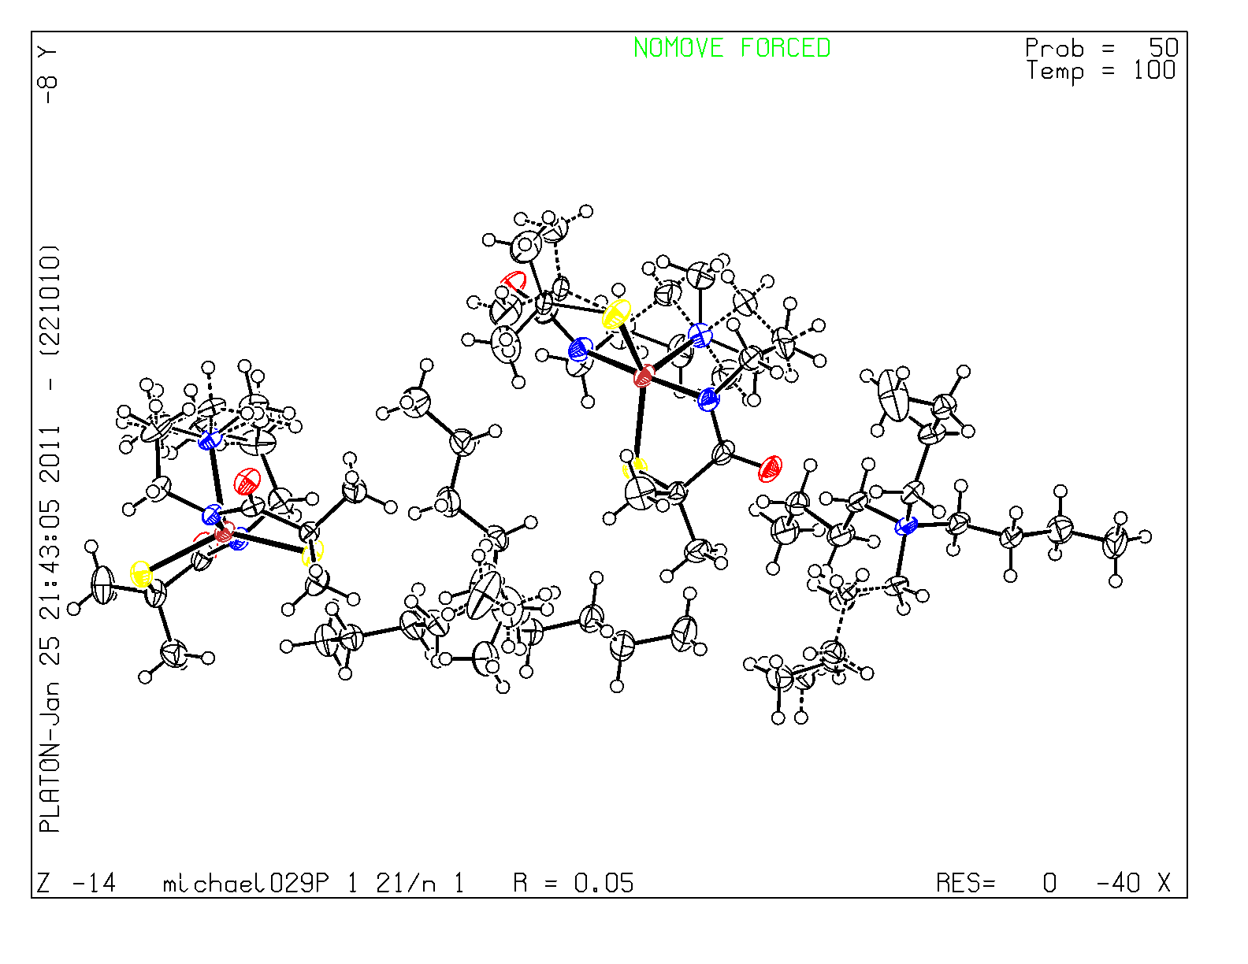

Figure 1. ORTEP of the structure with thermal ellipsoids at the 50% probability level.

Table 1: Crystallographic data for the structures provided.
Identification code michael029_0ma
Empirical formula C31 H63 Mn N4 O2 S2
Formula weight 642.91
Temperature 100(2) K
Wavelength 0.71073 Å
Crystal system Monoclinic
Space group P 2₁/n
Unit cell dimensions a = 19.5207(8) Å α= 90°.
b = 18.0890(7) Å β= 96.105(2)°.
c = 20.6700(8) Å γ = 90°.
Volume 7257.4(5) Å3
Z 8
Density (calculated) 1.177 Mg/m3
Absorption coefficient 0.510 mm-1
F(000) 2800
Crystal size 0.20 x 0.20 x 0.15 mm3
Theta range for data collection 1.77 to 28.36°.
Index ranges -26<=h<=26, -23<=k<=24, -27<=l<=27
Reflections collected 202124
Independent reflections 17961 [R(int) = 0.0846]
Completeness to theta = 25.00° 99.4 %
Max. and min. transmission 0.9275 and 0.9049
Refinement method Full-matrix least-squares on F2
Data / restraints / parameters 17961 / 34 / 867
Goodness-of-fit on F2 1.003
Final R indices [I>2sigma(I)] R1 = 0.0526, wR2 = 0.1069
R indices (all data) R1 = 0.1142, wR2 = 0.1337
Largest diff. peak and hole 0.781 and -0.490 e.Å-3

Bruker (2007) APEX2 (Version 2.1-4), SAINT (version 7.34A), SADABS (version 2007/4), BrukerAXS Inc, Madison, Wisconsin, USA.
(a) Altomare, A.; Burla, C.; Camalli M.; Cascarano L.; Giacovazzo C.; Guagliardi A.; Moliterni A.G.G.; Polidori G.; Spagna R. J. Appl. Cryst. 1999, 32, 115-119; (b) Altomare, A., Cascarano, G., Giacovazzo, C., Guagliardi, A., J. Appl. Cryst. 1993, 26, 343.
Sheldrick, G. M. SHELXL-97: Program for the Refinement of Crystal Structures 1997 University of Gottingen, Germany.
Mackay, S.; Edwards, C.; Henderson, A.; Gilmore, C.; Stewart, N.; Shankland, K.; Donald, A.; MaXus: a computer program for the solution and refinement of crystal structures from diffraction data. University of Glasgow, Scotland, 1997.
Waasmaier, D.; Kirfel, A. Acta Crystallogr. A. 1995, 51, 416.
Farrugia, L. J. Appl. Cryst. 1997, 30, 565

