Crystal Structure Report for A. Vignesh
by Werner Kaminsky
Sample
ID – NIAPFH
X-ray Crystallography Laboratory
University of Washington
31. July 2026

Data Collection started: 1/3/2017
Documentation finished: 1/4/2017

Data backup accessibly through http:
URL: http://cad4.cpac.washington.edu/structures

W.Kaminsky: tel. (206) 543 7585
(x-ray lab): tel. (206) 543 0210
Email: kaminsky@chem.washington.edu

Understanding crystallographic information is not trivial. If you discuss a structure in a publication, please let the crystallographers proof-read the final draft of that manuscript before you submit it.
For many structures it is true that crystallography is an intellectual performance (like synthesis or elucidation of mechanisms) and not a routine job. In these cases, particularly when the structures contribute significantly to the content of the publication, the crystallographers should be co-authors. Do not think this is not necessary because you pay for structures.
An orange prism, measuring 0.22 x 0.03 x 0.01 mm³ was mounted on a loop with oil. Data was collected at -173ºC on a Bruker APEX II single crystal X-ray diffractometer, Mo-radiation.

Crystal-to-detector distance was 40 mm and exposure time was 20 seconds per frame for all sets. The scan width was 0.5º. Data collection was 99.9% complete to 25º in ϑ. A total of 27077 reflections were collected covering the indices, -10<=h<=10, -16<=k<=16, -17<=l<=17. 5964 reflections were symmetry independent and the R_{int} = 0.0473 indicated that the data was excellent. Indexing and unit cell refinement indicated a triclinic lattice. The space group was found to be P‾1 (No. 2).

The data was integrated and scaled using SAINT, SADABS within the APEX2 software package by Bruker.

Solution by direct methods (SHELXS, SIR97) produced a complete heavy atom phasing model consistent with the proposed structure. The structure was completed by difference Fourier synthesis with SHELXL97., Scattering factors are from Waasmair and Kirfel. Hydrogen atoms were placed in geometrically idealised positions and constrained to ride on their parent atoms with C---H distances in the range 0.95-1.00 Angstrom. Isotropic thermal parameters U_{eq} were fixed such that they were 1.2U_{eq} of their parent atom Ueq for CH's and 1.5U_{eq} of their parent atom U_{eq} in case of methyl groups. All non-hydrogen atoms were refined anisotropically by full-matrix least-squares.

The furan oxygen atoms are forced close to each other via the hydrogen of the closest 5-ring carbon creating a hydrogen bond to nitrogen atoms as shown below (a similar network is with O2, N3, C12-H12, but instead of C10, C11 the disordered methyl interacts with N3 and O2).

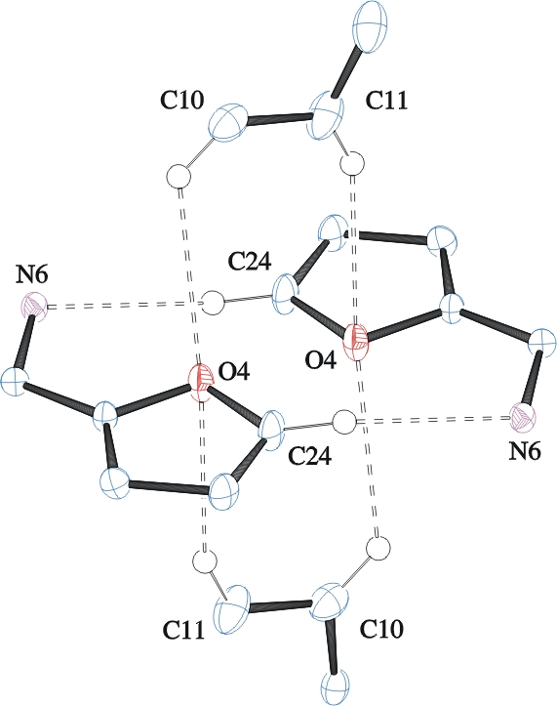
Figure 1, molecular interactions.

The structure is of high quality and ready for publication. Table 1 summarizes the data collection details. Figure 2 shows an ORTEP of the asymmetric unit.
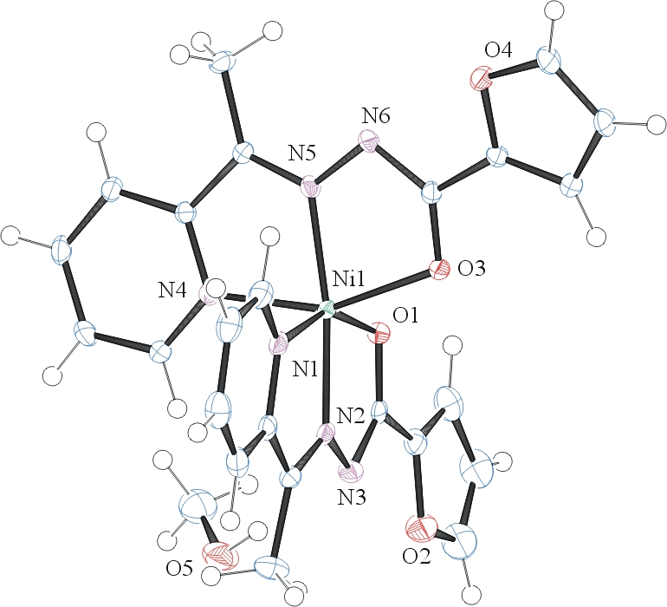

Figure 2. ORTEP of the structure with thermal ellipsoids at the 50% probability level. Disorder omitted for clarity.

Table 1: Crystallographic data for the structures provided.
Empirical formula C25 H24 N6 Ni O5
Formula weight 547.21
Temperature 100(2) K
Wavelength 0.71073 Å
Crystal system Triclinic
Space group P -1
Unit cell dimensions a = 7.9696(9) Å α= 70.941(4)°.
b = 11.9547(13) Å β= 77.930(4)°.
c = 13.5021(14) Å γ = 85.940(5)°.
Volume 1189.0(2) Å3
Z 2
Density (calculated) 1.528 Mg/m3
Absorption coefficient 0.867 mm-1
F(000) 568
Crystal size 0.22 x 0.03 x 0.01 mm3
Theta range for data collection 1.63 to 28.58°.
Index ranges -10<=h<=10, -16<=k<=16, -17<=l<=17
Reflections collected 27077
Independent reflections 5964 [R(int) = 0.0473]
Completeness to theta = 25.00° 99.9 %
Max. and min. transmission 0.9914 and 0.8322
Refinement method Full-matrix least-squares on F2
Data / restraints / parameters 5964 / 1 / 352
Goodness-of-fit on F2 1.027
Final R indices [I>2sigma(I)] R1 = 0.0398, wR2 = 0.0825
R indices (all data) R1 = 0.0635, wR2 = 0.0911
Largest diff. peak and hole 0.645 and -0.525 e.Å-3

Bruker (2007) APEX2 (Version 2.1-4), SAINT (version 7.34A), SADABS (version 2007/4), BrukerAXS Inc, Madison, Wisconsin, USA.
(a) Altomare A, Burla C, Camalli M, Cascarano G L, Giacovazzo C, Guagliardi A, Moliterni AGG, Polidori G, Spagna R. (1999) SIR97: a new tool for crystal structure determination and refinement Journal of Applied Crystallography, 32, 115-119. (b) Altomare A, Cascarano G L, Giacovazzo C, Guagliardi A. (1993) Completion and refinement of crystal structures with SIR 92. Journal of Applied Crystallography, 26, 343-350.
(a) Sheldrick GM. (1997) SHELXL-97, Program for the Refinement of Crystal Structures. University of Göttingen, Germany. (b) Sheldrick GM. (2013) Crystal structure refinement with SHELXL. Acta Cryst. (2015). C71, 3-8.
Mackay, S.; Edwards, C.; Henderson, A.; Gilmore, C.; Stewart, N.; Shankland, K.; Donald, A. (1997) MaXus: a computer program for the solution and refinement of crystal structures from diffraction data. University of Glasgow, Scotland,.
Waasmaier, D.; Kirfel, A. (1995) New Analytical Scattering Factor Functions for Free Atoms and Ions. Acta Crystallographica A., 51, 416-430.
Farrugia LJ. (1997) Ortep-3 for Windows. Journal of Applied Crystallography, 30, 565

