Crystal Structure Report for A. Vignesh
by Werner Kaminsky
Sample
ID – NISA
X-ray Crystallography Laboratory
University of Washington
29. July 2026

Data Collection started: 9/1/2016
Documentation finished: 9/23/2016

Data backup accessibly through http:
URL: http://cad4.cpac.washington.edu/structures

W.Kaminsky: tel. (206) 543 7585
(x-ray lab): tel. (206) 543 0210
Email: kaminsky@chem.washington.edu

Understanding crystallographic information is not trivial. If you discuss a structure in a publication, please let the crystallographers proof-read the final draft of that manuscript before you submit it.
For many structures it is true that crystallography is an intellectual performance (like synthesis or elucidation of mechanisms) and not a routine job. In these cases, particularly when the structures contribute significantly to the content of the publication, the crystallographers should be co-authors. Do not think this is not necessary because you pay for structures.
An orange piece, measuring 0.25 x 0.17 x 0.13 mm³ was mounted on a loop with oil. Data was collected at -143ºC on a Nonius Kappa CCD FR590 single crystal X-ray diffractometer, Mo-radiation.

Crystal-to-detector distance was 30 mm and exposure time was 30 seconds per degree for all sets. The scan width was 2º. Data collection was 99% complete to 25º in ϑ. A total of 10152 merged reflections were collected covering the indices, -14<=h<=14, -13<=k<=14, -17<=l<=19. 6591 reflections were symmetry independent and the R_{int} = 0.0892 indicated that the data was of average quality. Indexing and unit cell refinement indicated a triclinic P lattice. The space group was found to be P‾1 (No.2).

The data was integrated and scaled using hkl-SCALEPACK. This program applies a multiplicative correction factor (S) to the observed intensities (I) and has the following form:

S is calculated from the scale and the B factor determined for each frame and is then applied to I to give the corrected intensity (I_{corr}).

Solution by direct methods (SHELXS, SIR97) produced a complete heavy atom phasing model consistent with the proposed structure. The structure was completed by difference Fourier synthesis with SHELXL97., Scattering factors are from Waasmair and Kirfel. Hydrogen atoms were placed in geometrically idealised positions and constrained to ride on their parent atoms with C---H distances in the range 0.95-1.00 Angstrom. Isotropic thermal parameters U_{eq} were fixed such that they were 1.2U_{eq} of their parent atom Ueq for CH's and 1.5U_{eq} of their parent atom U_{eq} in case of methyl groups. All non-hydrogen atoms were refined anisotropically by full-matrix least-squares.

The structure in addition to the shown, containes disordered water and methanol. The contribution of the disordered solvent to the diffraction pattern was removed with SQUEEZE. The dimeric complex contains a center of inversion.

The structure is of high quality and ready for publication. Table 1 summarizes the data collection details. Figure 1 shows an ORTEP of the asymmetric unit.

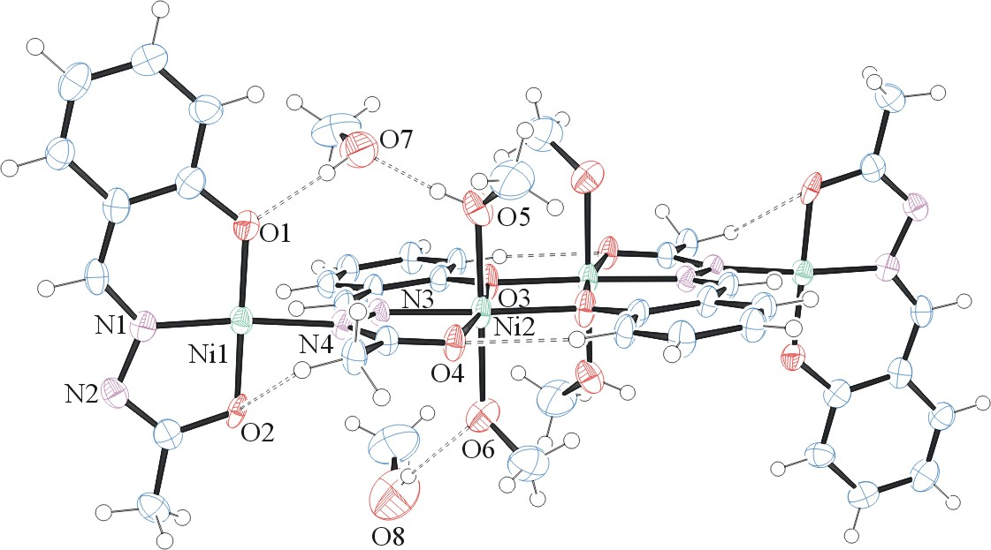
Figure 1. ORTEP of the structure with thermal ellipsoids at the 50% probability level. Disorder omitted for clarity. Methanols with O7 and O8 were not reproduced through the inversion.

Table 1: Crystallographic data for the structures provided.
Empirical formula C43 H60 N8 Ni4 O16
Formula weight 1179.83
Temperature 130(2) K
Wavelength 0.71073 Å
Crystal system Triclinic
Space group P -1
Unit cell dimensions a = 10.6361(18) Å α= 72.679(10)°.
b = 11.173(2) Å β= 66.527(9)°.
c = 14.522(2) Å γ = 60.449(10)°.
Volume 1365.9(4) Å3
Z 1
Density (calculated) 1.434 Mg/m3
Absorption coefficient 1.427 mm-1
F(000) 614
Crystal size 0.25 x 0.17 x 0.13 mm3
Theta range for data collection 2.11 to 28.36°.
Index ranges -14<=h<=14, -13<=k<=14, -17<=l<=19
Reflections collected 10152
Independent reflections 6591 [R(int) = 0.0892]
Completeness to theta = 25.00° 99.0 %
Max. and min. transmission 0.8362 and 0.7168
Refinement method Full-matrix least-squares on F2
Data / restraints / parameters 6591 / 8 / 337
Goodness-of-fit on F2 0.880
Final R indices [I>2sigma(I)] R1 = 0.0641, wR2 = 0.1411
R indices (all data) R1 = 0.1363, wR2 = 0.1617
Largest diff. peak and hole 1.003 and -0.778 e.Å-3

Otwinowsky, Z.; Minor, W. In: Methods in Enzymology; Carter, C. W., Jr., Sweet, R. M., Eds.; Academic Press: New York, 1997, 276, 307-326.
(a) Altomare, A.; Burla, C.; Camalli M.; Cascarano L.; Giacovazzo C.; Guagliardi A.; Moliterni A.G.G.; Polidori G.; Spagna R. J. Appl. Cryst. 1999, 32, 115-119; (b) Altomare, A., Cascarano, G., Giacovazzo, C., Guagliardi, A., J. Appl. Cryst. 1993, 26, 343.
(a) Sheldrick GM. (1997) SHELXL-97, Program for the Refinement of Crystal Structures. University of Göttingen, Germany. (b) Sheldrick GM. (2013) Crystal structure refinement with SHELXL. Acta Cryst. (2015). C71, 3-8.
Mackay, S.; Edwards, C.; Henderson, A.; Gilmore, C.; Stewart, N.; Shankland, K.; Donald, A.; MaXus: a computer program for the solution and refinement of crystal structures from diffraction data. University of Glasgow, Scotland, 1997.
Waasmaier, D.; Kirfel, A. Acta Crystallogr. A. 1995, 51, 416.
A. Spek, J. Appl. Cryst. (2003), 36, 7-13; P. van der Sluis & A. L. Spek, Acta Cryst. (1990). A46, 194-201.
Farrugia, L. J. Appl. Cryst. 1997, 30, 565

