Crystal Structure Report for
Cherif Ben Nasr
by Werner Kaminsky
ID – Nasr_3
X-ray Crystallography Laboratory
University of Washington
31. July 2026

Data Collection started: 3/19/2016
Documentation finished: 4/6/2016

Data backup accessibly through http:
URL: http://cad4.cpac.washington.edu/structures

W.Kaminsky: tel. (206) 543 7585
(x-ray lab): tel. (206) 543 0210
Email: kaminsky@chem.washington.edu

Understanding crystallographic information is not trivial. If you discuss a structure in a publication, please let the crystallographers proof-read the final draft of that manuscript before you submit it.
For many structures it is true that crystallography is an intellectual performance (like synthesis or elucidation of mechanisms) and not a routine job. In these cases, particularly when the structures contribute significantly to the content of the publication, the crystallographers should be co-authors. Do not think this is not necessary because you pay for structures.
A blue prism, measuring 0.30 x 0.17 x 0.05 mm³ was mounted on a loop with oil. Data was collected at -173ºC on a Bruker APEX II single crystal X-ray diffractometer, Mo-radiation.

Crystal-to-detector distance was 40 mm and exposure time was 10 seconds per frame for all sets. The scan width was 0.5º. Data collection was 99.9% complete to 25º in ϑ.

The data appeared twinned via two-fold rotation about (1 0 0) (CELL_NOW) and after multi-domain integration (SAINT, SADABS within the APEX2 software package by Bruker.) and merging (twinabs) a total of 124665 reflections covered the indices, -19<=h<=19, 0<=k<=24, -15<=l<=15. 14953 reflections were symmetry independent and the R_{int} = 0.0362 indicated that the data was excellent (average quality 0.07). Indexing and unit cell refinement indicated a primitive monoclinic lattice. The space group was found to be P 2₁/c (No.14).

Solution by direct methods (SHELXS, SIR97) produced a complete heavy atom phasing model consistent with the proposed structure. The structure was completed by difference Fourier synthesis with SHELXL97., Scattering factors are from Waasmair and Kirfel. Hydrogen atoms were placed in geometrically idealised positions and constrained to ride on their parent atoms with C---H distances in the range 0.95-1.00 Angstrom. Isotropic thermal parameters U_{eq} were fixed such that they were 1.2U_{eq} of their parent atom Ueq for CH's and 1.5U_{eq} of their parent atom U_{eq} in case of methyl groups. All non-hydrogen atoms were refined anisotropically by full-matrix least-squares.

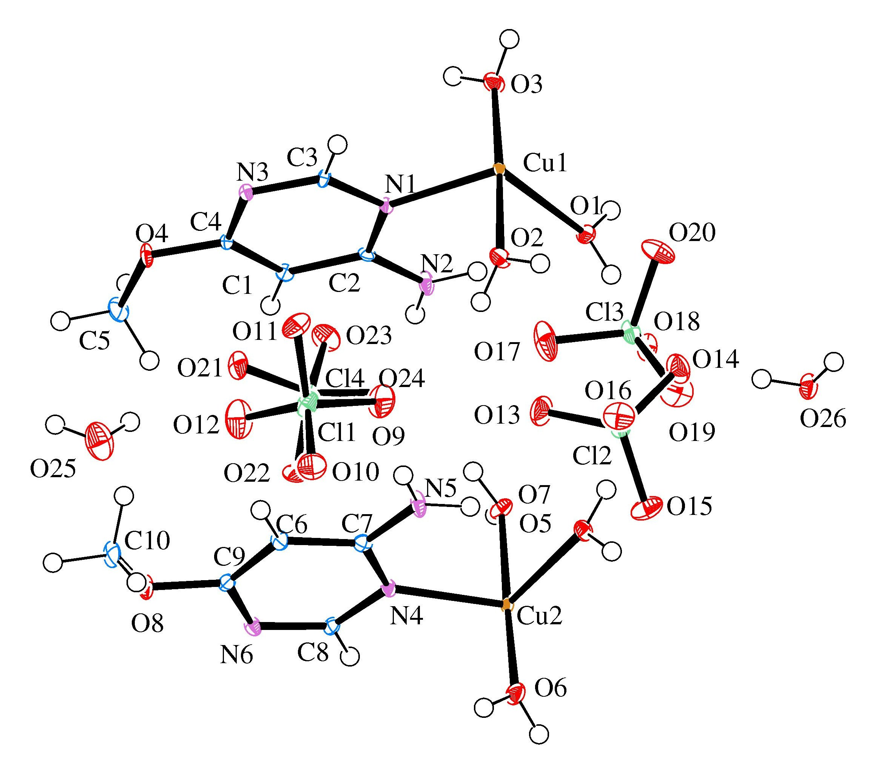Figure 1. ORTEP of the structure with thermal ellipsoids at the 50% probability level.
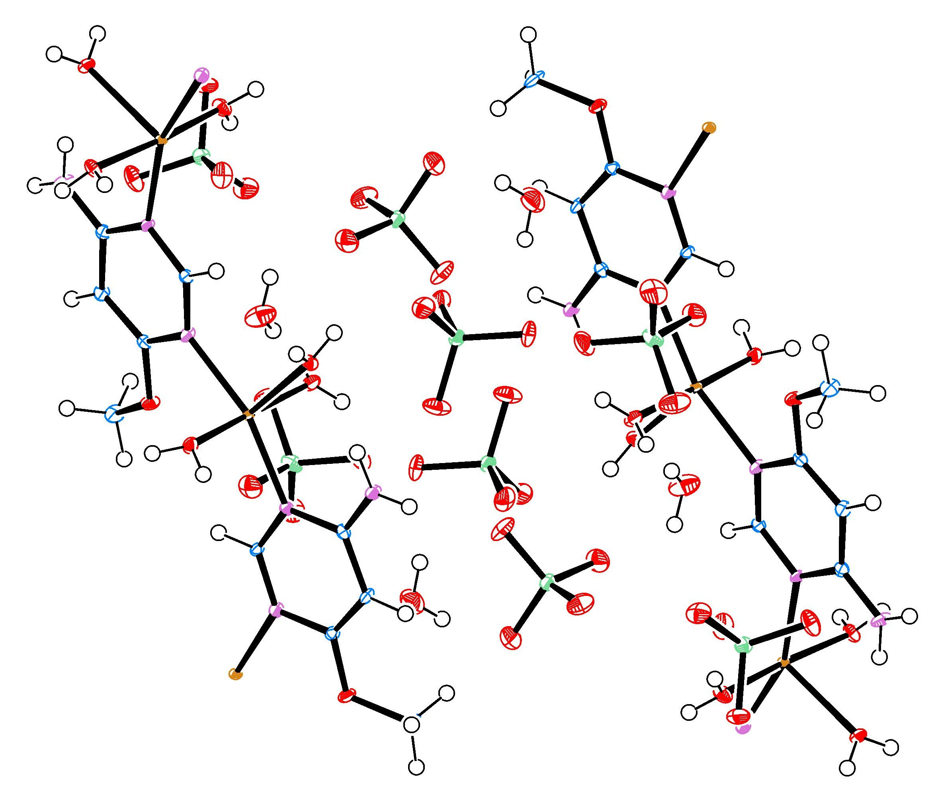
Figure 2. Structure packing. The structure contains 1-dim polymeric chains linked via Cu1-N3’ and similarly via Cu2-N6’.

The structure is of high quality and ready for publication. Table 1 summarizes the data collection details. Figure 1 shows an ORTEP of the asymmetric unit.

Table 1: Crystallographic data for the structures provided.
Empirical formula C5 H15 Cl2 Cu N3 O13
Formula weight 459.64
Temperature 100(2) K
Wavelength 0.71073 Å
Crystal system Monoclinic
Space group P 21/c
Unit cell dimensions a = 14.6815(7) Å α= 90°.
b = 18.3071(9) Å β= 94.399(2)°.
c = 11.4565(5) Å γ = 90°.
Volume 3070.2(2) Å3
Z 8
Density (calculated) 1.989 Mg/m3
Absorption coefficient 1.846 mm-1
F(000) 1864
Crystal size 0.30 x 0.17 x 0.05 mm3
Theta range for data collection 1.391 to 28.419°.
Index ranges -19<=h<=19, 0<=k<=24, -15<=l<=15
Reflections collected 124665
Independent reflections 14953 [R(int) = 0.0362]
Completeness to theta = 25.000° 99.9 %
Absorption correction Semi-empirical from equivalents
Refinement method Full-matrix least-squares on F2
Data / restraints / parameters 14953 / 24 / 484
Goodness-of-fit on F2 1.141
Final R indices [I>2sigma(I)] R1 = 0.0305, wR2 = 0.0805
R indices (all data) R1 = 0.0354, wR2 = 0.0825
Largest diff. peak and hole 0.532 and -0.533 e.Å-3

Sheldrick, G. M. (2005). CELL_NOW. University of Goettingen, Germany.
Bruker (2007) APEX2 (Version 2.1-4), SAINT (version 7.34A), SADABS (version 2007/4), BrukerAXS Inc, Madison, Wisconsin, USA.
Sheldrick, G. M. (2007). TWINABS. University of Goettingen, Germany.
(a) Altomare A, Burla C, Camalli M, Cascarano G L, Giacovazzo C, Guagliardi A, Moliterni AGG, Polidori G, Spagna R. (1999) SIR97: a new tool for crystal structure determination and refinement Journal of Applied Crystallography, 32, 115-119. (b) Altomare A, Cascarano G L, Giacovazzo C, Guagliardi A. (1993) Completion and refinement of crystal structures with SIR 92. Journal of Applied Crystallography, 26, 343-350.
(a) Sheldrick GM. (1997) SHELXL-97, Program for the Refinement of Crystal Structures. University of Göttingen, Germany. (b) Sheldrick GM. (2013) Crystal structure refinement with SHELXL. Acta Cryst. (2015). C71, 3-8.
Mackay, S.; Edwards, C.; Henderson, A.; Gilmore, C.; Stewart, N.; Shankland, K.; Donald, A. (1997) MaXus: a computer program for the solution and refinement of crystal structures from diffraction data. University of Glasgow, Scotland,.
Waasmaier, D.; Kirfel, A. (1995) New Analytical Scattering Factor Functions for Free Atoms and Ions. Acta Crystallographica A., 51, 416-430.
Farrugia LJ. (1997) Ortep-3 for Windows. Journal of Applied Crystallography, 30, 565

