Crystal Structure Report for
Cherif Ben Nasr
by Werner Kaminsky
ID – Nasr_K2
X-ray Crystallography Laboratory
University of Washington
31. July 2026

Data Collection started: 6/16/2016
Documentation finished: 6/28/2016

Data backup accessibly through http:
URL: http://cad4.cpac.washington.edu/structures

W.Kaminsky: tel. (206) 543 7585
(x-ray lab): tel. (206) 543 0210
Email: kaminsky@chem.washington.edu

Understanding crystallographic information is not trivial. If you discuss a structure in a publication, please let the crystallographers proof-read the final draft of that manuscript before you submit it.
For many structures it is true that crystallography is an intellectual performance (like synthesis or elucidation of mechanisms) and not a routine job. In these cases, particularly when the structures contribute significantly to the content of the publication, the crystallographers should be co-authors. Do not think this is not necessary because you pay for structures.
A colorless prism, measuring 0.38 x 0.17 x 0.13 mm³ was mounted on a loop with oil. Data was collected at -173ºC on a Bruker APEX II single crystal X-ray diffractometer, Mo-radiation.

Crystal-to-detector distance was 40 mm and exposure time was 10 seconds per frame for all sets. The scan width was 0.5º. Data collection was 99.3% complete to 25º in ϑ. A total of 18692 reflections were collected covering the indices, -9<=h<=9, -11<=k<=11, -14<=l<=14. 3018 reflections were symmetry independent and the R_{int} = 0.0168 indicated that the data was brilliant. Indexing and unit cell refinement indicated a triclinic lattice. The space group was found to be P‾1 (No. 2).

The data was integrated and scaled using SAINT, SADABS within the APEX2 software package by Bruker.

Solution by direct methods (SHELXS, SIR97) produced a complete heavy atom phasing model consistent with the proposed structure. The structure was completed by difference Fourier synthesis with SHELXL97., Scattering factors are from Waasmair and Kirfel. Hydrogen atoms were placed in geometrically idealised positions and constrained to ride on their parent atoms with C---H distances in the range 0.95-1.00 Angstrom. Isotropic thermal parameters U_{eq} were fixed such that they were 1.2U_{eq} of their parent atom Ueq for CH's and 1.5U_{eq} of their parent atom U_{eq} in case of methyl groups. All non-hydrogen atoms were refined anisotropically by full-matrix least-squares.

Table 1. Hydrogen bonds for nasr_k2_0m [Å and °].
____________________________________________________________________________
D-H...A d(D-H) d(H...A) d(D...A) <(DHA)
____________________________________________________________________________
N(3)-H(3A)...O(7)#2 0.868(17) 2.156(16) 2.9126(13) 145.4(14)
N(3)-H(3B)...O(8)#3 0.829(17) 2.092(17) 2.9202(13) 176.0(15)
O(8)-H(8O)...O(2) 0.786(19) 1.987(19) 2.7544(12) 165.2(17)
O(3)-H(3O)...O(4) 0.811(19) 1.997(19) 2.7950(13) 167.9(18)
O(7)-H(7P)...N(2) 0.87(2) 1.95(2) 2.8147(13) 176.0(17)
O(2)-H(2O)...O(6)#4 0.836(19) 1.89(2) 2.7056(12) 166.2(17)
O(2)-H(2P)...O(8)#5 0.81(2) 1.90(2) 2.7027(12) 169.8(19)
O(3)-H(3P)...O(7)#6 0.804(19) 1.96(2) 2.7425(12) 164.3(18)
O(8)-H(8P)...O(5) 0.760(19) 1.971(19) 2.7090(13) 163.6(18)
O(7)-H(7O)...O(6)#7 0.767(18) 2.072(18) 2.8198(12) 164.9(17)
____________________________________________________________________________
Symmetry transformations used to generate equivalent atoms:
#1 -x+1,-y+1,-z #2 -x+1,-y+2,-z-1 #3 -x,-y+1,-z-1 #4 x,y-1,z #5 -x,-y+1,-z #6 -x+1,-y+2,-z
#7 x+1,y,z

Several hydrogen bonds connect water, Cd-complex and the anions (Table 1).

Figure 1. ORTEP of the extended asymmetric unit with thermal ellipsoids at the 50% probability level.

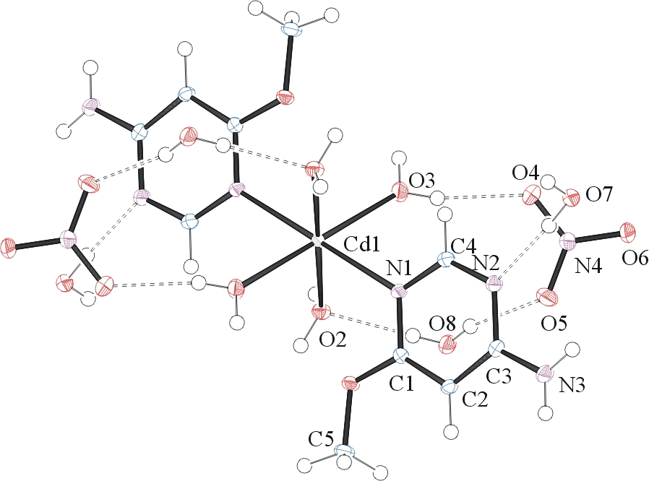
The structure is of high quality and ready for publication. Table 2 summarizes the data collection details. Figure 1 shows an ORTEP of the asymmetric unit.

Table 1: Crystallographic data for the structures provided.
Empirical formula C10 H30 Cd N8 O16
Formula weight 630.82
Temperature 100(2) K
Wavelength 0.71073 Å
Crystal system Triclinic
Space group P -1
Unit cell dimensions a = 7.2198(4) Å α= 104.930(3)°.
b = 8.6074(5) Å β= 105.991(3)°.
c = 10.5992(6) Å γ = 91.935(3)°.
Volume 607.91(6) Å3
Z 1
Density (calculated) 1.723 Mg/m3
Absorption coefficient 0.985 mm-1
F(000) 322
Crystal size 0.38 x 0.17 x 0.13 mm3
Theta range for data collection 2.08 to 28.47°.
Index ranges -9<=h<=9, -11<=k<=11, -14<=l<=14
Reflections collected 18692
Independent reflections 3018 [R(int) = 0.0168]
Completeness to theta = 25.00° 99.3 %
Max. and min. transmission 0.8826 and 0.7058
Refinement method Full-matrix least-squares on F2
Data / restraints / parameters 3018 / 0 / 201
Goodness-of-fit on F2 1.093
Final R indices [I>2sigma(I)] R1 = 0.0135, wR2 = 0.0346
R indices (all data) R1 = 0.0137, wR2 = 0.0348
Largest diff. peak and hole 0.377 and -0.366 e.Å-3

Bruker (2007) APEX2 (Version 2.1-4), SAINT (version 7.34A), SADABS (version 2007/4), BrukerAXS Inc, Madison, Wisconsin, USA.
(a) Altomare A, Burla C, Camalli M, Cascarano G L, Giacovazzo C, Guagliardi A, Moliterni AGG, Polidori G, Spagna R. (1999) SIR97: a new tool for crystal structure determination and refinement Journal of Applied Crystallography, 32, 115-119. (b) Altomare A, Cascarano G L, Giacovazzo C, Guagliardi A. (1993) Completion and refinement of crystal structures with SIR 92. Journal of Applied Crystallography, 26, 343-350.
(a) Sheldrick GM. (1997) SHELXL-97, Program for the Refinement of Crystal Structures. University of Göttingen, Germany. (b) Sheldrick GM. (2013) Crystal structure refinement with SHELXL. Acta Cryst. (2015). C71, 3-8.
Mackay, S.; Edwards, C.; Henderson, A.; Gilmore, C.; Stewart, N.; Shankland, K.; Donald, A. (1997) MaXus: a computer program for the solution and refinement of crystal structures from diffraction data. University of Glasgow, Scotland,.
Waasmaier, D.; Kirfel, A. (1995) New Analytical Scattering Factor Functions for Free Atoms and Ions. Acta Crystallographica A., 51, 416-430.
Farrugia LJ. (1997) Ortep-3 for Windows. Journal of Applied Crystallography, 30, 565

