Crystal Structure Report for A. Vignesh
by Werner Kaminsky
ID – NiNAAH
X-ray Crystallography Laboratory
University of Washington
31. July 2026

Data Collection started: 6/14/2018
Documentation finished: 6/19/2018

Data backup accessibly through http:
URL: http://cad4.cpac.washington.edu/structures

W.Kaminsky: tel. (206) 543 7585
(x-ray lab): tel. (206) 543 0210
Email: kaminsky@chem.washington.edu

Understanding crystallographic information is not trivial. If you discuss a structure in a publication, please let the crystallographers proof-read the final draft of that manuscript before you submit it.
For many structures it is true that crystallography is an intellectual performance (like synthesis or elucidation of mechanisms) and not a routine job. In these cases, particularly when the structures contribute significantly to the content of the publication, the crystallographers should be co-authors. Do not think this is not necessary because you pay for structures. Even I have to pay for my own structures for my research.
A red prism, measuring 0.4 x 0.25 x 0.10 mm³ was mounted on a loop with oil. Data was collected at 22ºC on a Nonius Kappa CCD FR590 single crystal X-ray diffractometer, Mo-radiation.

Crystal-to-detector distance was 30 mm and exposure time was 60 seconds per degree for all sets. The scan width was 2º. Data collection was 99.8% complete to 25º in ϑ. A total of 11504 merged reflections were collected covering the indices, -10<=h<=11, -14<=k<=14, -20<=l<=20. 6905 reflections were symmetry independent and the R_{int} = 0.0467 indicated that the data was good. Indexing and unit cell refinement indicated a triclinic lattice. The space group was found to be P‾1 (No.2).

The data was integrated and scaled using hkl-SCALEPACK. This program applies a multiplicative correction factor (S) to the observed intensities (I) and has the following form:

S is calculated from the scale and the B factor determined for each frame and is then applied to I to give the corrected intensity (I_{corr}).

Solution by direct methods (SHELXS, SIR97) produced a complete heavy atom phasing model consistent with the proposed structure. The structure was completed by difference Fourier synthesis with SHELXL97., Scattering factors are from Waasmair and Kirfel. Hydrogen atoms were placed in geometrically idealised positions and constrained to ride on their parent atoms with C---H distances in the range 0.95-1.00 Angstrom. Isotropic thermal parameters U_{eq} were fixed such that they were 1.2U_{eq} of their parent atom Ueq for CH's and 1.5U_{eq} of their parent atom U_{eq} in case of methyl groups. All non-hydrogen atoms were refined anisotropically by full-matrix least-squares.

The crystals ‘exploded’ upon cooling, indicating the presence of a structural phase transition of thermodynamic first order character. Thus, data was collected at room-temperature.

The contribution of disordered solvent to the diffraction pattern was removed with SQUEEZE

The structure is of high quality and ready for publication. Table 1 summarizes the data collection details. Figure 1 shows an ORTEP of the asymmetric unit.

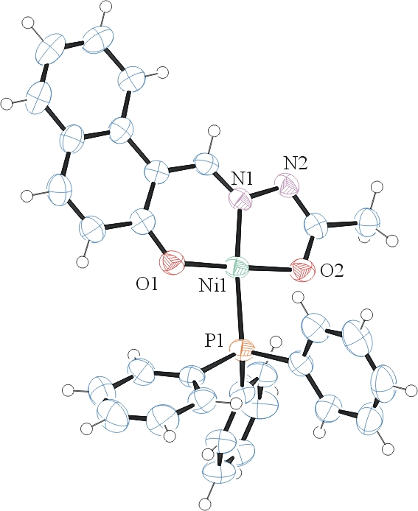
Figure 1. ORTEP of the structure with thermal ellipsoids at the 50% probability level.

Table 1: Crystallographic data for the structures provided.
Empirical formula C31 H25 N2 Ni O2 P
Formula weight 547.21
Temperature 295(2) K
Wavelength 0.71073 Å
Crystal system Triclinic
Space group P -1
Unit cell dimensions a = 8.9126(5) Å α= 105.089(4)°.
b = 11.0450(9) Å β= 93.960(4)°.
c = 15.3874(12) Å γ = 100.472(4)°.
Volume 1427.30(18) Å3
Z 2
Density (calculated) 1.273 Mg/m3
Absorption coefficient 0.765 mm-1
F(000) 568
Crystal size 0.400 x 0.245 x 0.100 mm3
Theta range for data collection 2.054 to 28.138°.
Index ranges -10<=h<=11, -14<=k<=14, -20<=l<=20
Reflections collected 11504
Independent reflections 6905 [R(int) = 0.0467]
Completeness to theta = 25.000° 99.8 %
Refinement method Full-matrix least-squares on F2
Data / restraints / parameters 6905 / 0 / 335
Goodness-of-fit on F2 0.945
Final R indices [I>2sigma(I)] R1 = 0.0455, wR2 = 0.1085
R indices (all data) R1 = 0.0849, wR2 = 0.1254
Largest diff. peak and hole 0.294 and -0.578 e.Å-3

Otwinowsky, Z.; Minor, W. In: Methods in Enzymology; Carter, C. W., Jr., Sweet, R. M., Eds.; Academic Press: New York, 1997, 276, 307-326.
(a) Altomare, A.; Burla, C.; Camalli M.; Cascarano L.; Giacovazzo C.; Guagliardi A.; Moliterni A.G.G.; Polidori G.; Spagna R. J. Appl. Cryst. 1999, 32, 115-119; (b) Altomare, A., Cascarano, G., Giacovazzo, C., Guagliardi, A., J. Appl. Cryst. 1993, 26, 343.
Sheldrick, G. M. SHELXL-97: Program for the Refinement of Crystal Structures 1997 University of Gottingen, Germany.
Mackay, S.; Edwards, C.; Henderson, A.; Gilmore, C.; Stewart, N.; Shankland, K.; Donald, A.; MaXus: a computer program for the solution and refinement of crystal structures from diffraction data. University of Glasgow, Scotland, 1997.
Waasmaier, D.; Kirfel, A. Acta Crystallogr. A. 1995, 51, 416.
A. Spek, J. Appl. Cryst. (2003), 36, 7-13; P. van der Sluis & A. L. Spek, Acta Cryst. (1990). A46, 194-201.
Farrugia, L. J. Appl. Cryst. 1997, 30, 565

