Crystal Structure Report for
Peter Dunn
by Werner Kaminsky
ID – PD_2
X-ray Crystallography Laboratory
University of Washington
29. July 2026

Data Collection started: 5/30/2019
Documentation finished: 6/10/2019

Data backup accessibly through http:
URL: http://cad4.cpac.washington.edu/structures

W.Kaminsky: tel. (206) 543 7585
(x-ray lab): tel. (206) 543 0210
Email: kaminsky@chem.washington.edu

Understanding crystallographic information is not trivial. If you discuss a structure in a publication, please let the crystallographers proof-read the final draft of that manuscript before you submit it.
For many structures it is true that crystallography is an intellectual performance (like synthesis or elucidation of mechanisms) and not a routine job. In these cases, particularly when the structures contribute significantly to the content of the publication, the crystallographers should be co-authors. Do not think this is not necessary because you pay for structures. Even I have to pay for my own structures for my research.
A black plate, measuring 0.55 x 0.46 x 0.10 mm³ was mounted on a loop with oil. Data was collected at -143ºC on a Nonius Kappa CCD FR590 single crystal X-ray diffractometer, Mo-radiation.

Crystal-to-detector distance was 30 mm and exposure time was 60 seconds per degree for all sets. The scan width was 1.9º. Data collection was xx.x% complete to 25º in ϑ. A total of 12598 merged reflections were collected covering the indices, -14<=h<=15, -13<=k<=15, -17<=l<=17. 7731 reflections were symmetry independent and the R_{int} = 0.0959 indicated that the data was of average quality. Indexing and unit cell refinement indicated a triclinic P lattice. The space group was found to be P‾1 (No.2).

The data was integrated and scaled using hkl-SCALEPACK. This program applies a multiplicative correction factor (S) to the observed intensities (I) and has the following form:

S is calculated from the scale and the B factor determined for each frame and is then applied to I to give the corrected intensity (I_{corr}).

Solution by direct methods (SHELXT or SIR97) produced a complete heavy atom phasing model consistent with the proposed structure. The structure was completed by difference Fourier synthesis with SHELXL., Scattering factors are from Waasmair and Kirfel. Hydrogen atoms were placed in geometrically idealised positions and constrained to ride on their parent atoms with C---H distances in the range 0.95-1.00 Angstrom. Isotropic thermal parameters U_{eq} were fixed such that they were 1.2U_{eq} of their parent atom Ueq for CH's and 1.5U_{eq} of their parent atom U_{eq} in case of methyl groups. All non-hydrogen atoms were refined anisotropically by full-matrix least-squares.

The porphyrin is accompanied by DCM molecules, one of which is disordered. The Ru is located on an inversion center and only half of the complex appears in the asymmetric unit.

The structure is of high quality and ready for publication. Table 1 summarizes the data collection details. Figure 1 shows an ORTEP of the asymmetric unit.

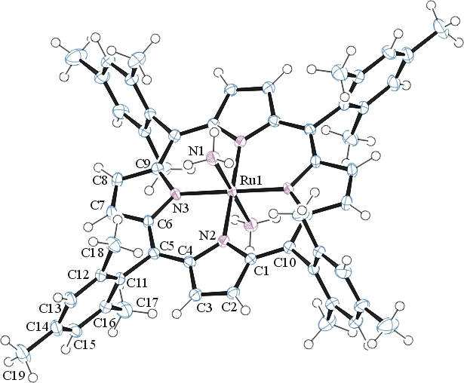

Figure 1. ORTEP of the structure with thermal ellipsoids at the 50% probability level. DCM solvent omitted for clarity.

Table 1: Crystallographic data for the structures provided.
Empirical formula C72 H90 N6 O4 Ru
Formula weight 1204.56
Temperature 130(2) K
Wavelength 0.71073 Å
Crystal system Triclinic
Space group P -1
Unit cell dimensions a = 11.2702(7) Å α= 100.208(3)°.
b = 11.8317(7) Å β= 90.767(3)°.
c = 12.8794(10) Å γ = 110.714(3)°.
Volume 1575.56(19) Å3
Z 1
Density (calculated) 1.270 Mg/m3
Absorption coefficient 0.303 mm-1
F(000) 640
Crystal size 0.550 x 0.460 x 0.100 mm3
Theta range for data collection 2.223 to 28.379°.
Index ranges -14<=h<=15, -13<=k<=15, -17<=l<=17
Reflections collected 12598
Independent reflections 7731 [R(int) = 0.0959]
Completeness to theta = 25.000° 99.7 %
Refinement method Full-matrix least-squares on F2
Data / restraints / parameters 7731 / 60 / 399
Goodness-of-fit on F2 1.027
Final R indices [I>2sigma(I)] R1 = 0.0643, wR2 = 0.1407
R indices (all data) R1 = 0.0876, wR2 = 0.1521
Largest diff. peak and hole 1.334 and -1.143 e.Å-3

Otwinowsky, Z.; Minor, W. In: Methods in Enzymology; Carter, C. W., Jr., Sweet, R. M., Eds.; Academic Press: New York, 1997, 276, 307-326.
Sheldrick GM. (2015) SHELXT - Integrated space-group and crystal-structure determination. Acta Cryst. A71, 3-8.
(a) Altomare A, Burla C, Camalli M, Cascarano G L, Giacovazzo C, Guagliardi A, Moliterni AGG, Polidori G, Spagna R. (1999) SIR97: a new tool for crystal structure determination and refinement Journal of Applied Crystallography, 32, 115-119. (b) Altomare A, Cascarano G L, Giacovazzo C, Guagliardi A. (1993) Completion and refinement of crystal structures with SIR 92. Journal of Applied Crystallography, 26, 343-350.
(a) Sheldrick GM. (1997) SHELXL-97, Program for the Refinement of Crystal Structures. University of Göttingen, Germany. (b) Sheldrick GM. (2015) Crystal structure refinement with SHELXL. Acta Cryst. (2015). C71, 3–8
Mackay, S.; Edwards, C.; Henderson, A.; Gilmore, C.; Stewart, N.; Shankland, K.; Donald, A. (1997) MaXus: a computer program for the solution and refinement of crystal structures from diffraction data. University of Glasgow, Scotland,.
Waasmaier, D.; Kirfel, A. Acta Crystallogr. A. 1995, 51, 416.
Farrugia, L. J. Appl. Cryst. 1997, 30, 565

