Crystal Structure Report for J Kovacs
by Werner Kaminsky
Sample Submitted by Paige Gannon
ID – PG114
X-ray Crystallography Laboratory
University of Washington
28. July 2026

Data Collection started: 8/8/2020
Documentation finished: 9/3/2020

Data backup accessibly through http:
URL: http://cad4.cpac.washington.edu/structures

W.Kaminsky: tel. (206) 543 7585
(x-ray lab): tel. (206) 543 0210
Email: kaminsky@chem.washington.edu

Understanding crystallographic information is not trivial. If you discuss a structure in a publication, please let the crystallographers proof-read the final draft of that manuscript before you submit it.
For many structures it is true that crystallography is an intellectual performance (like synthesis or elucidation of mechanisms) and not a routine job. In these cases, particularly when the structures contribute significantly to the content of the publication, the crystallographers should be co-authors. Do not think this is not necessary because you pay for structures.
An orange plate, measuring 0.28 x 0.09 x 0.03 mm³ was mounted on a loop with oil. Data was collected at -173ºC on a Bruker APEX II single crystal X-ray diffractometer, Mo-radiation.

Crystal-to-detector distance was 40 mm and exposure time was 60 seconds per frame for all sets. The scan width was 0.5º. Data collection was 95.3% complete to 25º in ϑ. A total of 43374 reflections were collected covering the indices, -13<=h<=13, -68<=k<=67, -27<=l<=27. 23568 reflections were symmetry independent and the R_{int} = 0.2447 indicated that the data was of marginal quality. Indexing and unit cell refinement indicated a primitive monoclinic lattice. The space group was found to be P 2₁/n (No. 14).

The data was integrated and scaled using SAINT, SADABS within the APEX2 software package by Bruker.

Solution by direct methods (SHELXT or SIR97) produced a complete heavy atom phasing model consistent with the proposed structure. The structure was completed by difference Fourier synthesis with SHELXL., Scattering factors are from Waasmair and Kirfel. Hydrogen atoms were placed in geometrically idealised positions and constrained to ride on their parent atoms with C---H distances in the range 0.95-1.00 Angstrom. Isotropic thermal parameters U_{eq} were fixed such that they were 1.2U_{eq} of their parent atom Ueq for CH's and 1.5U_{eq} of their parent atom U_{eq} in case of methyl groups. All non-hydrogen atoms were refined anisotropically by full-matrix least-squares.

The data appeared twinned via 180 degrees about [0 0 1] (CELL_NOW). In addition, a large number of disordered acetonitrile solvent molecules required application of SQUEEZE to remove solvent contribution to the diffraction pattern.

Two cage structures are accompanied by two FeCl₄²⁻ anions balancing total charges.

The data was very week, thus the structure is of lower quality and marginally suitable for publication.
Table 1 summarizes the data collection details. Figure 1 shows an ORTEP of the asymmetric unit.

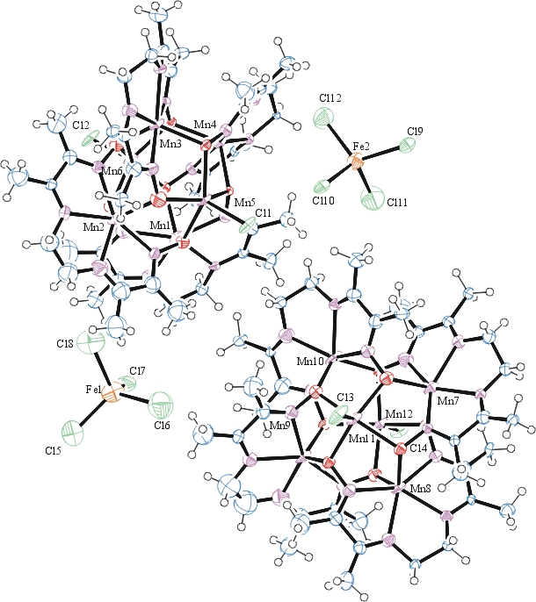
Figure 1. ORTEP of the structure with thermal ellipsoids at the 50% probability level. Solvent omitted for clarity.

Table 1: Crystallographic data for the structures provided.
Empirical formula C40 H64 Cl6 Fe Mn6 N16 O8
Formula weight 1495.26
Temperature 100(2) K
Wavelength 0.71073 Å
Crystal system Monoclinic
Space group P 21/n
Unit cell dimensions a = 11.568(5) Å α= 90.000(5)°.
b = 56.793(5) Å β= 90.145(5)°.
c = 22.835(5) Å γ = 90.000(5)°.
Volume 15002(7) Å3
Z 8
Density (calculated) 1.324 Mg/m3
Absorption coefficient 1.427 mm-1
F(000) 6064
Crystal size 0.280 x 0.090 x 0.030 mm3
Theta range for data collection 1.397 to 25.389°.
Index ranges -13<=h<=13, -68<=k<=67, -27<=l<=27
Reflections collected 43374
Independent reflections 23568 [R(int) = 0.2447]
Completeness to theta = 25.000° 95.3 %
Refinement method Full-matrix least-squares on F2
Data / restraints / parameters 23568 / 1773 / 1420
Goodness-of-fit on F2 1.077
Final R indices [I>2sigma(I)] R1 = 0.1493, wR2 = 0.3662
R indices (all data) R1 = 0.3101, wR2 = 0.4300
Largest diff. peak and hole 1.627 and -1.010 e.Å-3

Bruker (2007) APEX2 (Version 2.1-4), SAINT (version 7.34A), SADABS (version 2007/4), BrukerAXS Inc, Madison, Wisconsin, USA.
Sheldrick GM. (2015) SHELXT - Integrated space-group and crystal-structure determination. Acta Cryst. A71, 3-8.
(a) Altomare A, Burla C, Camalli M, Cascarano G L, Giacovazzo C, Guagliardi A, Moliterni AGG, Polidori G, Spagna R. (1999) SIR97: a new tool for crystal structure determination and refinement Journal of Applied Crystallography, 32, 115-119. (b) Altomare A, Cascarano G L, Giacovazzo C, Guagliardi A. (1993) Completion and refinement of crystal structures with SIR 92. Journal of Applied Crystallography, 26, 343-350.
(a) Sheldrick GM. (1997) SHELXL-97, Program for the Refinement of Crystal Structures. University of Göttingen, Germany. (b) Sheldrick GM. (2015) Crystal structure refinement with SHELXL. Acta Cryst. (2015). C71, 3–8
Mackay, S.; Edwards, C.; Henderson, A.; Gilmore, C.; Stewart, N.; Shankland, K.; Donald, A. (1997) MaXus: a computer program for the solution and refinement of crystal structures from diffraction data. University of Glasgow, Scotland,.
Waasmaier, D.; Kirfel, A. (1995) New Analytical Scattering Factor Functions for Free Atoms and Ions. Acta Crystallographica A., 51, 416-430.
Sheldrick, G. M. (2005). CELL_NOW. University of Goettingen, Germany.
(a) A. Spek, J. Appl. Cryst. (2003), 36, 7-13; (b) P. van der Sluis & A. L. Spek, Acta Cryst. (1990). A46, 194-201. (c) Spek, A. L. (2009). Acta. Cryst. D65, 148-155.
Farrugia LJ. (1997) Ortep-3 for Windows. Journal of Applied Crystallography, 30, 565

