Crystal Structure Report for A. Vignesh
by Werner Kaminsky
ID – PdSMQ
X-ray Crystallography Laboratory
University of Washington
31. July 2026

Data Collection started: 11/7/2017
Documentation finished: 11/15/2017

Data backup accessibly through http:
URL: http://cad4.cpac.washington.edu/structures

W.Kaminsky: tel. (206) 543 7585
(x-ray lab): tel. (206) 543 0210
Email: kaminsky@chem.washington.edu

Understanding crystallographic information is not trivial. If you discuss a structure in a publication, please let the crystallographers proof-read the final draft of that manuscript before you submit it.
For many structures it is true that crystallography is an intellectual performance (like synthesis or elucidation of mechanisms) and not a routine job. In these cases, particularly when the structures contribute significantly to the content of the publication, the crystallographers should be co-authors. Do not think this is not necessary because you pay for structures. Even I have to pay for my own structures for my research.
A red prism, measuring 0.25 x 0.15 x 0.10 mm³ was mounted on a loop with oil. Data was collected at -143ºC on a Nonius Kappa CCD FR590 single crystal X-ray diffractometer, Mo-radiation.

Crystal-to-detector distance was 30 mm and exposure time was 90 seconds per degree for all sets. The scan width was 2º. Data collection was 99.9% complete to 25º in ϑ. A total of 29984 partial and complete reflections were collected covering the indices, -17<=h<=15, -14<=k<=12, -16<=l<=12. 4394 reflections were symmetry independent and the R_{int} = 0.1096 indicated that the data was appropriate. Indexing and unit cell refinement indicated a triclinic P lattice. The space group was found to be P 2/n (No. 13).

The data was integrated and scaled using hkl-SCALEPACK. This program applies a multiplicative correction factor (S) to the observed intensities (I) and has the following form:

S is calculated from the scale and the B factor determined for each frame and is then applied to I to give the corrected intensity (I_{corr}).

Solution by direct methods (SHELXS, SIR97) produced a complete heavy atom phasing model consistent with the proposed structure. The structure was completed by difference Fourier synthesis with SHELXL97., Scattering factors are from Waasmair and Kirfel. Hydrogen atoms were placed in geometrically idealised positions and constrained to ride on their parent atoms with C---H distances in the range 0.95-1.00 Angstrom. Isotropic thermal parameters U_{eq} were fixed such that they were 1.2U_{eq} of their parent atom Ueq for CH's and 1.5U_{eq} of their parent atom U_{eq} in case of methyl groups. All non-hydrogen atoms were refined anisotropically by full-matrix least-squares.

The contribution of disordered Chloroform – methanol mix to the diffraction pattern was removed with SQUEEZE

Half of the molecule is symmetry related to the other, creating a Pd₂-dimereric compound.

The structure is of high quality and ready for publication. Table 1 summarizes the data collection details. Figure 1 shows an ORTEP of the molecule.

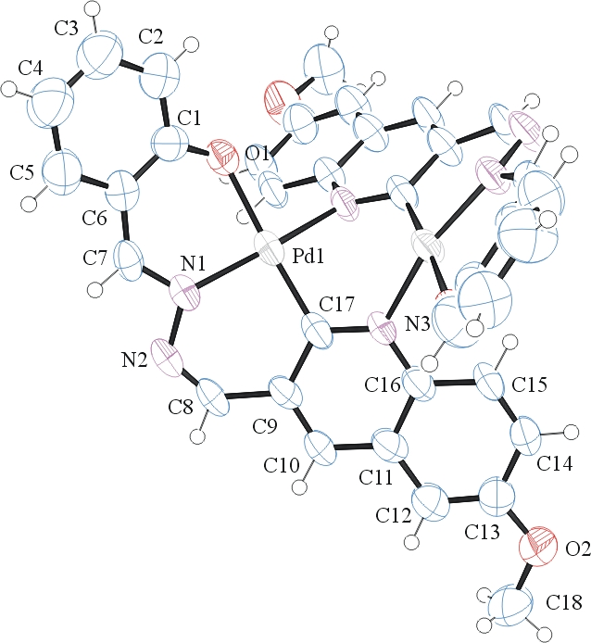
Figure 1. ORTEP of the structure with thermal ellipsoids at the 50% probability level. Disorder and solvent omitted for clarity.

Table 1: Crystallographic data for the structures provided.
Empirical formula C36 H26 N6 O4 Pd2
Formula weight 819.43
Temperature 294(2) K
Wavelength 0.71073 Å
Crystal system Monoclinic
Space group P 2/n
Unit cell dimensions a = 13.122(3) Å α= 90°.
b = 10.972(2) Å β= 90.27(3)°.
c = 12.517(3) Å γ = 90°.
Volume 1802.2(7) Å3
Z 2
Density (calculated) 1.510 Mg/m3
Absorption coefficient 1.043 mm-1
F(000) 816
Crystal size 0.250 x 0.150 x 0.100 mm3
Theta range for data collection 2.243 to 28.319°.
Index ranges -17<=h<=15, -14<=k<=12, -16<=l<=12
Reflections collected 11226
Independent reflections 4394 [R(int) = 0.1096]
Completeness to theta = 25.000° 99.9 %
Refinement method Full-matrix least-squares on F2
Data / restraints / parameters 4394 / 54 / 230
Goodness-of-fit on F2 0.930
Final R indices [I>2sigma(I)] R1 = 0.0575, wR2 = 0.1330
R indices (all data) R1 = 0.1597, wR2 = 0.1758
Largest diff. peak and hole 0.456 and -1.398 e.Å-3

Otwinowsky, Z.; Minor, W. In: Methods in Enzymology; Carter, C. W., Jr., Sweet, R. M., Eds.; Academic Press: New York, 1997, 276, 307-326.
(a) Altomare, A.; Burla, C.; Camalli M.; Cascarano L.; Giacovazzo C.; Guagliardi A.; Moliterni A.G.G.; Polidori G.; Spagna R. J. Appl. Cryst. 1999, 32, 115-119; (b) Altomare, A., Cascarano, G., Giacovazzo, C., Guagliardi, A., J. Appl. Cryst. 1993, 26, 343.
Sheldrick, G. M. SHELXL-97: Program for the Refinement of Crystal Structures 1997 University of Gottingen, Germany.
Mackay, S.; Edwards, C.; Henderson, A.; Gilmore, C.; Stewart, N.; Shankland, K.; Donald, A.; MaXus: a computer program for the solution and refinement of crystal structures from diffraction data. University of Glasgow, Scotland, 1997.
Waasmaier, D.; Kirfel, A. Acta Crystallogr. A. 1995, 51, 416.
A. Spek, J. Appl. Cryst. (2003), 36, 7-13; P. van der Sluis & A. L. Spek, Acta Cryst. (1990). A46, 194-201.
Farrugia, L. J. Appl. Cryst. 1997, 30, 565

