Crystal Structure Report for
R. Prabhakaran
by Werner Kaminsky
Sample Submitted by C. Elamathi
ID – QETSC
X-ray Crystallography Laboratory
University of Washington
28. July 2026

Data Collection started: 1/28/2020
Documentation finished: 2/4/2020

Data backup accessibly through http:
URL: http://cad4.cpac.washington.edu/structures

W.Kaminsky: tel. (206) 543 7585
(x-ray lab): tel. (206) 543 0210
Email: kaminsky@chem.washington.edu

Understanding crystallographic information is not trivial. If you discuss a structure in a publication, please let the crystallographers proof-read the final draft of that manuscript before you submit it.
For many structures it is true that crystallography is an intellectual performance (like synthesis or elucidation of mechanisms) and not a routine job. In these cases, particularly when the structures contribute significantly to the content of the publication, the crystallographers should be co-authors. Do not think this is not necessary because you pay for structures.
A colorless needle, measuring 0.6 x 0.20 x 0.15 mm³ was mounted on a loop with oil. Data was collected at -173ºC on a Nonius Kappa CCD FR590 single crystal X-ray diffractometer, Mo-radiation.

Crystal-to-detector distance was 37.8 mm and exposure time was 90 seconds per degree for all sets. The scan width was 1.2º. Data collection was 99.7% complete to 25º in ϑ. A total of 22801 partial and complete reflections were collected covering the indices, -8<=h<=8, -13<=k<=14, -26<=l<=26. A total of 6005 merged and 3389 symmetry independent reflections with R_{int} = 0.0537 were collected. Indexing and unit cell refinement indicated a primitive monoclinic lattice. The space group was found to be P 2₁/n (No.14).

The data was integrated and scaled using hkl-SCALEPACK. This program applies a multiplicative correction factor (S) to the observed intensities (I) and has the following form:

S is calculated from the scale and the B factor determined for each frame and is then applied to I to give the corrected intensity (I_{corr}).

Solution by direct methods (SHELXT or SIR97) produced a complete heavy atom phasing model consistent with the proposed structure. The structure was completed by difference Fourier synthesis with SHELXL., Scattering factors are from Waasmair and Kirfel. Hydrogen atoms were placed in geometrically idealised positions and constrained to ride on their parent atoms with C---H distances in the range 0.95-1.00 Angstrom. Isotropic thermal parameters U_{eq} were fixed such that they were 1.2U_{eq} of their parent atom Ueq for CH's and 1.5U_{eq} of their parent atom U_{eq} in case of methyl groups. All non-hydrogen atoms were refined anisotropically by full-matrix least-squares.

The structure is of high quality and ready for publication. Table 1 summarizes the data collection details. Figure 1 shows an ORTEP of the asymmetric unit.

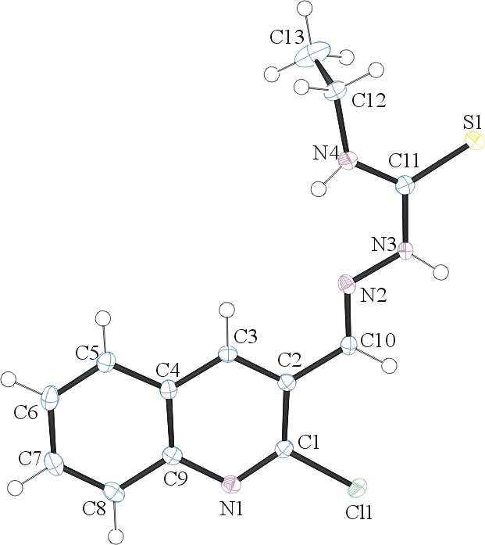
Figure 1. ORTEP of the structure with thermal ellipsoids at the 50% probability level.

Table 1: Crystallographic data for the structures provided.
Empirical formula C13 H13 Cl N4 S
Formula weight 292.78
Temperature 100(2) K
Wavelength 0.71073 Å
Crystal system Monoclinic
Space group P 2₁/n
Unit cell dimensions a = 6.1745(2) Å α= 90°.
b = 11.1615(4) Å β= 90.7480(10)°.
c = 20.0977(8) Å γ = 90°.
Volume 1384.95(9) Å3
Z 4
Density (calculated) 1.404 Mg/m3
Absorption coefficient 0.418 mm-1
F(000) 608
Crystal size 0.600 x 0.200 x 0.150 mm3
Theta range for data collection 3.439 to 28.274°.
Index ranges -8<=h<=8, -13<=k<=14, -26<=l<=26
Reflections collected 6005
Independent reflections 3389 [R(int) = 0.0537]
Completeness to theta = 25.000° 99.7 %
Refinement method Full-matrix least-squares on F2
Data / restraints / parameters 3389 / 0 / 178
Goodness-of-fit on F2 1.028
Final R indices [I>2sigma(I)] R1 = 0.0378, wR2 = 0.0959
R indices (all data) R1 = 0.0510, wR2 = 0.1025
Largest diff. peak and hole 0.476 and -0.398 e.Å-3

Otwinowsky, Z.; Minor, W. In: Methods in Enzymology; Carter, C. W., Jr., Sweet, R. M., Eds.; Academic Press: New York, 1997, 276, 307-326.
Sheldrick GM. (2015) SHELXT - Integrated space-group and crystal-structure determination. Acta Cryst. A71, 3-8.
(a) Altomare A, Burla C, Camalli M, Cascarano G L, Giacovazzo C, Guagliardi A, Moliterni AGG, Polidori G, Spagna R. (1999) SIR97: a new tool for crystal structure determination and refinement Journal of Applied Crystallography, 32, 115-119. (b) Altomare A, Cascarano G L, Giacovazzo C, Guagliardi A. (1993) Completion and refinement of crystal structures with SIR 92. Journal of Applied Crystallography, 26, 343-350.
(a) Sheldrick GM. (1997) SHELXL-97, Program for the Refinement of Crystal Structures. University of Göttingen, Germany. (b) Sheldrick GM. (2015) Crystal structure refinement with SHELXL. Acta Cryst. (2015). C71, 3–8
Mackay, S.; Edwards, C.; Henderson, A.; Gilmore, C.; Stewart, N.; Shankland, K.; Donald, A. (1997) MaXus: a computer program for the solution and refinement of crystal structures from diffraction data. University of Glasgow, Scotland,.
Waasmaier, D.; Kirfel, A. Acta Crystallogr. A. 1995, 51, 416.
Farrugia, L. J. Appl. Cryst. 1997, 30, 565

