Crystal Structure Report for A. Velian
by Paige M Gannon & Werner Kaminsky
Sample Submitted by Robert Love
ID – RJL070
X-ray Crystallography Laboratory
University of Washington
30. July 2026

Data Collection started: 7/29/2022
Documentation finished: 8/11/2022

Data backup accessibly through http:
URL: http://cad4.cpac.washington.edu/structures

W.Kaminsky: tel. (206) 543 7585
(x-ray lab): tel. (206) 543 0210
Email: kaminsky@chem.washington.edu

Understanding crystallographic information is not trivial. If you discuss a structure in a publication, please let the crystallographers proof-read the final draft of that manuscript before you submit it.
For many structures it is true that crystallography is an intellectual performance (like synthesis or elucidation of mechanisms) and not a routine job. In these cases, particularly when the structures contribute significantly to the content of the publication, the crystallographers should be co-authors. Do not think this is not necessary because you pay for structures.
A black piece, measuring 0.15 x 0.12 x 0.10 mm³ was mounted on a loop with oil. Data was collected at -173ºC on a Bruker APEX II single crystal X-ray diffractometer, Mo-radiation, equipped with a Miracol X-ray optical collimator.

Crystal-to-detector distance was 40 mm and exposure time was 10 seconds per frame for all sets. The scan width was 0.5º. Data collection was 99.7% complete to 25º in ϑ. A total of 55704 reflections were collected covering the indices, -33<=h<=33, -34<=k<=34, -23<=l<=23. 14454 reflections were symmetry independent and the R_{int} = 0.1356 indicated that the data was of acceptable quality. Indexing and unit cell refinement indicated a C-centered monoclinic lattice. The space group was found to be C 2/c (No. 15).

The data was integrated and scaled using SAINT, SADABS within the APEX2 software package by Bruker.

Solution by direct methods (SHELXT or SIR97) produced a complete heavy atom phasing model consistent with the proposed structure. The structure was completed by difference Fourier synthesis with SHELXL. Scattering factors are from Waasmair and Kirfel. Hydrogen atoms were placed in geometrically idealised positions and constrained to ride on their parent atoms with C---H distances in the range 0.95-1.00 Angstrom. Isotropic thermal parameters U_{eq} were fixed such that they were 1.2U_{eq} of their parent atom Ueq for CH's and 1.5U_{eq} of their parent atom U_{eq} in case of methyl groups. All non-hydrogen atoms were refined anisotropically by full-matrix least-squares.

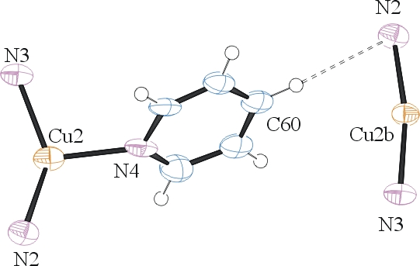
Half of a cluster is related to the rest via symmetry. A disordered Et₂O ether solvent was found and modelling required to refine those atoms in an idealized rigid unit (AFIX 6 .. AFIX 0 loop). Similarily, a disordered pyridine required pairwise correlation of displacement parameters. The (disordered) pyridine binds to a disordered Cu2 of one cluster and hydrogen bonds to N2 of a symmetry related cluster whereby Cu2b, with which the Cu2 is disordered with, appearing at a larger distance to C60 than the Cu2 of that symmetry related cluster (and vice versa). Cu2/Cu2b appears twice in the expanded molecule with halfe pyridines binding to each Cu2, which results in a 1-dim polimeric structure.

To improve C-C bond accuracys, similar moieties to N1,P1, C1..C19 were related via ‘SAME’ loops. Some disordered atoms required ISOR and RIGU stabilization for the displacement parameter. 32 bad reflections were omitted from the refinement. The structure is of high quality and ready for publication. Table 1 summarizes the data collection details. Figure 1 shows an ORTEP of the asymmetric unit.

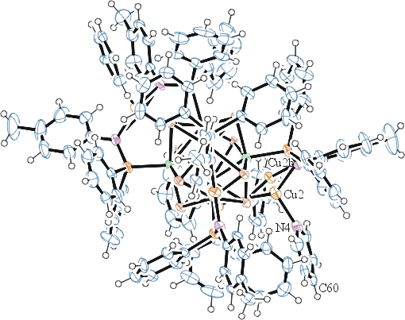
Figure 1. ORTEP of the (expanded) cluster with thermal ellipsoids at the 50% probability level. Disorder and solvent omitted for clarity.

Table 1: Crystallographic data for the structures provided.
Empirical formula C123 H117 Co6 Cu3 N7 O P6 Se8
Formula weight 3070.93
Temperature 100(2) K
Wavelength 0.71073 Å
Crystal system Monoclinic
Space group C 2/c
Unit cell dimensions a = 25.3770(18) Å α= 90°.
b = 26.0482(19) Å β= 93.415(5)°.
c = 17.6805(13) Å γ = 90°.
Volume 11666.5(15) Å3
Z 4
Density (calculated) 1.748 Mg/m3
Absorption coefficient 3.998 mm-1
F(000) 6092
Crystal size 0.150 x 0.120 x 0.100 mm3
Theta range for data collection 1.608 to 28.278°.
Index ranges -33<=h<=33, -34<=k<=34, -23<=l<=23
Reflections collected 55704
Independent reflections 14454 [R(int) = 0.1356]
Completeness to theta = 25.000° 99.7 %
Refinement method Full-matrix least-squares on F2
Data / restraints / parameters 14454 / 222 / 730
Goodness-of-fit on F2 1.097
Final R indices [I>2sigma(I)] R1 = 0.0659, wR2 = 0.1402
R indices (all data) R1 = 0.1709, wR2 = 0.2046
Largest diff. peak and hole 2.086 and -1.324 e.Å-3

Bruker (2007) APEX2 (Version 2.1-4), SAINT (version 7.34A), SADABS (version 2007/4), BrukerAXS Inc, Madison, Wisconsin, USA.
(a) Sheldrick GM. (2008) A short history of SHELX. Acta Cryst. A64, 112-122. (b) Sheldrick GM. (2015) SHELXT - Integrated space-group and crystal-structure determination. Acta Cryst. A71, 3-8.
(a) Altomare A, Burla C, Camalli M, Cascarano G L, Giacovazzo C, Guagliardi A, Moliterni AGG, Polidori G, Spagna R. (1999) SIR97: a new tool for crystal structure determination and refinement Journal of Applied Crystallography, 32, 115-119. (b) Altomare A, Cascarano G L, Giacovazzo C, Guagliardi A. (1993) Completion and refinement of crystal structures with SIR 92. Journal of Applied Crystallography, 26, 343-350.
(a) Sheldrick GM. (1997) SHELXL-97, Program for the Refinement of Crystal Structures. University of Göttingen, Germany. (b) Sheldrick GM. (2015) Crystal structure refinement with SHELXL. Acta Cryst. C71, 3–8
Waasmaier, D.; Kirfel, A. (1995) New Analytical Scattering Factor Functions for Free Atoms and Ions. Acta Crystallographica A., 51, 416-430.
Farrugia LJ. (1997) Ortep-3 for Windows. Journal of Applied Crystallography, 30, 565

