Crystal Structure Report for D. Gamelin
by Werner Kaminsky
Sample Submitted by by Rachel Tenney
ID – RT106
X-ray Crystallography Laboratory
University of Washington
31. July 2026

Data Collection started: 6.9/2023
Documentation finished: 7/28/2023

Data backup accessibly through http:
URL: http://cad4.cpac.washington.edu/structures

W.Kaminsky: tel. (206) 543 7585
(x-ray lab): tel. (206) 543 0210
Email: kaminsky@chem.washington.edu

Understanding crystallographic information is not trivial. If you discuss a structure in a publication, please let the crystallographers proof-read the final draft of that manuscript before you submit it.
For many structures it is true that crystallography is an intellectual performance (like synthesis or elucidation of mechanisms) and not a routine job. In these cases, particularly when the structures contribute significantly to the content of the publication, the crystallographers should be co-authors. Do not think this is not necessary because you pay for structures.
A blue plate, measuring 0.10 x 0.03 x 0.01 mm³ was mounted on a loop with oil. Data was collected at -173ºC at the beamline 11.3.1 of the ALS-U Lawrence Berkeley National Laboratory via a three-circle, fixed chi Bruker D8 diffractometer with a Bruker PHOTON II CPAD detector.

Crystal-to-detector distance was 40 mm and exposure time was 1 seconds per frame for all sets. The scan width was 0.5º. Data collection was 99.7% complete to 25º in ϑ. A total of 2430 reflections were collected covering the indices, -9<=h<=9, -9<=k<=9, -13<=l<=13. 1263 reflections were symmetry independent and the R_{int} = 0.0538 indicated that the data was of good. Indexing and unit cell refinement indicated a primitive monoclnic lattice. The space group was found to be P 2₁/a (No. 14).

The data appeared twinned via 180 degrees about (0 0 1) (CELL_NOW) and after multi-domain integration (SAINT, SADABS within the APEX4 software package by Bruker) the data was merged utilizing twinabs.

Solution by direct methods (SHELXT or SIR97) produced a complete heavy atom phasing model consistent with the proposed structure. The structure was completed by difference Fourier synthesis with SHELXL. Scattering factors are from Waasmair and Kirfel. Hydrogen atoms were placed in geometrically idealised positions and constrained to ride on their parent atoms with C---H distances in the range 0.95-1.00 Angstrom. Isotropic thermal parameters U_{eq} were fixed such that they were 1.2U_{eq} of their parent atom Ueq for CH's and 1.5U_{eq} of their parent atom U_{eq} in case of methyl groups. All non-hydrogen atoms were refined anisotropically by full-matrix least-squares.

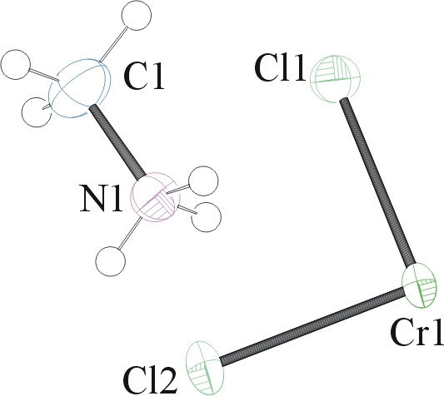
The protons on the amine were refined freely. The asymmetric unit on the right expands via the monoclinic symmetries to the 2-dim network shown in Figure 1.

The structure is of high quality and ready for publication. Table 1 summarizes the data collection details. Figure 1 shows an ORTEP of the asymmetric unit.

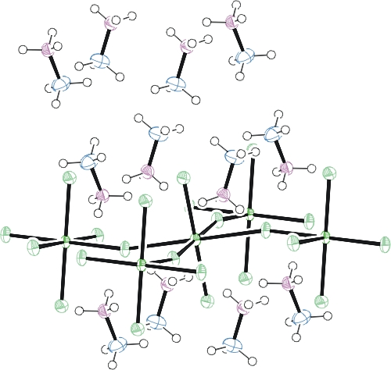
Figure 1. ORTEP of the structure with thermal ellipsoids at the 50% probability level.

Table 1: Crystallographic data for the structures provided.
Empirical formula C2 H12 Cl4 Cr N2
Formula weight 257.94
Temperature 100(2) K
Wavelength 0.7288 Å
Crystal system Monoclinic
Space group P 2₁/a
Unit cell dimensions a = 7.2317(19) Å α= 90°.
b = 7.437(2) Å β= 109.788(8)°.
c = 10.047(3) Å γ = 90°.
Volume 508.4(2) Å3
Z 2
Density (calculated) 1.685 Mg/m3
Absorption coefficient 2.246 mm-1
F(000) 260
Crystal size 0.100 x 0.030 x 0.010 mm3
Theta range for data collection 3.574 to 29.231°.
Index ranges -9<=h<=9, -9<=k<=9, -13<=l<=13
Reflections collected 2430
Independent reflections 1263 [R(int) = 0.0538]
Completeness to theta = 25.930° 99.7 %
Refinement method Full-matrix least-squares on F2
Data / restraints / parameters 1263 / 0 / 57
Goodness-of-fit on F2 1.070
Final R indices [I>2sigma(I)] R1 = 0.0416, wR2 = 0.1151
R indices (all data) R1 = 0.0529, wR2 = 0.1234
Extinction coefficient 0.024(7)
Largest diff. peak and hole 0.798 and -0.829 e.Å-3

Laura J. McCormick, Nico Giordano, Simon J. Teat, Christine M. Beavers: Crystals (2017), 7(12), 382.
Sheldrick, G. M. (2005). CELL_NOW. University of Goettingen, Germany.
Bruker (2007) APEX2 (Version 2.1-4), SAINT (version 7.34A), SADABS (version 2007/4), BrukerAXS Inc, Madison, Wisconsin, USA.
Sheldrick, G. M. (2007). TWINABS. University of Goettingen, Germany.
(a) Sheldrick GM. (2008) A short history of SHELX. Acta Cryst. A64, 112-122. (b) Sheldrick GM. (2015) SHELXT - Integrated space-group and crystal-structure determination. Acta Cryst. A71, 3-8.
(a) Altomare A, Burla C, Camalli M, Cascarano G L, Giacovazzo C, Guagliardi A, Moliterni AGG, Polidori G, Spagna R. (1999) SIR97: a new tool for crystal structure determination and refinement Journal of Applied Crystallography, 32, 115-119. (b) Altomare A, Cascarano G L, Giacovazzo C, Guagliardi A. (1993) Completion and refinement of crystal structures with SIR 92. Journal of Applied Crystallography, 26, 343-350.
(a) Sheldrick GM. (1997) SHELXL-97, Program for the Refinement of Crystal Structures. University of Göttingen, Germany. (b) Sheldrick GM. (2015) Crystal structure refinement with SHELXL. Acta Cryst. C71, 3–8
Waasmaier, D.; Kirfel, A. (1995) New Analytical Scattering Factor Functions for Free Atoms and Ions. Acta Crystallographica A., 51, 416-430.
Farrugia LJ. (1997) Ortep-3 for Windows. Journal of Applied Crystallography, 30, 565

