Crystal Structure Report for Dianne Xiao
by Paige M Gannon & Werner Kaminsky
Sample Submitted by Ryan Shafranek
ID – RTS_1158_IPA_30Mar
X-ray Crystallography Laboratory
University of Washington
31. July 2026

Data Collection started: 4/1/2022
Documentation finished: 4/12/2022

Data backup accessibly through http:
URL: http://cad4.cpac.washington.edu/structures

W.Kaminsky: tel. (206) 543 7585
(x-ray lab): tel. (206) 543 0210
Email: kaminsky@chem.washington.edu

Understanding crystallographic information is not trivial. If you discuss a structure in a publication, please let the crystallographers proof-read the final draft of that manuscript before you submit it.
For many structures it is true that crystallography is an intellectual performance (like synthesis or elucidation of mechanisms) and not a routine job. In these cases, particularly when the structures contribute significantly to the content of the publication, the crystallographers should be co-authors. Do not think this is not necessary because you pay for structures.
A blue needle, measuring 0.32 x 0.06 x 0.06 mm³ was mounted inside capillary with growth solution. Data was collected at -173ºC on a Bruker APEX II single crystal X-ray diffractometer, Mo-radiation, equipped with a Miracol X-ray optical collimator.

Crystal-to-detector distance was 40 mm and exposure time was 60 seconds per frame for all sets. The scan width was 0.5º. A total of 10625 reflections were collected covering the indices, -24<=h<=24, -23<=k<=23, -18<=l<=18. 5483 reflections were symmetry independent with R_{int} = 0.1778. Indexing and unit cell refinement indicated a C-centered monoclinic lattice. The space group was found to be C 2/m (No.12).

The data was integrated and scaled using SAINT, SADABS within the APEX2 software package by Bruker. The contribution of disordered solvent to the diffraction pattern was removed with SQUEEZE

Solution by direct methods (SHELXT or SIR97) produced a complete heavy atom phasing model consistent with the proposed structure. The structure was completed by difference Fourier synthesis with SHELXL. Scattering factors are from Waasmair and Kirfel. Hydrogen atoms were placed in geometrically idealised positions and constrained to ride on their parent atoms with C---H distances in the range 0.95-1.00 Angstrom. Isotropic thermal parameters U_{eq} were fixed such that they were 1.2U_{eq} of their parent atom Ueq for CH's and 1.5U_{eq} of their parent atom U_{eq} in case of methyl groups. All non-hydrogen atoms were refined anisotropically by full-matrix least-squares.

Due to the extensive solvent disorder, atomic positional coordinates exhibited a larger than usual uncertainty, which caused large displacement parameters. Those large parameters in turn cause diffraction intensities, via the Debye-Waller exponentials, to drop off quickly with increasing scattering angles. As a result, no scattering was ovserved beyond a resolution of 1.35.
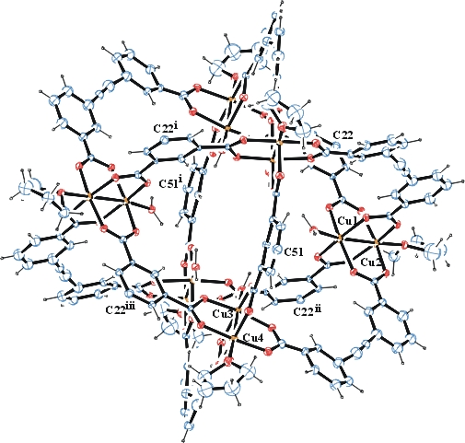
Figure 1. ORTEP of the expanded structure (with truncated phenyl(COO)2) with thermal ellipsoids at the 5% probability level.

The structure statistical data is of low quality, thus difficult to publish. Table 1 summarizes the data collection details. Figure 1 shows an ORTEP of the asymmetric unit.
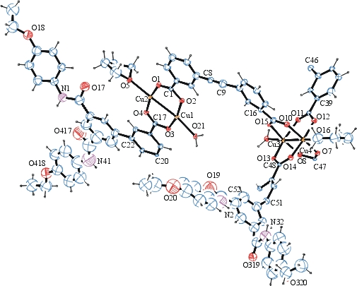
Figure 2. ORTEP of the asymmetric unit with thermal ellipsoids at the 5% probability level. Disorder omitted for clarity.

Table 1: Crystallographic data for the structures provided.
Empirical formula C312 H264 Cu12 N12 O84
Formula weight 6287.82
Temperature 100(2) K
Wavelength 0.71073 Å
Crystal system Monoclinic
Space group C 2/m
Unit cell dimensions a = 32.746(5) Å α= 90.000(5)°.
b = 31.540(5) Å β= 107.266(5)°.
c = 25.292(5) Å γ = 90.000(5)°.
Volume 24945(7) Å3
Z 2
Density (calculated) 0.837 Mg/m3
Absorption coefficient 0.552 mm-1
F(000) 6480
Crystal size 0.32 x 0.06 x 0.06 mm3
Theta range for data collection 0.917 to 15.262°.
Index ranges -24<=h<=24, -23<=k<=23, -18<=l<=18
Reflections collected 10625
Independent reflections 5483 [R(int) = 0.1778]
Completeness to theta = 15.262° 100.0 %
Refinement method Full-matrix least-squares on F2
Data / restraints / parameters 5483 / 1830 / 1039
Goodness-of-fit on F2 1.490
Final R indices [I>2sigma(I)] R1 = 0.1729, wR2 = 0.4338
R indices (all data) R1 = 0.2811, wR2 = 0.4893
Largest diff. peak and hole 0.791 and -0.642 e.Å-3

Bruker (2007) APEX2 (Version 2.1-4), SAINT (version 7.34A), SADABS (version 2007/4), BrukerAXS Inc, Madison, Wisconsin, USA.
(a) A. Spek, J. Appl. Cryst. (2003), 36, 7-13; (b) P. van der Sluis & A. L. Spek, Acta Cryst. (1990). A46, 194-201. (c) Spek, A. L. (2009). Acta. Cryst. D65, 148-155.
(a) Sheldrick GM. (2008) A short history of SHELX. Acta Cryst. A64, 112-122. (b) Sheldrick GM. (2015) SHELXT - Integrated space-group and crystal-structure determination. Acta Cryst. A71, 3-8.
(a) Altomare A, Burla C, Camalli M, Cascarano G L, Giacovazzo C, Guagliardi A, Moliterni AGG, Polidori G, Spagna R. (1999) SIR97: a new tool for crystal structure determination and refinement Journal of Applied Crystallography, 32, 115-119. (b) Altomare A, Cascarano G L, Giacovazzo C, Guagliardi A. (1993) Completion and refinement of crystal structures with SIR 92. Journal of Applied Crystallography, 26, 343-350.
(a) Sheldrick GM. (1997) SHELXL-97, Program for the Refinement of Crystal Structures. University of Göttingen, Germany. (b) Sheldrick GM. (2015) Crystal structure refinement with SHELXL. Acta Cryst. C71, 3–8
Waasmaier, D.; Kirfel, A. (1995) New Analytical Scattering Factor Functions for Free Atoms and Ions. Acta Crystallographica A., 51, 416-430.
Farrugia LJ. (1997) Ortep-3 for Windows. Journal of Applied Crystallography, 30, 565

