Crystal Structure Report for K Schlenker
by Werner Kaminsky
Sample Submitted by Emily Rabe
ID – Rabe010218
X-ray Crystallography Laboratory
University of Washington
31. July 2026

Data Collection started: 1/2/2018
Documentation finished: 1/10/2018

Data backup accessibly through http:
URL: http://cad4.cpac.washington.edu/structures

W.Kaminsky: tel. (206) 543 7585
(x-ray lab): tel. (206) 543 0210
Email: kaminsky@chem.washington.edu

Understanding crystallographic information is not trivial. If you discuss a structure in a publication, please let the crystallographers proof-read the final draft of that manuscript before you submit it.
For many structures it is true that crystallography is an intellectual performance (like synthesis or elucidation of mechanisms) and not a routine job. In these cases, particularly when the structures contribute significantly to the content of the publication, the crystallographers should be co-authors. Do not think this is not necessary because you pay for structures.
A small yellow prism, measuring 0.15 x 0.13 x 0.12 mm³ was mounted on a loop with oil. Data was collected at -173ºC on a Bruker APEX II single crystal X-ray diffractometer, Mo-radiation.

Crystal-to-detector distance was 40 mm and exposure time was 240 seconds per frame for all sets. The scan width was 1º. Data collection was 93.1% complete to 25º in ϑ. A total of 16298 reflections were collected covering the indices, -17<=h<=17, -17<=k<=17, -23<=l<=23. 1260 reflections were symmetry independent and the very large R_{int} = 0.9911 indicated that the data was quite problematic and most likely merohedrally twinned, which could not be resolved via multi-component integration. Indexing and unit cell refinement indicated a rombohedral/trigonal lattice. Through extensive trial and error, a solving space group was found to be R 3 c (No.161).

The data was integrated and scaled using SAINT, SADABS within the APEX2 software package by Bruker.

Solution by direct methods (SHELXS, SIR97) produced a complete heavy atom phasing model consistent with the proposed structure. The structure was completed by difference Fourier synthesis with SHELXL97., Scattering factors are from Waasmair and Kirfel. Hydrogen atoms were placed in geometrically idealised positions and constrained to ride on their parent atoms with C---H distances in the range 0.95-1.00 Angstrom. Isotropic thermal parameters U_{eq} were fixed such that they were 1.2U_{eq} of their parent atom Ueq for CH's and 1.5U_{eq} of their parent atom U_{eq} in case of methyl groups. All non-hydrogen atoms were refined anisotropically by full-matrix least-squares.

The structure is marginally obtained as the data was indeed twinned and the crystal small and of poor quality with tilted growth along the c-axis. Application of a twin law found via PLATON helped, but likely more than one twin relation was present.

The structural model should to be taken with a grain of salt as bond distances and displacement parameter are highly constraint to help conversion of the refinement. However, the geometry obtained is very plausible, including the water molecule that fills out infinite channels along the c-axis and appears 3-fold and is located slightly out of the plane of the organic molecule which contains a threefold symmetry axis through the central nitrogen.

The structure is of modest quality and may be hard get passed referees for publication. Table 1 summarizes the data collection details. Figure 1 shows an ORTEP of the asymmetric unit.

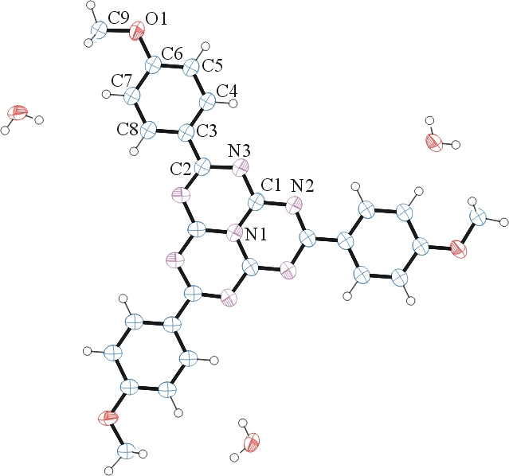

Figure 1. ORTEP of the structure with thermal ellipsoids at the 50% probability level. Water disorder omitted for clarity.

Table 1: Crystallographic data for the structures provided.
Empirical formula C27 H23 N7 O4
Formula weight 509.52
Temperature 100(2) K
Wavelength 0.71073 Å
Crystal system Trigonal
Space group R 3 c :H
Unit cell dimensions a = 14.358(4) Å α= 90°.
b = 14.358(4) Å β= 90°.
c = 19.236(6) Å γ = 120°.
Volume 3434(2) Å3
Z 6
Density (calculated) 1.478 Mg/m3
Absorption coefficient 0.103 mm-1
F(000) 1596
Crystal size 0.150 x 0.130 x 0.120 mm3
Theta range for data collection 1.950 to 25.179°.
Index ranges -17<=h<=17, -17<=k<=17, -23<=l<=23
Reflections collected 16298
Independent reflections 1260 [R(int) = 0.9911]
Completeness to theta = 25.000° 93.1 %
Refinement method Full-matrix least-squares on F2
Data / restraints / parameters 1260 / 121 / 44
Goodness-of-fit on F2 1.279
Final R indices [I>2sigma(I)] R1 = 0.3207, wR2 = 0.5396
R indices (all data) R1 = 0.5448, wR2 = 0.6496
Largest diff. peak and hole 0.974 and -0.671 e.Å-3

Bruker (2007) APEX2 (Version 2.1-4), SAINT (version 7.34A), SADABS (version 2007/4), BrukerAXS Inc, Madison, Wisconsin, USA.
(a) Altomare A, Burla C, Camalli M, Cascarano G L, Giacovazzo C, Guagliardi A, Moliterni AGG, Polidori G, Spagna R. (1999) SIR97: a new tool for crystal structure determination and refinement Journal of Applied Crystallography, 32, 115-119. (b) Altomare A, Cascarano G L, Giacovazzo C, Guagliardi A. (1993) Completion and refinement of crystal structures with SIR 92. Journal of Applied Crystallography, 26, 343-350.
(a) Sheldrick GM. (1997) SHELXL-97, Program for the Refinement of Crystal Structures. University of Göttingen, Germany. (b) Sheldrick GM. (2013) Crystal structure refinement with SHELXL. Acta Cryst. (2015). C71, 3-8.
Mackay, S.; Edwards, C.; Henderson, A.; Gilmore, C.; Stewart, N.; Shankland, K.; Donald, A. (1997) MaXus: a computer program for the solution and refinement of crystal structures from diffraction data. University of Glasgow, Scotland,.
Waasmaier, D.; Kirfel, A. (1995) New Analytical Scattering Factor Functions for Free Atoms and Ions. Acta Crystallographica A., 51, 416-430.
PLATON: Spek, A. L. (2009). Acta. Cryst. D65, 148-155.
Farrugia LJ. (1997) Ortep-3 for Windows. Journal of Applied Crystallography, 30, 565

