Crystal Structure Report for S. Adhikari
by Werner Kaminsky
ID – SA_SO_408
X-ray Crystallography Laboratory
University of Washington
28. July 2026

Data Collection started: 8/26/2024
Documentation finished: 9/4/2024

Data backup accessibly through http:
URL: http://cad4.cpac.washington.edu/structures

W.Kaminsky: tel. (206) 543 7585
(x-ray lab): tel. (206) 543 0210
Email: kaminsky@chem.washington.edu

Understanding crystallographic information is not trivial. If you discuss a structure in a publication, please let the crystallographers proof-read the final draft of that manuscript before you submit it.
For many structures it is true that crystallography is an intellectual performance (like synthesis or elucidation of mechanisms) and not a routine job. In these cases, particularly when the structures contribute significantly to the content of the publication, the crystallographers should be co-authors. Do not think this is not necessary because you pay for structures.
A yellow block, measuring 0.18 x 0.16 x 0.15 mm³ was mounted on a loop with oil. Data was collected at -173ºC on a Bruker APEX II single crystal X-ray diffractometer, Mo-radiation, equipped with a Miracol X-ray optical collimator.

Crystal-to-detector distance was 40 mm and exposure time was 3 seconds per frame for all sets. The scan width was 0.5º. Data collection was 100% complete to 25º in ϑ. A total of 10756 reflections were collected covering the indices, -10<=h<=10, -25<=k<=25, -19<=l<=19. 5464reflections were symmetry independent and the R_{int} = 0.0491 indicated that the data was of better than average quality (0.07). Indexing and unit cell refinement indicated a primitive monoclinic lattice. The space group was found to be P 2₁/n (No. 14).

The data was integrated and scaled using SAINT, SADABS within the APEX2 software package by Bruker.

Solution by direct methods (SHELXT or SIR97) produced a complete heavy atom phasing model consistent with the proposed structure. The structure was completed by difference Fourier synthesis with SHELXL. Scattering factors are from Waasmair and Kirfel. Hydrogen atoms were placed in geometrically idealised positions and constrained to ride on their parent atoms with C---H distances in the range 0.95-1.00 Angstrom. Isotropic thermal parameters U_{eq} were fixed such that they were 1.2U_{eq} of their parent atom Ueq for CH's and 1.5U_{eq} of their parent atom U_{eq} in case of methyl groups. All non-hydrogen atoms were refined anisotropically by full-matrix least-squares.

The structure is 1-dim polymeric (N4 .. Pb1).

The structure is of high quality and ready for publication. Table 1 summarizes the data collection details. Figure 1 shows an ORTEP of the asymmetric unit.

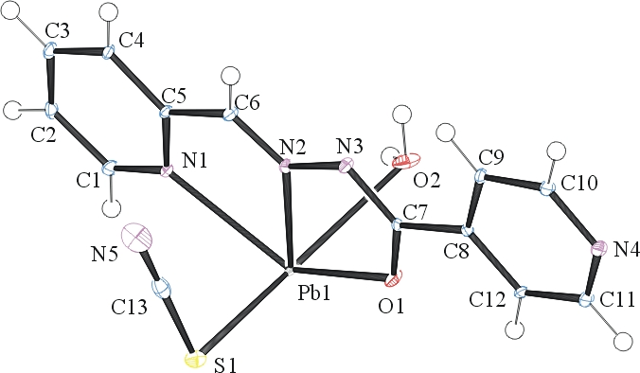
Figure 1. ORTEP of the asymmetric unit with thermal ellipsoids at the 50% probability level.

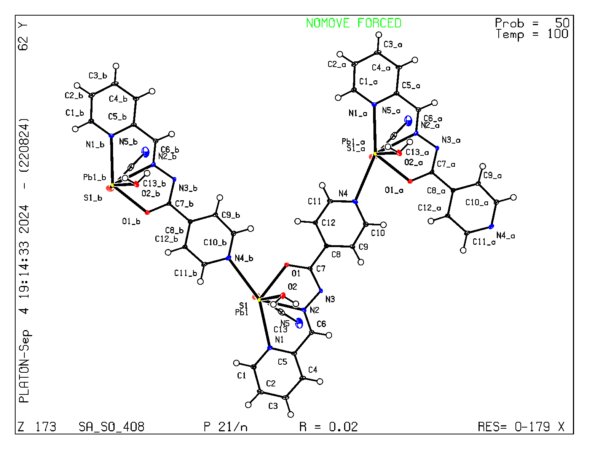Figure 2. The polymeric structure.

Table 1: Crystallographic data for the structures provided.
Empirical formula C13 H11 N5 O2 Pb S
Formula weight 508.52
Temperature 100(2) K
Wavelength 0.71073 Å
Crystal system Monoclinic
Space group P 2₁/n
Unit cell dimensions a = 7.0034(5) Å α= 90°.
b = 16.3121(10) Å β= 91.703(4)°.
c = 12.4165(8) Å γ = 90°.
Volume 1417.84(16) Å3
Z 4
Density (calculated) 2.382 Mg/m3
Absorption coefficient 12.061 mm-1
F(000) 952
Crystal size 0.180 x 0.160 x 0.150 mm3
Theta range for data collection 2.062 to 33.324°.
Index ranges -10<=h<=10, -25<=k<=25, -19<=l<=19
Reflections collected 10756
Independent reflections 5464 [R(int) = 0.0491]
Completeness to theta = 25.242° 100.0 %
Refinement method Full-matrix least-squares on F2
Data / restraints / parameters 5464 / 0 / 206
Goodness-of-fit on F2 1.094
Final R indices [I>2sigma(I)] R1 = 0.0240, wR2 = 0.0605
R indices (all data) R1 = 0.0271, wR2 = 0.0618
Extinction coefficient 0.00297(14)
Largest diff. peak and hole 2.395 and -2.714 e.Å-3

Bruker (2007) APEX2 (Version 2.1-4), SAINT (version 7.34A), SADABS (version 2007/4), BrukerAXS Inc, Madison, Wisconsin, USA.
(a) Sheldrick GM. (2008) A short history of SHELX. Acta Cryst. A64, 112-122. (b) Sheldrick GM. (2015) SHELXT - Integrated space-group and crystal-structure determination. Acta Cryst. A71, 3-8.
(a) Altomare A, Burla C, Camalli M, Cascarano G L, Giacovazzo C, Guagliardi A, Moliterni AGG, Polidori G, Spagna R. (1999) SIR97: a new tool for crystal structure determination and refinement Journal of Applied Crystallography, 32, 115-119. (b) Altomare A, Cascarano G L, Giacovazzo C, Guagliardi A. (1993) Completion and refinement of crystal structures with SIR 92. Journal of Applied Crystallography, 26, 343-350.
(a) Sheldrick GM. (1997) SHELXL-97, Program for the Refinement of Crystal Structures. University of Göttingen, Germany. (b) Sheldrick GM. (2015) Crystal structure refinement with SHELXL. Acta Cryst. C71, 3–8
Waasmaier, D.; Kirfel, A. (1995) New Analytical Scattering Factor Functions for Free Atoms and Ions. Acta Crystallographica A., 51, 416-430.
Farrugia LJ. (1997) Ortep-3 for Windows. Journal of Applied Crystallography, 30, 565

