Crystal Structure Report for K. Goldberg
by Werner Kaminsky
Sample Submitted by Greg Fulmer
ID – GRF006
X-ray Crystallography Laboratory
University of Washington
31. July 2026

Data Collection started:
Documentation finished:

Data backup accessibly through http:
URL: http://cad4.cpac.washington.edu/structures
Username: xray-user
Password: hkl-data

W.Kaminsky: tel. (206) 543 7585
(x-ray lab): tel. (206) 543 0210
Email: kaminsky@chem.washington.edu

Understanding crystallographic information is not trivial. If you discuss a structure in a publication, please let the crystallographers proof-read the final draft of that manuscript before you submit it.
For many structures it is true that crystallography is an intellectual performance (like synthesis or elucidation of mechanisms) and not a routine job. In these cases, particularly when the structures contribute significantly to the content of the publication, the crystallographers should be co-authors. Do not think this is not necessary because you pay for structures. Even I have to pay for my own structures for my research.
A colorless plate, measuring 0.35 x 0.20 x 0.02 mm³ was mounted on a loop with oil. Data was collected at -143ºC on a Nonius Kappa CCD FR590 single crystal X-ray diffractometer, Mo-radiation.

Crystal-to-detector distance was 30 mm and exposure time was 50 seconds per degree for all sets. The scan width was 2º. Data collection was 92.9% complete to 25.3º and 94.3% complete to 25º in ϑ. A total of 71296 partial and complete reflections were collected covering the indices, h = -11 to 11, k = -23 to 21, l = -20 to 23. 12420 reflections were symmetry independent and the R_{int} = 0.1717 indicated that the data was problematic (average quality 0.07). Indexing and unit cell refinement indicated a triclinic P lattice. The space group was found to be P‾1 (No.2).

The data was integrated and scaled using hkl-SCALEPACK. This program applies a multiplicative correction factor (S) to the observed intensities (I) and has the following form:

S is calculated from the scale and the B factor determined for each frame and is then applied to I to give the corrected intensity (I_{corr}).

Solution by direct methods (SHELXS, SIR97) produced a complete heavy atom phasing model consistent with the proposed structure. The structure was completed by difference Fourier synthesis with SHELXL97., Scattering factors are from Waasmair and Kirfel. Hydrogen atoms were placed in geometrically idealised positions and constrained to ride on their parent atoms with C---H distances in the range 0.95-1.00 Angstrom. Isotropic thermal parameters U_{eq} were fixed such that they were 1.2U_{eq} of their parent atom Ueq for CH's and 1.5U_{eq} of their parent atom U_{eq} in case of methyl groups. All non-hydrogen atoms were refined anisotropically by full-matrix least-squares.

One disordered toluene molecule, was found. Two t-butylls were disordered and the CF₃ moieties showed enhanced thermal motion which required some restraints to ensure convergence of the structure refinement. The hydrogen on O1 was placed to balance charges.

The structure is of high quality and ready for publication. Table 1 summarizes the data collection details. Figure 1 shows an ORTEP of the asymmetric unit.

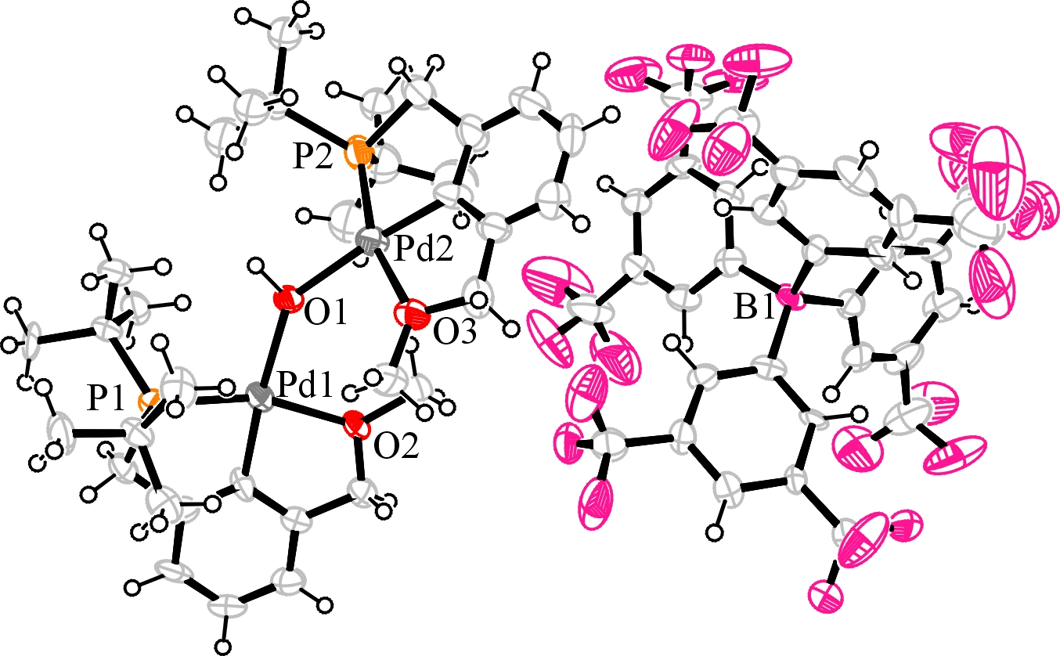
Figure 1. ORTEP of the structure with thermal ellipsoids at the 50% probability level. Disorder and solvent omitted for clarity.

Table 1: Crystallographic data for the structures provided.
Property | The structure at 130(2) K
Empirical Formula | 2(C₃₄ H₅₇ O₃ P₂ Pd₂), 2(C₃₂ H₁₂ B F₂₄), C₇ H₈
Formula Weight | 3395.66
Temperature K | 130(2)
Wavelength Å | 0.71073
Habit/color | Plate colorless
Crystal System, space group | Triclinic, P‾1 (No. 2)
Unit Cell Dimensions
a, Å  b, Å  c, Å  α, (deg.)  β, (deg.)  γ, (deg.) | 9.7961(10)  19.388(3)  19.765(2)  96.546(13)  96.997(12)  96.935(4)
Volume (Å³) | 3667.0(8)
Density Mg/m³ | 1.538
Reflections Collected/Unique | 20342 / 12420
Rint / Rσ | 0.1717 / 0.3537
ϑm / completeness | 25º / 94.3%
Final R indices [I>2σ(I)]
R1, wR2 | 0.0707, 0.1166
R indices (all data)
R1, wR2 | 0.2446, 0.1684

Otwinowsky, Z.; Minor, W. In: Methods in Enzymology; Carter, C. W., Jr., Sweet, R. M., Eds.; Academic Press: New York, 1997, 276, 307-326.
(a) Altomare, A.; Burla, C.; Camalli M.; Cascarano L.; Giacovazzo C.; Guagliardi A.; Moliterni A.G.G.; Polidori G.; Spagna R. J. Appl. Cryst. 1999, 32, 115-119; (b) Altomare, A., Cascarano, G., Giacovazzo, C., Guagliardi, A., J. Appl. Cryst. 1993, 26, 343.
Sheldrick, G. M. SHELXL-97: Program for the Refinement of Crystal Structures 1997 University of Gottingen, Germany.
Mackay, S.; Edwards, C.; Henderson, A.; Gilmore, C.; Stewart, N.; Shankland, K.; Donald, A.; MaXus: a computer program for the solution and refinement of crystal structures from diffraction data. University of Glasgow, Scotland, 1997.
Waasmaier, D.; Kirfel, A. Acta Crystallogr. A. 1995, 51, 416.
Farrugia, L. J. Appl. Cryst. 1997, 30, 565

