Crystal Structure Report for B. Cossairt
by Sebastian Krajewski
&
Werner Kaminsky
Sample Submitted by Soren Sandeno
ID – SFS_InAs_PhAc_PEt2Ph_TolPent
X-ray Crystallography Laboratory
University of Washington
31. July 2026

Data Collection started: 10/30/2023
Documentation finished: 11/2/2023

Data backup accessibly through http:
URL: http://cad4.cpac.washington.edu/structures

W.Kaminsky: tel. (206) 543 7585
(x-ray lab): tel. (206) 543 0210
Email: kaminsky@chem.washington.edu

Understanding crystallographic information is not trivial. If you discuss a structure in a publication, please let the crystallographers proof-read the final draft of that manuscript before you submit it.
For many structures it is true that crystallography is an intellectual performance (like synthesis or elucidation of mechanisms) and not a routine job. In these cases, particularly when the structures contribute significantly to the content of the publication, the crystallographers should be co-authors. Do not think this is not necessary because you pay for structures.
An orange block, measuring 0.07 x 0.06 x 0.05 mm³ was mounted on a loop with oil. Data was collected at -173ºC on a Bruker APEX II single crystal X-ray diffractometer, Mo-radiation, equipped with a Miracol X-ray optical collimator.

Crystal-to-detector distance was 40 mm and exposure time was 120 seconds per frame for all sets. The scan width was 0.7º. Data collection was 99.9% complete to 24.407º in ϑ. A total of 176486 reflections were collected covering the indices, -44<=h<=44, -24<=k<=24, -43<=l<=43. 43904 reflections were symmetry independent and the elevated R_{int} = 0.2442 relates to the small sample size. Indexing and unit cell refinement indicated a monoclinic lattice. The space group was found to be P 2₁/c (No.14).

The data was integrated and scaled using SAINT, SADABS within the APEX2 software package by Bruker.

Solution by direct methods (SHELXT or SIR97) produced a complete heavy atom phasing model consistent with the proposed structure. The structure was completed by difference Fourier synthesis with SHELXL. Scattering factors are from Waasmair and Kirfel. Hydrogen atoms were placed in geometrically idealised positions and constrained to ride on their parent atoms with C---H distances in the range 0.95-1.00 Angstrom. Isotropic thermal parameters U_{eq} were fixed such that they were 1.2U_{eq} of their parent atom Ueq for CH's and 1.5U_{eq} of their parent atom U_{eq} in case of methyl groups. All non-hydrogen atoms were refined anisotropically by full-matrix least-squares.

The core is roughly bullet-shaped with a tip and (As1) a flat end (As18) exhibiting pseudo-C3 symmetry along axis (As1 As7 As8 As26 As18).

The contribution of disordered toluene and possibly pentane solvent to the diffraction pattern was removed with SQUEEZE, and some disorder was modeled.

The structure is of good quality and ready for publication (provided the small sample size and thus reduced data quality is mentioned). Table 1 summarizes the data collection details. Figure 1 shows an ORTEP of the asymmetric unit.

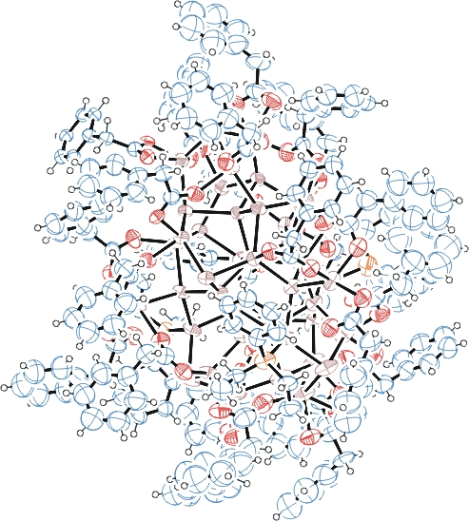
Figure 1. ORTEP of the structure with thermal ellipsoids at the 50% probability level. Disorder omitted for clarity.

Table 1: Crystallographic data for the structures provided.
Empirical formula C222 H213 As18 In26 O48 P3
Formula weight 8075.70
Temperature 100(2) K
Wavelength 0.71073 Å
Crystal system Monoclinic
Space group P 2₁/c
Unit cell dimensions a = 36.969(3) Å α= 90°.
b = 20.6296(18) Å β= 103.421(4)°.
c = 36.014(4) Å γ = 90°.
Volume 26716(4) Å3
Z 4
Density (calculated) 2.008 Mg/m3
Absorption coefficient 4.489 mm-1
F(000) 15368
Crystal size 0.070 x 0.060 x 0.050 mm3
Theta range for data collection 1.133 to 24.407°.
Index ranges -44<=h<=44, -24<=k<=24, -43<=l<=43
Reflections collected 43904
Independent reflections 43904 [R(int) = 0.2442]
Completeness to theta = 24.407° 99.9 %
Refinement method Full-matrix least-squares on F2
Data / restraints / parameters 43904 / 10248 / 2775
Goodness-of-fit on F2 1.091
Final R indices [I>2sigma(I)] R1 = 0.1409, wR2 = 0.2368
R indices (all data) R1 = 0.3388, wR2 = 0.2802
Largest diff. peak and hole 2.610 and -1.360 e.Å-3

Bruker (2007) APEX2 (Version 2.1-4), SAINT (version 7.34A), SADABS (version 2007/4), BrukerAXS Inc, Madison, Wisconsin, USA.
(a) Sheldrick GM. (2008) A short history of SHELX. Acta Cryst. A64, 112-122. (b) Sheldrick GM. (2015) SHELXT - Integrated space-group and crystal-structure determination. Acta Cryst. A71, 3-8.
(a) Altomare A, Burla C, Camalli M, Cascarano G L, Giacovazzo C, Guagliardi A, Moliterni AGG, Polidori G, Spagna R. (1999) SIR97: a new tool for crystal structure determination and refinement Journal of Applied Crystallography, 32, 115-119. (b) Altomare A, Cascarano G L, Giacovazzo C, Guagliardi A. (1993) Completion and refinement of crystal structures with SIR 92. Journal of Applied Crystallography, 26, 343-350.
(a) Sheldrick GM. (1997) SHELXL-97, Program for the Refinement of Crystal Structures. University of Göttingen, Germany. (b) Sheldrick GM. (2015) Crystal structure refinement with SHELXL. Acta Cryst. C71, 3–8
Waasmaier, D.; Kirfel, A. (1995) New Analytical Scattering Factor Functions for Free Atoms and Ions. Acta Crystallographica A., 51, 416-430.
(a) A. Spek, J. Appl. Cryst. (2003), 36, 7-13; (b) P. van der Sluis & A. L. Spek, Acta Cryst. (1990). A46, 194-201. (c) Spek, A. L. (2009). Acta. Cryst. D65, 148-155.
Farrugia LJ. (1997) Ortep-3 for Windows. Journal of Applied Crystallography, 30, 565

