Crystal Structure Report for B. Cossairt
by Werner Kaminsky
Sample Submitted by Soren Sandeno
ID – sfs_tbufragment
X-ray Crystallography Laboratory
University of Washington
29. July 2026

Data Collection started: 3/8/2023
Documentation finished: 3/21/2023

Data backup accessibly through http:
URL: http://cad4.cpac.washington.edu/structures

W.Kaminsky: tel. (206) 543 7585
(x-ray lab): tel. (206) 543 0210
Email: kaminsky@chem.washington.edu

Understanding crystallographic information is not trivial. If you discuss a structure in a publication, please let the crystallographers proof-read the final draft of that manuscript before you submit it.
For many structures it is true that crystallography is an intellectual performance (like synthesis or elucidation of mechanisms) and not a routine job. In these cases, particularly when the structures contribute significantly to the content of the publication, the crystallographers should be co-authors. Do not think this is not necessary because you pay for structures.
A colorless piece, measuring 0.32 x 0.13 x 0.10 mm³ was mounted on a loop with oil. Data was collected at -173ºC on a Bruker APEX II single crystal X-ray diffractometer, Mo-radiation, equipped with a Miracol X-ray optical collimator.

Crystal-to-detector distance was 60 mm and exposure time was 60 seconds per frame for all sets. The scan width was 0.5º. Data collection was 99.5% complete to 25º in ϑ. A total of 181658 merged reflections were collected covering the indices, -53<=h<=53, -29<=k<=29, -58<=l<=58. 92324 reflections were symmetry independent and the R_{int} = 0.0559 indicated that the data was of good quality. Indexing and unit cell refinement indicated a primitive monoclinic – protein size lattice. The space group was found to be P 2₁/n (No. 14).

The data was integrated and scaled using SAINT, SADABS within the APEX2 software package by Bruker.

Solution by direct methods (SHELXT or SIR97) produced a complete heavy atom phasing model consistent with the proposed structure. The structure was completed by difference Fourier synthesis with SHELXL., Scattering factors are from Waasmair and Kirfel. Hydrogen atoms were placed in geometrically idealised positions and constrained to ride on their parent atoms with C---H distances in the range 0.95-1.00 Angstrom. Isotropic thermal parameters U_{eq} were fixed such that they were 1.2U_{eq} of their parent atom Ueq for CH's and 1.5U_{eq} of their parent atom U_{eq} in case of methyl groups. All non-hydrogen atoms were refined anisotropically by full-matrix least-squares.

The R1 of the structure appears elevated due to a large amount of disorder. There is one water molecule (O79) which establishes hydrogen bonds to O33 and O37. 15 of the 39 organic CO2CH2phen-t-but moieties were found to be disordered, which required to link all organic moieties and their disordered renditions with ‘SAME’. While all C and O atoms were restraint with ISOR to help keep the displacement parameter matrices positive definite, the disordered ones were restraint with SIMU. Very few atoms needed additional restraints. Some difluorobenzene solvent molecules were found, but the contribution of additional unidentified solvent, located between the four molecules in the unit cell, to the diffraction pattern was removed with SQUEEZE. The checkcif of the structure shows a few remaining B-warnings, which can be dealt with but that would need somewhat unreasonable constraints.
The structure is nevertheless of high quality and ready for publication. Table 1 summarizes the data collection details. Figure 1 shows an ORTEP of the asymmetric unit.

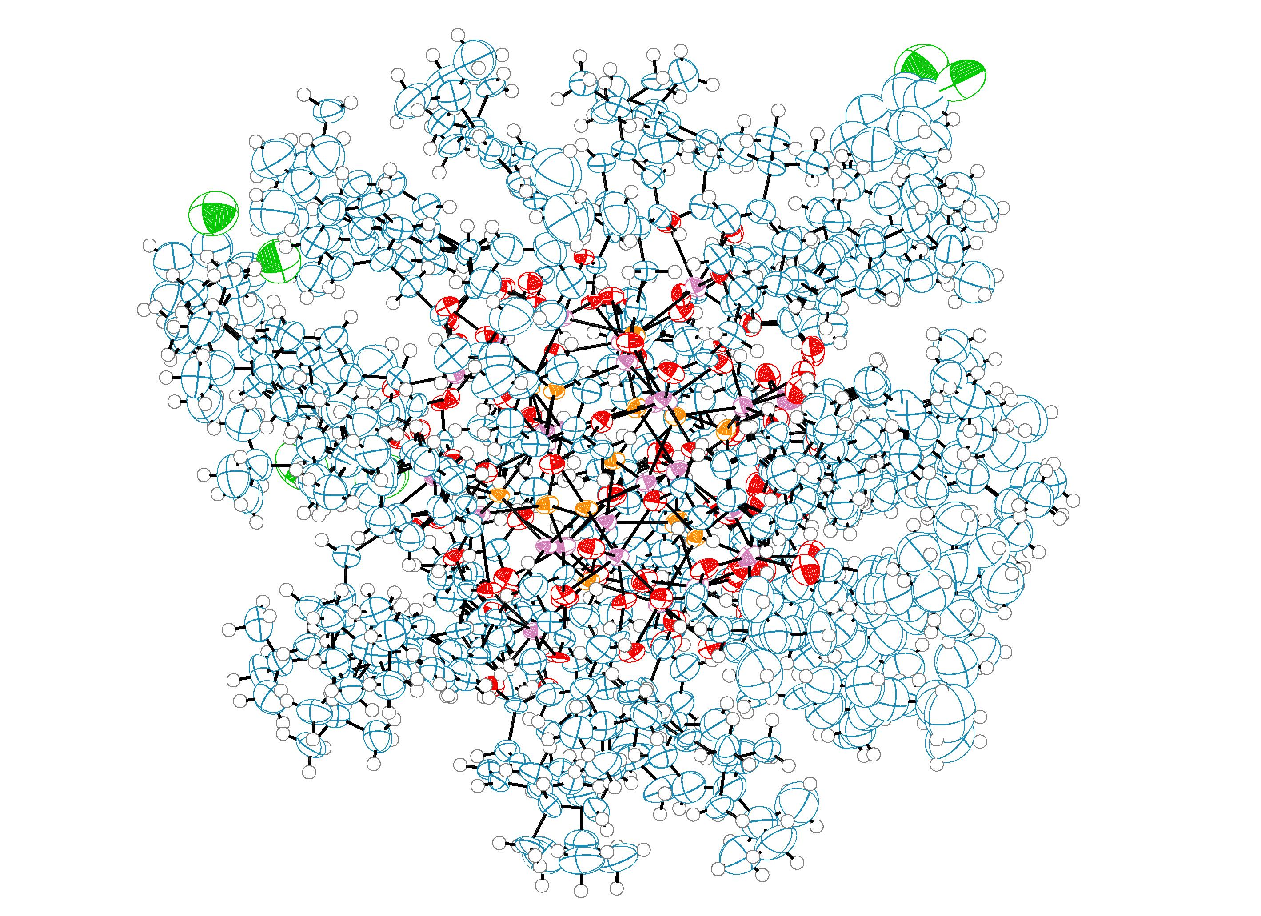
Figure 1. ORTEP of the structure with thermal ellipsoids at the 50% probability level. Hydrogen atoms and disorder omitted for clarity.

Table 1: Crystallographic data for the structures provided.
Empirical formula C480 H595 F4 In26 O79 P13
Formula weight 11092.45
Temperature 100(2) K
Wavelength 0.71073 Å
Crystal system Monoclinic
Space group P 21/n
Unit cell dimensions a = 44.699(3) Å α= 90°.
b = 24.8681(14) Å β= 107.109(3)°.
c = 49.437(3) Å γ = 90°.
Volume 52521(5) Å3
Z 4
Density (calculated) 1.403 Mg/m3
Absorption coefficient 1.221 mm-1
F(000) 22448
Crystal size 0.320 x 0.130 x 0.100 mm3
Theta range for data collection 0.947 to 25.027°.
Index ranges -53<=h<=53, -29<=k<=29, -58<=l<=58
Reflections collected 181658
Independent reflections 92324 [R(int) = 0.0559]
Completeness to theta = 25.027° 99.5 %
Refinement method Full-matrix least-squares on F2
Data / restraints / parameters 92324 / 49441 / 6275
Goodness-of-fit on F2 1.162
Final R indices [I>2sigma(I)] R1 = 0.1391, wR2 = 0.2798
R indices (all data) R1 = 0.1749, wR2 = 0.2963
Largest diff. peak and hole 2.337 and -1.440 e.Å-3

Bruker (2007) APEX2 (Version 2.1-4), SAINT (version 7.34A), SADABS (version 2007/4), BrukerAXS Inc, Madison, Wisconsin, USA.
Sheldrick GM. (2015) SHELXT - Integrated space-group and crystal-structure determination. Acta Cryst. A71, 3-8.
(a) Altomare A, Burla C, Camalli M, Cascarano G L, Giacovazzo C, Guagliardi A, Moliterni AGG, Polidori G, Spagna R. (1999) SIR97: a new tool for crystal structure determination and refinement Journal of Applied Crystallography, 32, 115-119. (b) Altomare A, Cascarano G L, Giacovazzo C, Guagliardi A. (1993) Completion and refinement of crystal structures with SIR 92. Journal of Applied Crystallography, 26, 343-350.
’Sheldrick : A short history of SHELX . Acta Cryst. (2008), A64, 112-122
Mackay, S.; Edwards, C.; Henderson, A.; Gilmore, C.; Stewart, N.; Shankland, K.; Donald, A. (1997) MaXus: a computer program for the solution and refinement of crystal structures from diffraction data. University of Glasgow, Scotland,.
Waasmaier, D.; Kirfel, A. (1995) New Analytical Scattering Factor Functions for Free Atoms and Ions. Acta Crystallographica A., 51, 416-430.
(a) A. Spek, J. Appl. Cryst. (2003), 36, 7-13; (b) P. van der Sluis & A. L. Spek, Acta Cryst. (1990). A46, 194-201. (c) Spek, A. L. (2009). Acta. Cryst. D65, 148-155.
Farrugia LJ. (1997) Ortep-3 for Windows. Journal of Applied Crystallography, 30, 565

